**SETTINGS**

You need to locate your test. It should look something like this:

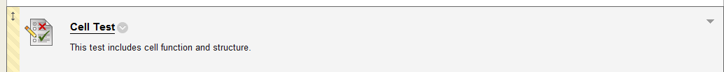



When you click on the arrow pointed down to the right of the test.

You will see the following options pop up:

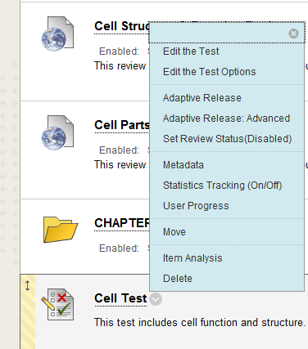



**If you want to set up your test so that you do not have to go into the test each semester and change when it is available to the students, you will want to set it up so it looks like the following:**

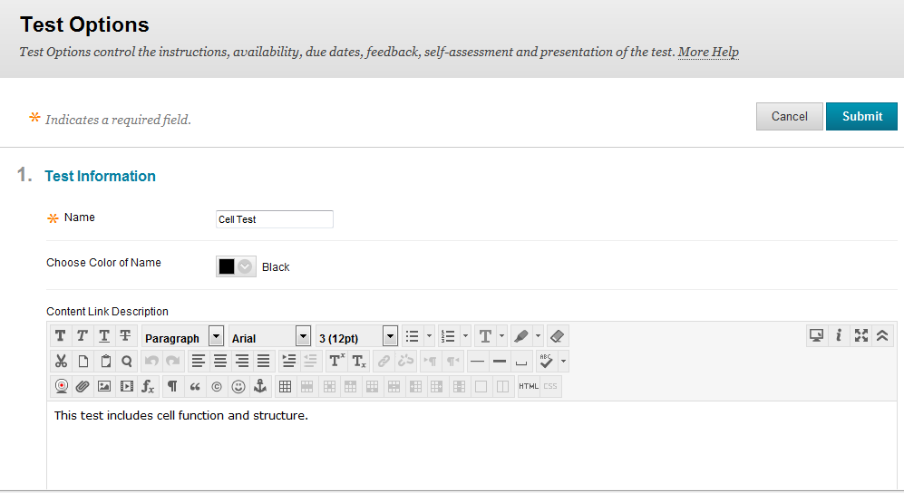



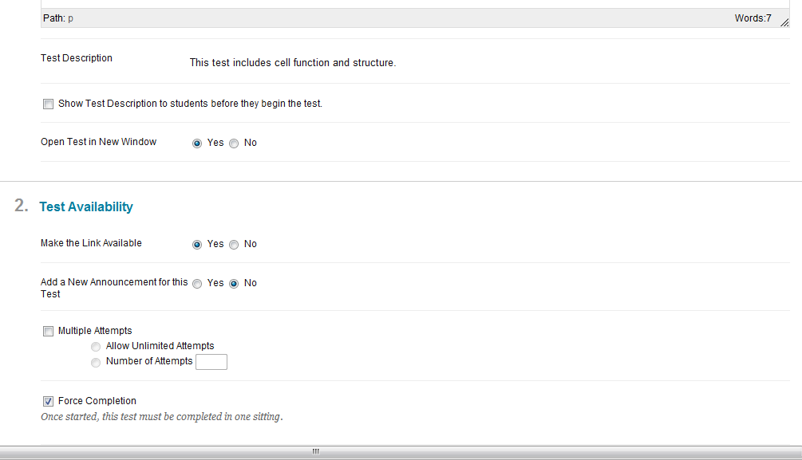



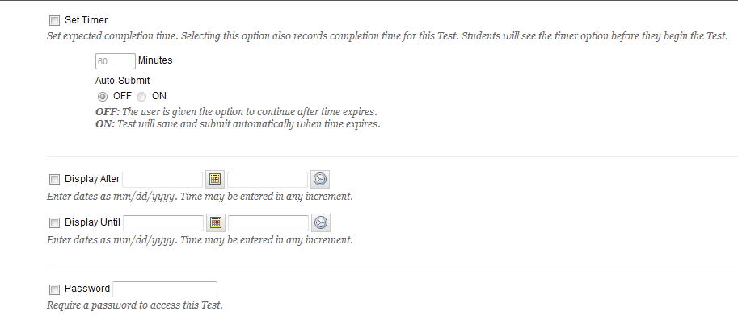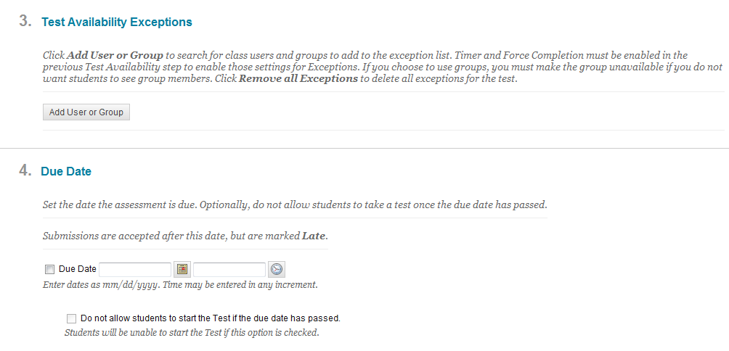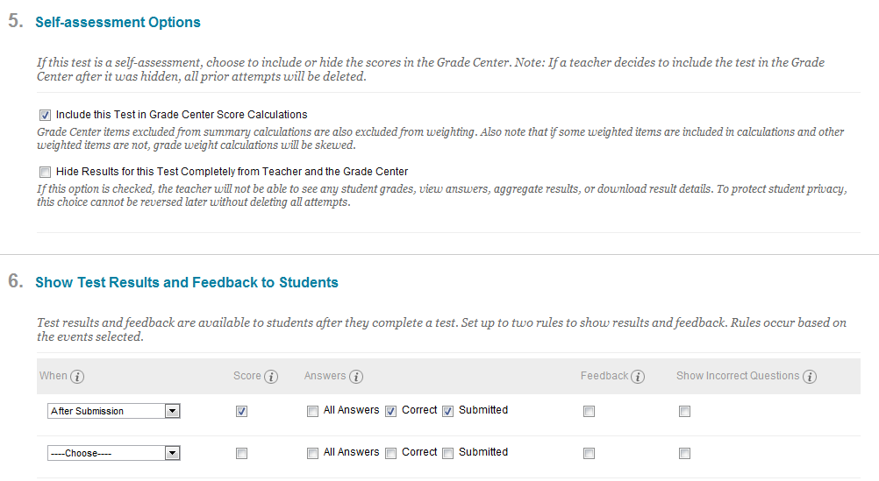



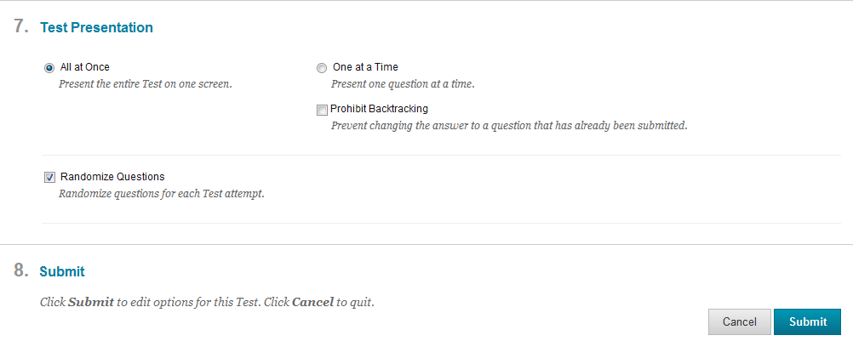



Then you click on submit.

You can go back multiple times to this setting.

**Limited Settings – We want our test to be available for a short time. These are the following changes that you want to make from the above choices:**

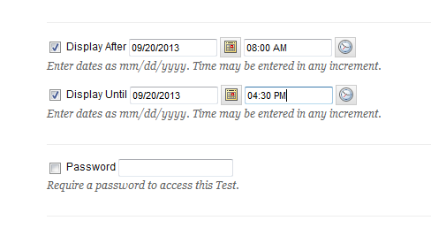



**On our semester tests, when we want to have the questions grouped together by chapters we do NOT select Randomize Questions.**

