**You want an extra credit question for a test.**

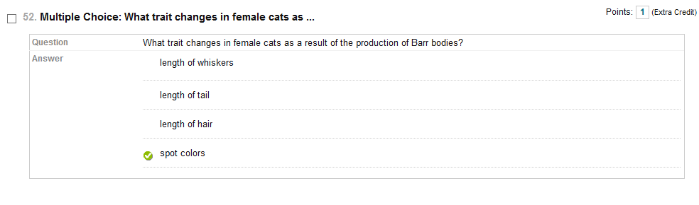

**All you have to do is type in your question and click on SUBMIT.**

**Now you have to click on the upper right hand side. Change UPDATE POINTS and click on EXTRA CREDIT and click on SUBMIT. We usually give extra credit questions the value of 1 point.**





