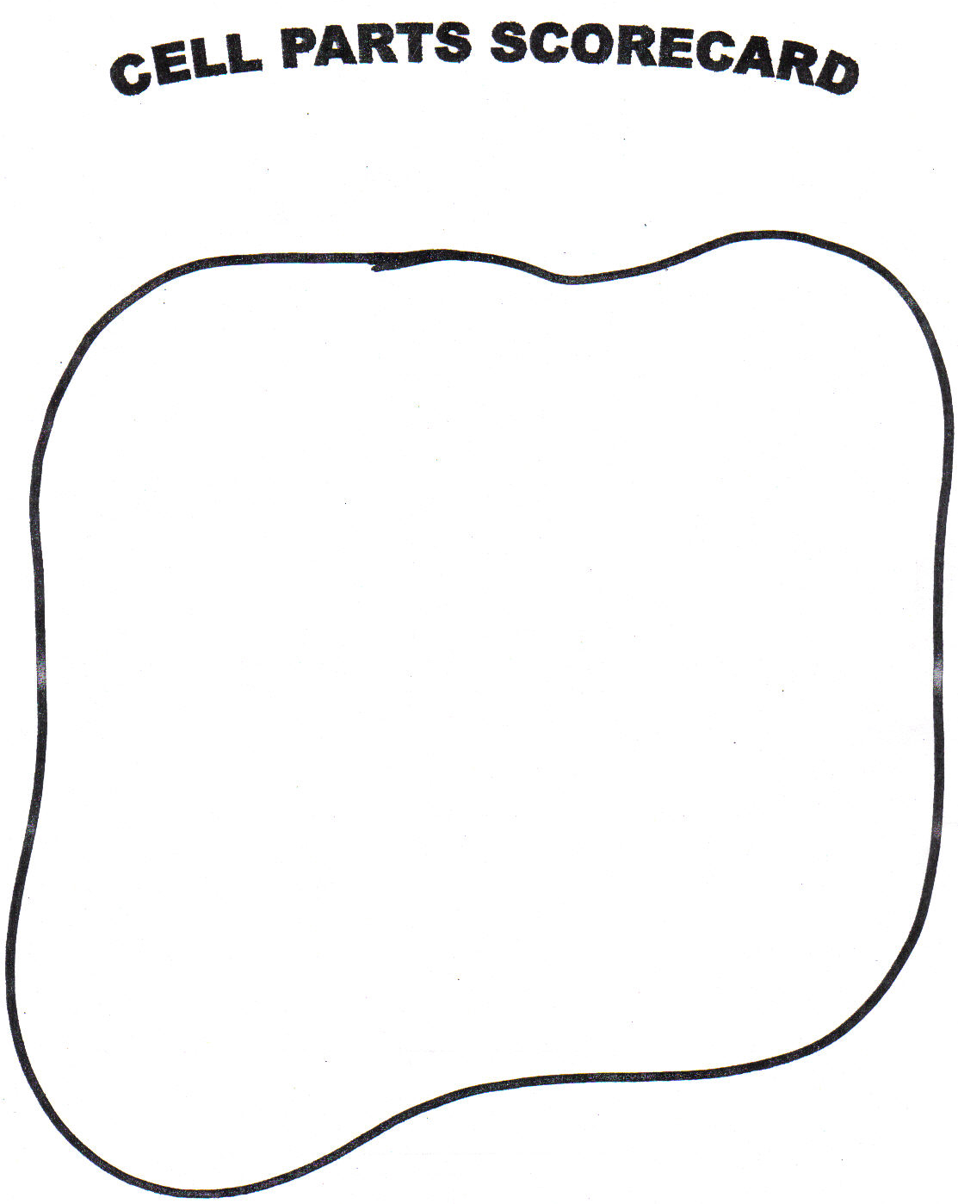

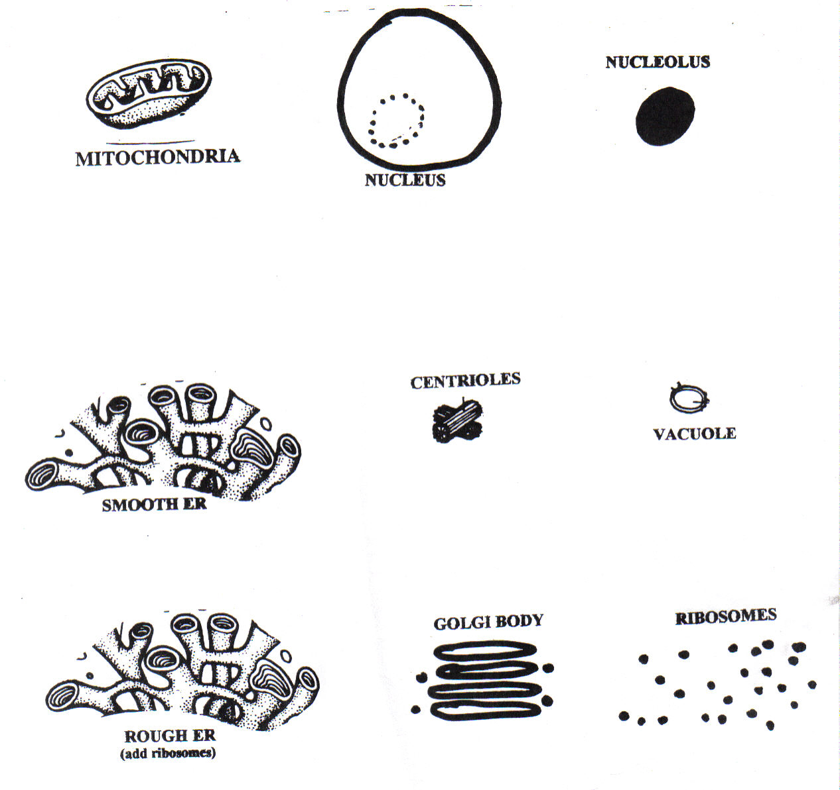

Build a cell game created by Kelly Riedell http://kr021.k12.sd.us

Mitochondria, ER, vacuole, centrioles images from:
The Biology Coloring Book, Robert D. Griffin, Barnes and Noble Books, 1986

