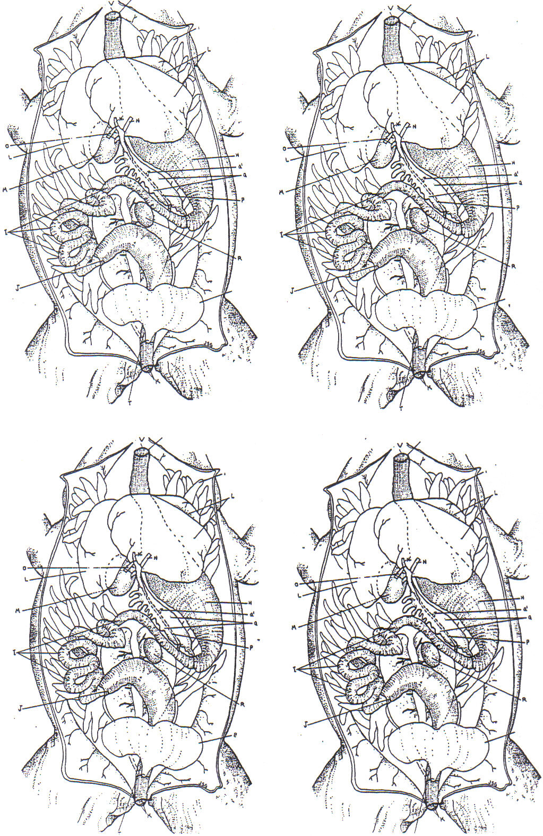

Image from: The Zoology Coloring Book,

