CELL PARTS RELAY GAME

- Copy the following pages. You will need one set for each team.
- Buy some “make your own magnets” magnetic sheets.
(Walmart has these in their craft department)
- Cut out the cell parts pictures, peel the protective cover off the magnetic sheets, and stick down the pictures on the sticky side to make the game pieces.
- Use your black board (ours are magnetic) to draw an ANIMAL CELL, a PLANT CELL, and a circle with the words BOTH in between the two.
- Each team gets a set of magnetic cell parts.
- Choose individual students from each team to answer the ?. When you describe a function, the students must choose the correct part, race to the board, and stick it in the correct place (plant, animal, or both).
- First one to correctly place the part gets a point.
- Each student should have a turn. You can play with different modifications, such as
they can consult their team if they don’t know the answer or they can “tag
a friend” to go up in their place, etc.

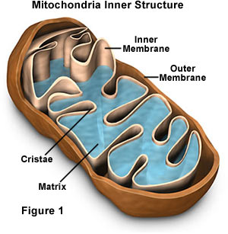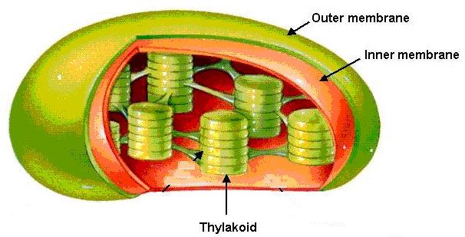
MITOCHONDRIA CHLOROPLAST

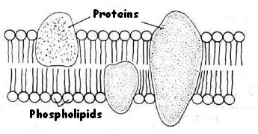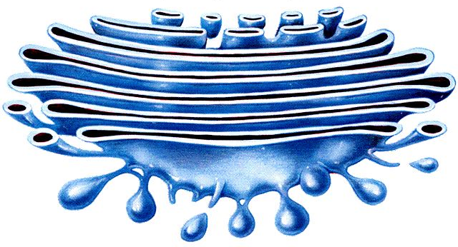
CELL MEMBRANE GOLGI BODY

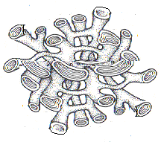
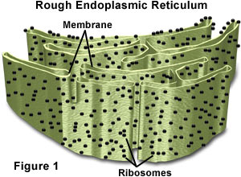

SMOOTH ER
ROUGH ER

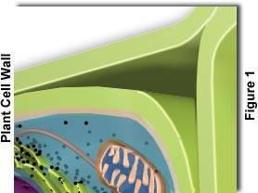
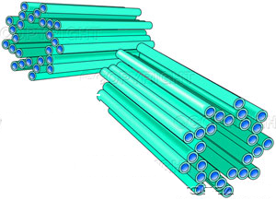
CENTRIOLES CELL WALL

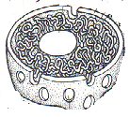

NUCLEOLUS

NUCLEUS

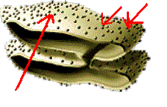
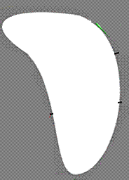
VACUOLE RIBOSOMES

IMAGE SOURCES:
Mitochondria- http://www.biologyclass.net/mitochondria.jpe
Chloroplast-http://www.science.siu.edu/plant-biology/PLB117/JPEGs%20CD/0076.JPG
Cell membrane- http://www.borg.com/~lubehawk/membrane.jpg
Cell wall- http://www.biologyclass.net/plantcell2.jpe
Golgi body-http://www.science.siu.edu/plant-biology/PLB117/JPEGs%20CD/0074.JPG
Smooth ER-The Biology Coloring Book, Robert D. Griffin, Barnes and Noble Books, 1986
Rough ER- http://www.biologyclass.net/endoplasmic.jpe
Nucleus- The Biology Coloring Book, Robert D. Griffin, Barnes and Noble Books, 1986
Ribosomes- http://www.biology.arizona.edu/CELL_BIO/tutorials/pev/page3.html
Vacuole & nucleolus – by Riedell

