NAME __________________________

Chapter 9- CELLULAR RESPIRATION TEST
(2 points each)

MULTIPLE CHOICE: Write the letter of the answer that best completes the statement on the blank to the left of the question.

______What reactants are needed for cellular respiration?
A. glucose and carbon dioxide
B. glucose and oxygen
C. carbon dioxide and oxygen
D. oxygen and lactic acid
E. carbon dioxide and water

______ Which of the following is the correct sequence of events during cellular respiration?
A. glycolysis → fermentation → Krebs cycle
B. Krebs cycle → Electron Transport → glycolysis
C. glycolysis → Krebs cycle → Electron Transport
D. Electron Transport → Krebs cycle → glycolysis

______ What happens during the Krebs cycle?
A. H⁺ ions and oxygen form water.
B. Lactic acid is formed using fermentation.
C. A glucose molecule is broken down into 2 pyruvic acid molecules.
D. H⁺ ions build up on one side the mitochondrial membrane.
E. Pyruvic acid is broken down in a series of steps into CO₂

______ What happens during glycolysis?
A. H⁺ ions and oxygen form water.
B. Lactic acid is formed using fermentation.
C. H⁺ ions build up on one side the mitochondrial membrane.
D. A glucose molecule is broken down into 2 pyruvic acid molecules.
E. Pyruvic acid is broken down in a series of steps into CO₂

______ What happens during alcoholic fermentation?
A. Pyruvic acid reacts with NADH to make alcohol, release CO₂, and regenerate NAD⁺
B. H⁺ ions and oxygen form water.
C. A glucose joins with Co-A to make pyruvic acid.
D. H⁺ ions build up on one side the mitochondrial membrane.
E. Citric acid is broken down in a series of steps into CO₂

______ In eukaryotic cells, most of cellular respiration takes place in the ______________________.
A. nuclei
B. chloroplasts
C. cytoplasm
D. mitochondria
______ What substance produced by alcoholic fermentation makes bread rise?
A. oxygen
B. lactic acid
C. CO₂
D. water
E. alcohol

______ Which of the following are products of cellular respiration?
A. CO₂ and H₂O
B. O₂ and CO₂
C. O₂ and glucose
D. CO₂ and glucose

______ The energy of the electrons passing along the Electron Transport Chain, is used to make ______
A. lactic acid
B. citric acid
C. alcohol
D. ATP

______ During Electron Transport, energy from moving electrons causes H⁺ ions to build up in the ___________________.
A. mitochondrial matrix
B. cytoplasm
C. intermembrane space
D. cristae

_______ Which of these requires oxygen?
A. cellular respiration
B. lactic acid fermentation
C. alcoholic fermentation
D. glycolysis

_______ Which of these organisms perform cellular respiration?
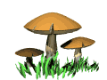 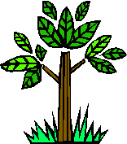  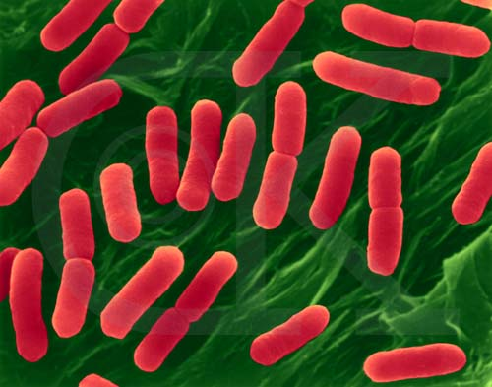(bacteria)
A B C D

A. only C
B. only A and C
C. only A and B
D. all of the above

_______ The net gain of ATP from GLYCOLYSIS is ___________.
A. 1
B. 2
C. 4
D. 36

______ Because fermentation takes place in the absence of oxygen it is said to be _______________.
A. cyclic
B. aerobic
C. anaerobic
D. essential

______ Which stage of cellular respiration produces the most ATP’s?
A. glycolysis
B. Actyl-CoA formation
C. Krebs cycle
D. Electron transport

______ The unit used by scientists to measure the energy in food is the ________________.
A. calorie
B. Calorie
C. ATP score
D. glycogen index

______ An athlete needing a QUICK BURST of energy for a 50 yard dash is getting his/her ATP from
A. cellular respiration
B. alcoholic fermentation
C. lactic acid fermentation
D. electron transport

______ A marathon runner needing energy for an EXTENDED PERIOD of time is getting his/her ATP from _________________________
A. photosynthesis
B. lactic acid fermentation
C. alcoholic fermentation
D. cellular respiration

______ The products of photosynthesis are the ________________________
A. reactants of cellular respiration
B. products of cellular respiration
C. products of glycolysis
D. the reactants of fermentation

______ Which electron carrier produces more ATP when it passes its electrons through the Electron Transport chain?
A. FADH₂
B. NADH
C. Neither, these both produce the same number of ATP’s

______ Which coenzyme helper molecule reacts with pyruvic acid and helps it enter the Krebs cycle?
A. ATP
B. lactic acid
C. NADPH
D. Co-A

______ Which process is used to make beer and wine?
A. lactic acid fermentation
B. alcoholic fermentation
C. Krebs cycle
D. Electron Transport

______ Which molecule is the last electron acceptor at the end of the Electron Transport chain?
A. O₂
B. NAD⁺
C. FADH₂
D. NADPH

______ Which 6 carbon molecule is formed in the first step of the Krebs cycle when Acetyl-CoA attaches its 2 carbon acetyl group to a 4 carbon molecule?
A. glucose
B. pyruvic acid
C. lactic acid
D. citric acid

______ Yogurt, cheese, and sauerkraut are all produced by microorganisms using ___________________
A. Krebs cycle
B. alcoholic fermentation
C. lactic acid fermentation
D. photosynthesis

______ When exercising for extended periods of time, _________________ can be used to make ATP when glucose is used up.
A. alcohol and CO₂
B. glycogen and fat
C. citric acid and alcohol
D. pyruvic acid and CO₂

_____ During lactic acid and alcoholic fermentation ____________________________________
A. NAD⁺ is regenerated so glycolysis can continue
B. oxygen is required
C. 36 ATP’s are made
D. pyruvic acid joins with Acetyl-CoA

______ What happens to the 6 carbons that are in glucose during cellular respiration?
A. They join with NADH and move along the Electron Transport Chain.
B. They end up as alcohol in beer and wine.
C. They end up in CO₂ and are released into the atmosphere.
D. They end up in lactic acid and are stored as fat.
______ What happens to the NADH and FADH₂ molecules produced during glycolysis and Krebs cycle?
A. Their electrons are used to charge acetyl-CoA
B. Their electrons enter the Electron Transport Chain
C. They join with pyruvic acid to make lactic acid
D. They accept carbons from glucose to make alcohol

______ How many CO₂ molecules are produced from 1 molecule of glucose during cellular respiration?
A. 1
B. 2
C. 6
D. 36

______ The Krebs cycle is also called the ________________ cycle.
A. citric acid
B. lactic acid
C. pyruvic acid

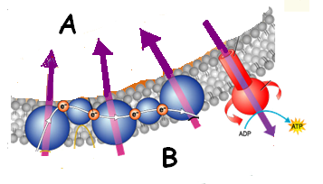
______ During cellular respiration, which enzyme spins
and joins a phosphate group to ADP to
make ATP?
A. Coenzyme A
B. NADH
C. ATP synthase
D. pyruvic acid

______ On which side of the membrane is the matrix?

A or B

_______ The movement of _______________________ causes the production of ATP.
A. electrons in the Krebs cycle
B. pyruvic acid into the mitochondria
C. CO₂ out of the mitochondria
D. H⁺ ions across the inner membrane

______ This is the equation for _________________________
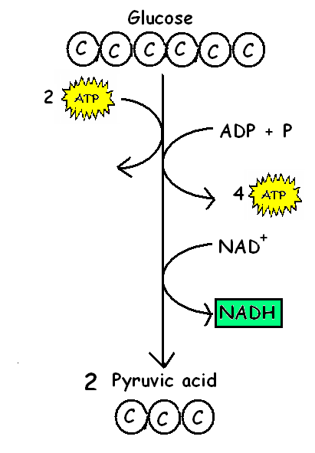
A. Krebs cycle
B. lactic acid fermentation
C. alcoholic fermentation
D. citric acid charging
E. glycolysis

______ If NO OXYGEN is available, where will these 2 pyruvic
acid molecules go next?
A. cellular respiration
B. fermentation
C. Krebs cycle
D. photosynthesis

_______ In the presence of OXYGEN, where will these
2 pyruvic acid molecules go next?
A. lactic acid fermentation
B. alcoholic fermentation
C. the Krebs cycle
D. photosynthesis

LABEL THE FOLLOWING PARTS OF A MITOCHONDRION:

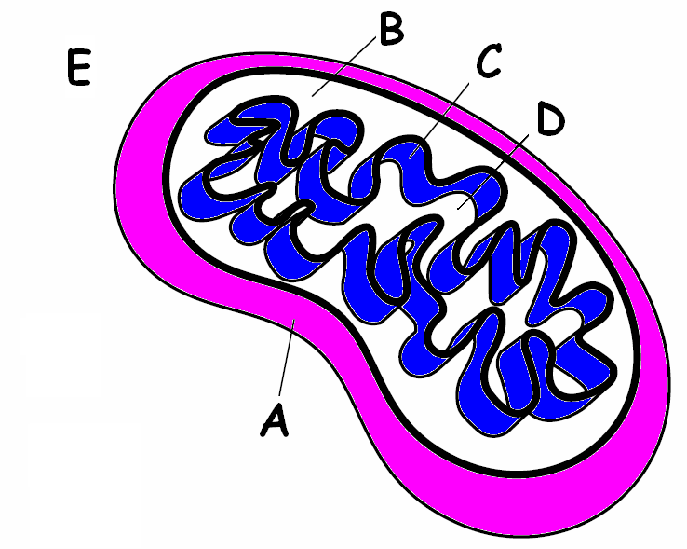
_______ Matrix

_______ Intermembrane space

_______ Inner membrane

_______ Outer membrane

_______ Cytoplasm

USE THE LETTERS FROM THE DIAGRAM TO SHOW WHERE THE FOLLOWING REACTIONS ARE LOCATED:

______ Glycolysis

______ Krebs cycle

______ Electron Transport Chain

Use WORDS from the WORD BANK and ADD NUMBERS to complete the equation or cellular respiration.

CO₂ H₂O O₂ C₆H₁₂O₆ energy

_____________ + ____________ → _____________ + _____________ + ______________

* * * * * * * * * * * * * * *
BONUS QUESTIONS:
Another name for the inner membrane in a mitochondria is the ____________________.

Name the natural substance found in muscles that regenerates ATP
for extended energy for muscle activity which is used as a dietary
supplement to increase muscle strength and performance _________________________

NAME __________________________

Chapter 9- CELLULAR RESPIRATION TEST
(2 points each)

MULTIPLE CHOICE: Write the letter of the answer that best completes the statement on the blank to the left of the question.

______What reactants are needed for cellular respiration?
A. glucose and carbon dioxide
B. carbon dioxide and water
C. carbon dioxide and oxygen
D. oxygen and lactic acid
E. glucose and oxygen

______ Which of the following is the correct sequence of events during cellular respiration?
A. glycolysis → Krebs cycle → Electron Transport
B. Krebs cycle → Electron Transport → glycolysis
C. glycolysis → fermentation → Krebs cycle
D. Electron Transport → Krebs cycle → glycolysis

______ What happens during the Krebs cycle?
A. H⁺ ions and oxygen form water.
B. Pyruvic acid is broken down in a series of steps into CO₂
C. A glucose molecule is broken down into 2 pyruvic acid molecules.
D. H⁺ ions build up on one side the mitochondrial membrane.
E. Lactic acid is formed using fermentation.

______ What happens during glycolysis?
A. H⁺ ions and oxygen form water.
B. Lactic acid is formed using fermentation.
C. A glucose molecule is broken down into 2 pyruvic acid molecules.
D. H⁺ ions build up on one side the mitochondrial membrane.
E. Pyruvic acid is broken down in a series of steps into CO₂

______ What happens during alcoholic fermentation?
A. H⁺ ions build up on one side the mitochondrial membrane.
B. H⁺ ions and oxygen form water.
C. A glucose joins with Co-A to make pyruvic acid.
D. Pyruvic acid reacts with NADH to make alcohol, release CO₂, and regenerate NAD⁺
E. Citric acid is broken down in a series of steps into CO₂

______ In eukaryotic cells, most of cellular respiration takes place in the ______________________.
A. nuclei
B. mitochondria
C. cytoplasm
D. chloroplasts
______ What substance produced by alcoholic fermentation makes bread rise?
A. oxygen
B. lactic acid
C. water
D. CO₂
E. alcohol

______ Which of the following are products of cellular respiration?
A. O₂ and CO₂
B. CO₂ and H₂O
C. O₂ and glucose
D. CO₂ and glucose

______ The energy of the electrons passing along the Electron Transport Chain, is used to make ______
A. ATP
B. citric acid
C. alcohol
D. lactic acid

______ During Electron Transport, energy from moving electrons causes H⁺ ions to build up in the ___________________.
A. mitochondrial matrix
B. cytoplasm
C. cristae
D. intermembrane space

_______ Which of these requires oxygen?
A. lactic acid fermentation
B. cellular respiration
C. alcoholic fermentation
D. glycolysis

_______ Which of these organisms perform cellular respiration?
(bacteria)
A B C D

A. all of the above
B. only A and C
C. only A and B
D. only C

_______ The net gain of ATP from GLYCOLYSIS is ___________.
A. 36
B. 4
C. 2
D. 1

______ Because fermentation takes place in the absence of oxygen it is said to be _______________.
A. cyclic
B. aerobic
C. essential
D. anaerobic

______ Which stage of cellular respiration produces the most ATP’s?
A. glycolysis
B. Electron transport
C. Krebs cycle
D. Actyl-CoA formation

______ The unit used by scientists to measure the energy in food is the ________________.
A. calorie
B. ATP score
C. Calorie
D. glycogen index

______ An athlete needing a QUICK BURST of energy for a 50 yard dash is getting his/her ATP from
A. cellular respiration
B. electron transport
C. lactic acid fermentation
D. alcoholic fermentation

______ A marathon runner needing energy for an EXTENDED PERIOD of time is getting his/her ATP from _________________________
A. cellular respiration
B. lactic acid fermentation
C. alcoholic fermentation
D. photosynthesis

______ The products of photosynthesis are the ________________________
A. products of cellular respiration
B. reactants of cellular respiration
C. products of glycolysis
D. the reactants of fermentation

______ Which electron carrier produces more ATP when it passes its electrons through the Electron Transport chain?
A. NADH
B. FADH₂
C. Neither, these both produce the same number of ATP’s
______ Which coenzyme helper molecule reacts with pyruvic acid and helps it enter the Krebs cycle?
A. ATP
B. Co-A
C. NADPH
D. lactic acid

______ Which process is used to make beer and wine?
A. lactic acid fermentation
B. Krebs cycle
C. alcoholic fermentation
D. Electron Transport

______ Which molecule is the last electron acceptor at the end of the Electron Transport chain?
A. NADPH
B. NAD⁺
C. FADH₂
D. O₂

______ Which 6 carbon molecule is formed in the first step of the Krebs cycle when Acetyl-CoA attaches its 2 carbon acetyl group to a 4 carbon molecule?
A. citric acid
B. pyruvic acid
C. lactic acid
D. glucose

______ Yogurt, cheese, and sauerkraut are all produced by microorganisms using ___________________
A. Krebs cycle
B. lactic acid fermentation
C. alcoholic fermentation
D. photosynthesis

______ When exercising for extended periods of time, _________________ can be used to make ATP when glucose is used up.
A. alcohol and CO₂
B. citric acid and alcohol
C. glycogen and fat
D. pyruvic acid and CO₂

_____ During lactic acid and alcoholic fermentation ____________________________________
A. pyruvic acid joins with Acetyl-CoA
B. oxygen is required
C. 36 ATP’s are made
D. NAD⁺ is regenerated so glycolysis can continue

______ What happens to the 6 carbons that are in glucose during cellular respiration?
A. They join with NADH and move along the Electron Transport Chain.
B. They end up in CO₂ and are released into the atmosphere.
C. They end up in lactic acid and are stored as fat.
D. They end up as alcohol in beer and wine.
______ What happens to the NADH and FADH₂ molecules produced during glycolysis and Krebs cycle?
A. Their electrons are used to charge acetyl-CoA
B. They accept carbons from glucose to make alcohol
C. They join with pyruvic acid to make lactic acid
D. Their electrons enter the Electron Transport Chain

______ How many CO₂ molecules are produced from 1 molecule of glucose during cellular respiration?
A. 36
B. 6
C. 2
D. 1

______ The Krebs cycle is also called the ________________ cycle.
A. pyruvic acid
B. lactic acid
C. citric acid

______ During cellular respiration, which enzyme spins
and joins a phosphate group to ADP to
make ATP?
A. ATP synthase
B. NADH
C. Coenzyme A
D. pyruvic acid

______ On which side of the membrane is the matrix?

A or B

_______ The movement of _______________________ causes the production of ATP.
A. electrons in the Krebs cycle
B. pyruvic acid into the mitochondria
C. H⁺ ions across the inner membrane
D. CO₂ out of the mitochondria

______ This is the equation for _________________________
A. Krebs cycle
B. lactic acid fermentation
C. glycolysis
D. citric acid charging
E. alcoholic fermentation

______ If NO OXYGEN is available, where will these 2 pyruvic
acid molecules go next?
A. photosynthesis
B. cellular respiration
C. Krebs cycle
D. fermentation

_______ In the presence of OXYGEN, where will these
2 pyruvic acid molecules go next?
A. the Krebs cycle
B. alcoholic fermentation
C. lactic acid fermentation
D. photosynthesis

LABEL THE FOLLOWING PARTS OF A MITOCHONDRION:

_______ Inner membrane

_______ Cytoplasm

_______ Intermembrane space

_______ Outer membrane

_______ Matrix

USE THE LETTERS FROM THE DIAGRAM TO SHOW WHERE THE FOLLOWING REACTIONS ARE LOCATED:

______ Krebs cycle

______ Glycolysis

______ Electron Transport Chain

Use WORDS from the WORD BANK and ADD NUMBERS to complete the equation or cellular respiration.

CO₂ H₂O O₂ C₆H₁₂O₆ energy

_____________ + ____________ → _____________ + _____________ + ______________

* * * * * * * * * * * * * * *
BONUS QUESTIONS:
Another name for the inner membrane in a mitochondria is the ____________________.

Name the natural substance found in muscles that regenerates ATP
for extended energy for muscle activity which is used as a dietary
supplement to increase muscle strength and performance _________________________

