DNA REPLICATION
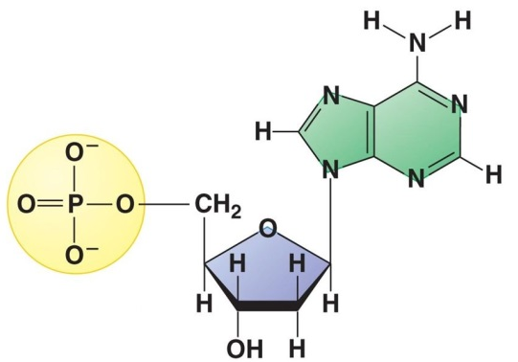
• Name this subunit used to make DNA
• Label the 3 parts
• Nitrogen bases with one ring = __________________
EXAMPLES: _____________________________________
• Nitrogen bases with two rings = __________________
EXAMPLES: ______________________________________

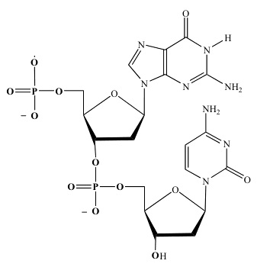

• Number the carbons in the two sugar molecules.
• Circle one nucleotide subunit
• Label the 3’ and 5’ ends of this molecule
• Which parts of nucleotide make up:
the “sides of the ladder”?
the “rungs of the ladder”?

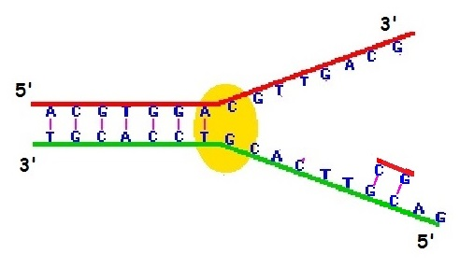

• Label the REPLICATION FORK in the diagram above
• Add the NAME OF THE ENZYME shown that unwinds the DNA strand.
• Use COLOR to add PRIMERS to each template strand to show where each new strand will start.
* Most primers are 8-10 bases long. Make yours 2 bases long.
THE FIRST ONE IS DONE FOR YOU!
• Add ARROWS to show which direction replication will happen on each strand.
• Use a different color to fill in nucleotides matching complementary bases to make a new strand.
• Label the small fragments on one of the strands.
• Label LAGGING and LEADING strands.

REPLICATION QUESTIONS
1. Name the subunit used to make DNA.
2. Which parts of this subunit make up the “backbone” of the DNA helix?
3. Which parts of this subunit make up the “steps of the ladder” in the DNA helix?
4. The two DNA strands run in opposite directions. What vocab word describes this orientation?
5. EXPLAIN what the 5’ and 3’ designations mean.
6. How are “primer” subunits different from the subunits used to fill in the new strand?
7. Which enzyme adds the primer sections?
8. What are the rules DNA POLYMERASE operates under that makes it so the strands have to be
copied in different directions?
9. Which enzyme adds DNA nucleotides to the primers?
10. What are the short segments on the lagging strand called?
1. What enzyme removes primers and replaces them with DNA nucleotides?
12. What enzyme joins these segments together?
13. Explain why telomeres are needed on the tips of eukaryotic DNA.
14. Explain why bacterial DNA doesn’t need telomeres?

