DESKTOP RFLP ANALYSIS
LAY OUT 3 YARN PIECES ON YOUR DESK DON’T STRETCH !
TRIM ALL YOUR YARN PIECES SO THEY ARE THE SAME LENGTH- 50 cm
Use the “restriction enzymes” provided to:
- Cut one piece of yarn with EcoRI –Cuts at 8 cm AND 22 cm
- Cut one piece of yarn with HindIII– Cuts at 18 cm AND 35 cm
- Cut one piece of yarn with BOTH EcoRI AND HindIII
Set up the top of your desk as a gel
- Use sticky notes to LABEL the + and – poles
- Use sticky notes to LABEL your lanes
Load your “gel” with your “DNA” that has been cut with “restriction enzymes”
Complete RFLP analysis and draw a picture of the results below.

EcoR1 HindIII EcoR1 + HindIII

ANALYSIS QUESTIONS:
1. EXPLAIN WHY DNA moves in an electric field toward the POSITIVE pole.
2. EXPLAIN the relationship between FRAGMENT SIZE and DISTANCE MOVED on a gel.
Linus Pauling used RFLP analysis to show that the sickle cell mutation caused a change in the
DNA code. He cut the gene from a person with normal hemoglobin and a person with sickle cell
anemia with a restriction enzyme and compared them using RFLP analysis. Use what you know
about the sickle cell mutation and restriction recognition sites to EXPLAIN why the gel
patterns in these people might show different numbers and lengths of fragments on a gel.

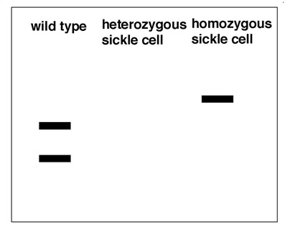
MAKE A PREDICTION about what the gel pattern from a person who is
heterozygous for the sickle cell allele might look like.
FILL IN THE GEL RESULTS and EXPLAIN YOUR ANSWER.

In this activity you compared “DNA” from the same person cut with different restriction enzymes
(EcoR1 and HindIII). PREDICT THE RESULTS if the SAME restriction enzyme was used on DNA
from DIFFERENT people instead of different restriction enzymes on same DNA?
DRAW A PICTURE and EXPLAIN your answer.

Give at least FOUR (4) EXAMPLES of what DNA analysis could be used for.

