BILL-MUTATIONS
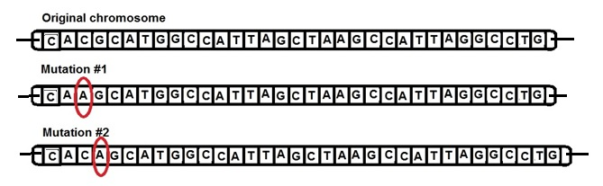
Both of these mutations put an Adenine (A) where it doesn’t belong in the DNA code
but they DON’T HAVE THE SAME IMPACT on the resulting protein produced.
Mutation #1 is an example of which type of mutation ? ________________________
Mutation #2 is an example of which type of mutation? ________________________
How might Mutation #1 affect the protein produced?
_____________________________________________________________________
_____________________________________________________________________
How might Mutation #2 affect the protein produced?
_____________________________________________________________________
_____________________________________________________________________
Which of these is likely to cause the most disruption in the amino acid sequence of the protein
this gene codes for? EXPLAIN YOUR ANSWER

WHAT’S THE DIFFERENCE? COMPARE & CONTRAST:
MISSENSE, NONSENSE, and SILENT mutations.
USE YOUR CODON CHART.
Choose an mRNA codon and show how a substitution could produce each one of the above.

