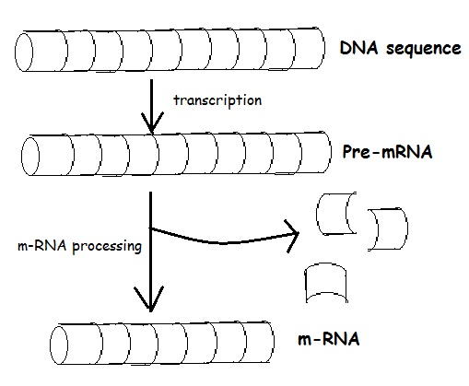
EXPLAIN IT TO HOMER: Alternative Splicing
Use the diagrams provided to show how alternative splicing works.
Use color/labels to identify introns and exons.
EXPLAIN what is happening.
WHAT ADVANTAGE DOES THIS GIVE THE CELL?

EXPLAIN IT TO HOMER: Alternative Splicing
Use the diagrams provided to show how alternative splicing works.
Use color/labels to identify introns and exons.
EXPLAIN what is happening.
WHAT ADVANTAGE DOES THIS GIVE THE CELL?

