The following data were collected by observing subcellular structures
of three different types of eukaryotic cells.
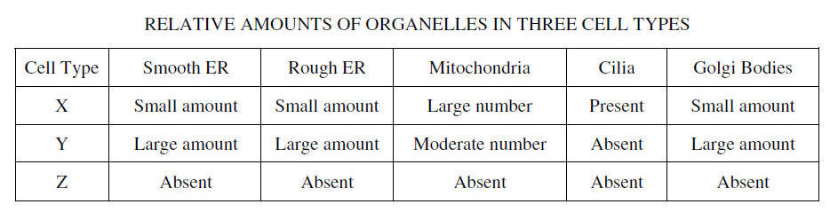
Based on the analysis of the data,
IDENTIFY a likely primary function of each cell type and
EXPLAIN how the data support the identification.

The following data were collected by observing subcellular structures
of three different types of eukaryotic cells.
Based on the analysis of the data,
IDENTIFY a likely primary function of each cell type and
EXPLAIN how the data support the identification.

The following data were collected by observing subcellular structures
of three different types of eukaryotic cells.
Based on the analysis of the data,
IDENTIFY a likely primary function of each cell type and
EXPLAIN how the data support the identification.

