SIGNAL TRANSDUCTION PATHWAYS
Widely CONSERVED across ALL DOMAINS
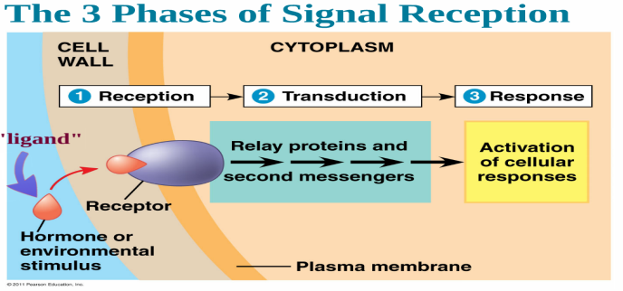

RECEPTION

SIGNAL MOLECULES = _______________________
Shape of ligand matches __________________________

HYDROPHILIC LIGANDS

HYDROPHOBIC LIGANDS

TRANSDUCTION = intracellular cascade that transfers/amplifies signal from
plasma membrane to nucleus or other cellular effectors
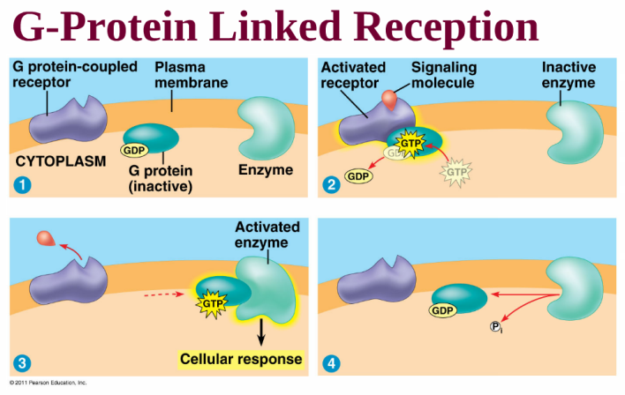
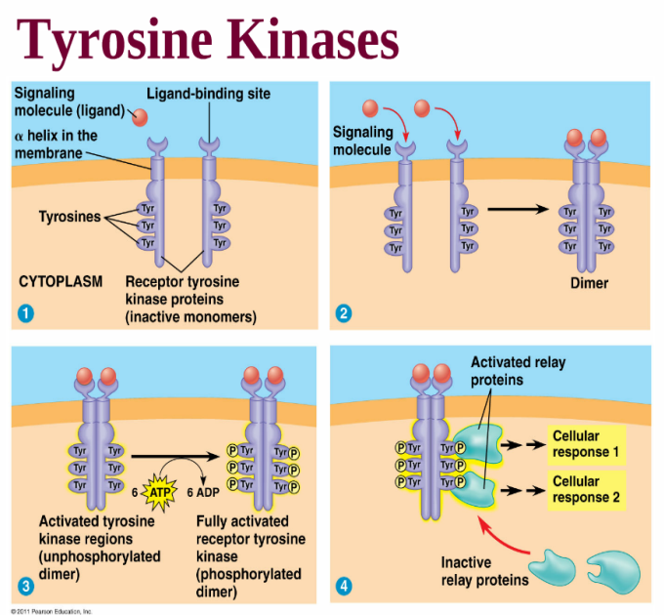
G-PROTEINS:
- attached to ___________________
- are activated by transfer of phosphate
from _________
- ________________ G-protein can then
activate another enzyme
____________________________________________________________________
_________________= proteins that
phosphorylate (add phosphate groups to)
another molecule to “turn it on”
TYROSINE KINASES:
- proteins attached to
________________
- join to form ______________ when
ligand binds to receptor
- are activated by transfer of
phosphate from _________
- remain ACTIVE as long as ligand
is attached
- ________________ dimers can then
activate another enzyme
_____________________________________________________________________
-Ligand binds to ligand-gated ion
channel and __________ “gate”
-Incoming IONS act as
________________________
to trigger response
-Gate stays open as long as ligand
is attached

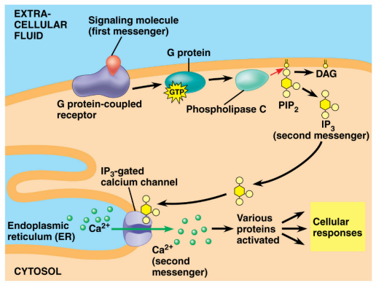
SECOND MESSENGERS
Internal signaling molecules released due to external signal
Trigger response pathway in cell
CALCIUM IONS- Ca⁺⁺

___________________ of Ca⁺⁺ ions into cell or
___________________ of Ca⁺⁺ ions internally can trigger a response
CYCLIC AMP
Typical SECOND MESSENGER that affects metabolism
Production of c-AMP can activate other molecules

PHSOPHORYLAITON CASCADE
Allows cell to ______________________ original signal

RESPONSE
Gene is turned on
Message is made and translated into a protein that will do something

