MODELING PROTEINS-Part 1
ADD YOUR MODEL TO YOUR BILL and complete the following:
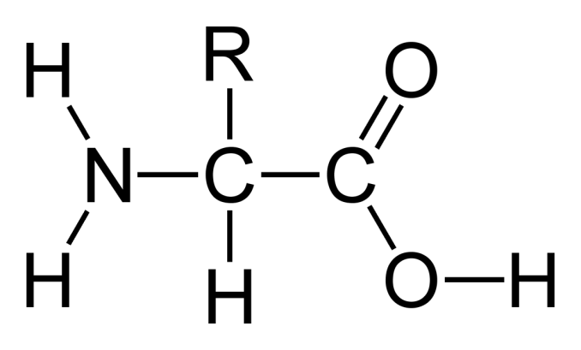
1. LABEL the monomer subunit used to make proteins.
2. Label the alpha carbon
3. Circle the carboxyl group
4. Draw a triangle around the amino group
ATTACH your paper model and LABEL the following:
5. LABEL the type of chemical reaction used to make proteins.
6. Label the type of bond used to make proteins.
7. Draw arrows to identify these bonds in your model
8. Label the N-terminus and C-terminus
9. Put SQUARES around the R groups
10. Use your amino acid chart to identify & label the type of R group
(non-polar, polar, charge basic, charged acidic, etc)
11. Label each amino acid as hydrophobic or hydrophilic
12. Label the level of protein structure your model represents ( 1°, 2°, 3°, or 4° )
QUESTIONS
1. Which TWO functional groups do all amino acids share?
2. How are the amino acids different from one another?
3. Where do the amino acid subunits used to build proteins in organisms come from?
4. Look at the handout showing the structure of the 20 amino acids used to make proteins.
How many have an asymmetric carbon? What does that mean?
5. Because they are made from a variety of amino acids, proteins are AMPHIPATHIC.
Explain what that means.
6. Describe how this property is related to tertiary structure in proteins.
7. What other kind of macromolecule you learned about is also amphipathic?

QUESTIONS
1. Identify and label the type of 2° structures below.
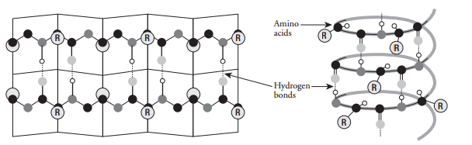
_________________________ ___________________________

2. LABELTHE KINDS OF BONDS INVOLVED IN THE 3° STRUCTURE OF PROTEINS
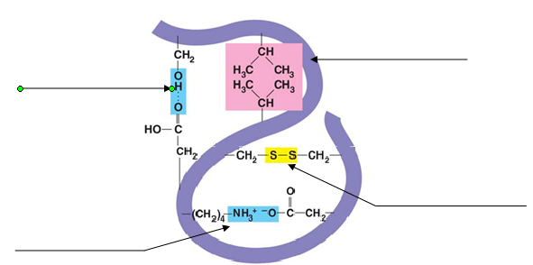

3 What determines the primary structure of a protein?
4. What determines the tertiary structure of proteins?
5. How is a polypeptide different from a protein?
6. What are chaperonins and what is their role in protein structure?
7. What happens to proteins during DENATURATION?
8. Which of the four levels of protein structure is maintained after denaturing?
Which are disrupted? EXPLAIN WHY.
9. Name some of the environmental factors that can result in denaturing proteins.
10. Enzymes are proteins. What would happen to the structure and function of an enzyme
that was exposed to heat or a drastic change in pH?

LEVEL OF PROTEIN ORGANIZATION |  | TYPE of BONDS or INTERACTIONS  HOLDING IT TOGETHER | AMINO ACID GROUPS INVOLVED
PRIMARY STRUCTURE
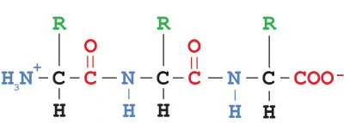
SECONDARY STRUCTURE
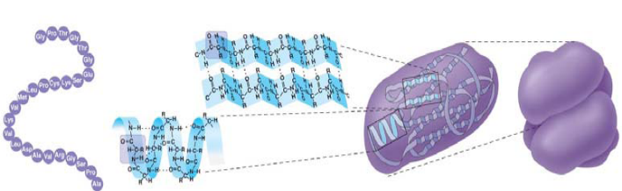
TERTIARY STRUCTURE
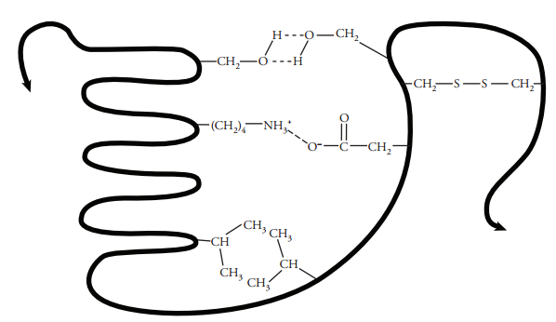
QUATERNARY STRUCTURE
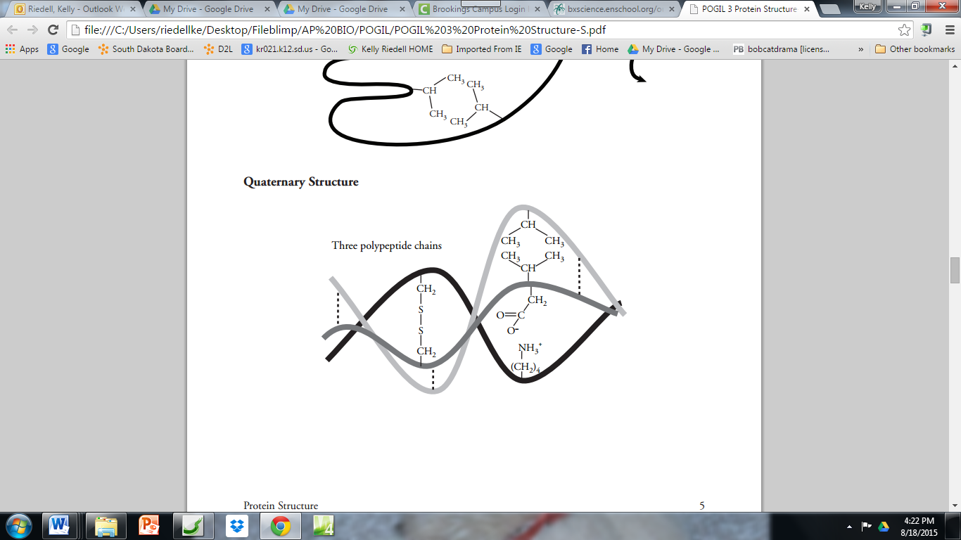

Modified from Holtzclaw & Holtzclaw/Kim Foglia/Lynn Miriello study guides/POGIL

