Watch Bozeman Biology video- FIVE FINGERS OF EVOLUTION
All of these cause EVOLUTION
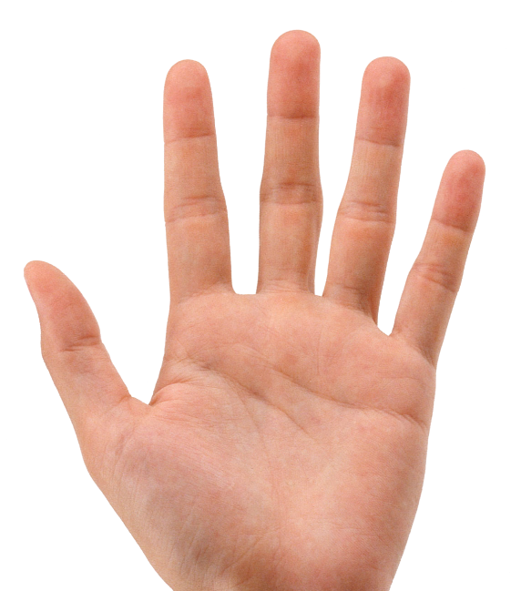

EXPLAIN WHAT THESE ARE and HOW THEY COULD
CHANGE THE ALLELE FREQUENCIES IN A POPULATION

