NAME _______________________
ORIGIN OF LIFE FOR DUMMIES
Read your textbook (Chapter 24) and watch Bozeman Origin of Life & Abiogenesis videos then
EXPLAIN the following. GIVE EXAMPLES if appropriate
HOW OLD IS THE EARTH?

HOW WAS THE EARLY ATMOSPHERE DIFFERENT THAN IT IS TODAY?

WHEN DID LIFE FIRST APPEAR ON THE PLANET?

EXPLAIN THE SEQUENCE OF THE APPEARANCE OF THE VARIOUS LIFE FORMS
(Use words like: eukaryotes, multicellular, plants, animals, unicellular, prokaryotes, etc)

THEORIES OF THE ORIGIN OF LIFE:
PRIMORDIAL SOUP
METABOLISM FIRST

GENES FIRST (RNA WORLD)

PROTOCELLS

STROMATOLITES

MILLER & UREY EXPERIMENT
Label the diagram below and explain what this experiment was about.
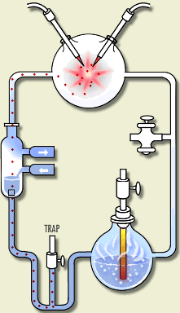

WHAT CHARACTERISTICS FOUND IN THE LATEST COMMON ANCESTOR (LUA)
ARE SHARED BY ALL LIFE ON EARTH?

