USE THE KARYOTYPES PROVIDED BELOW TO
IDENTIFY THE SEX OF THE INDIVIDUALS BELOW
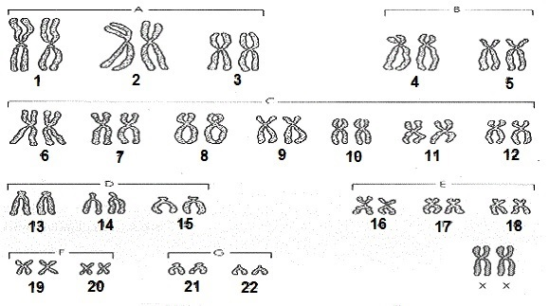
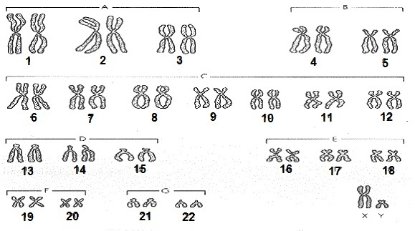

_________________________ __________________________
******************************************************************************
IDENTIFY THE SEX and GENETIC DISORDER OF THE FOLLOWING INDIVIDUALS
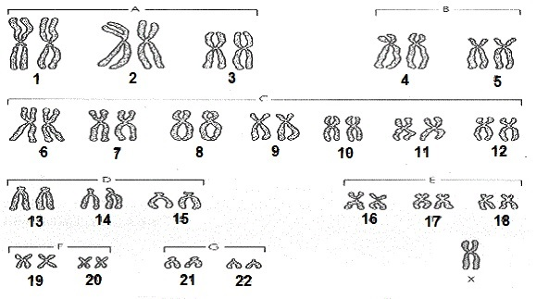
MALE FEMALE
_______________________
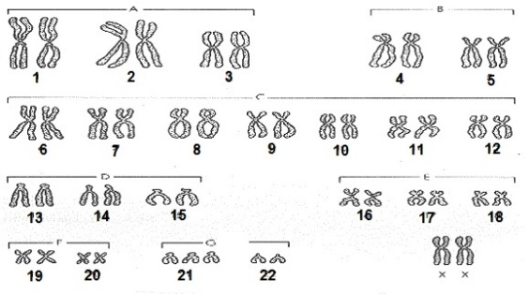
**********************************************************************

MALE FEMALE
____________________

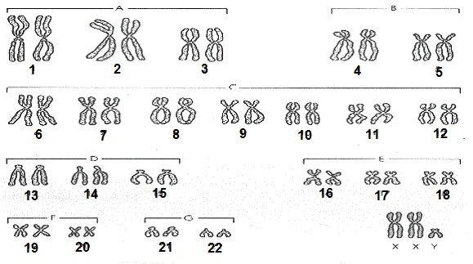
**********************************************************************
MALE FEMALE
_______________________

