Refresh your “Bio Brain” about: GENETICS VOCAB
Use the diagram below to identify & label the generations in
Mendel’s genetic experiments
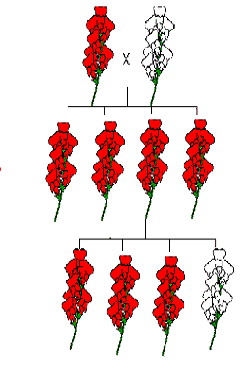

DOMINANT:
RECESSIVE:
HOMOZYGOUS (pure-breeding):
HETEROZYGOUS (hybrid):
GENOTYPE:
PHENOTYPE:

