BOZEMAN VIDEO- Genetic Recombination and Gene Mapping

MORGAN’S EXPERIMENT

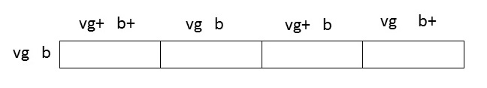

NO CROSSING OVER

CROSSING OVER

BILL Bozeman Video Notes-Kelly Riedell/Brookings Biology

