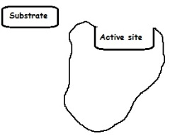
BOZEMAN BIOLOGY-Video Notes for ENZYMES
Catalase is an enzyme that breaks down ____________
Write the equation for the breakdown of H₂O₂ by catalase.
________________ → _______________ + _________________

What are two kinds of enzyme inhibition?
_____________________ _____________________
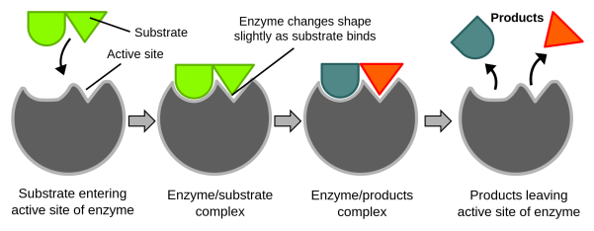

ACTIVATION- turns enzymes _________
COFACTORS: are ________________________= Don’t contain carbon
EX:
COENZYMES: are __________________ = contain carbon
EX:
Many ________________________ in our diet act as coenzymes.

INHIBITION: turns enzymes _________
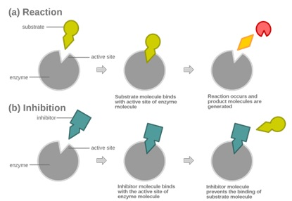
COMPETITIVE INHIBITION:

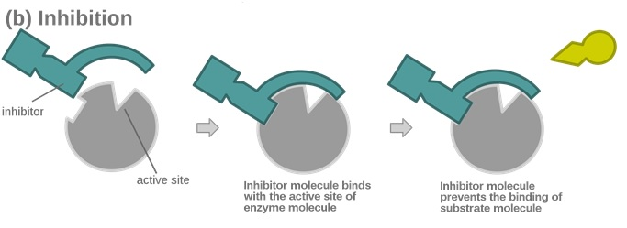
ALLOSTERIC (NONCOMPETITIVE)

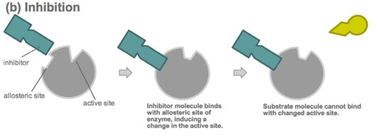

The rate of a chemical reaction can be determined by measuring 2 THINGS:
__________________________created
__________________________consumed
Most human enzymes have an optimum temperature of ________

