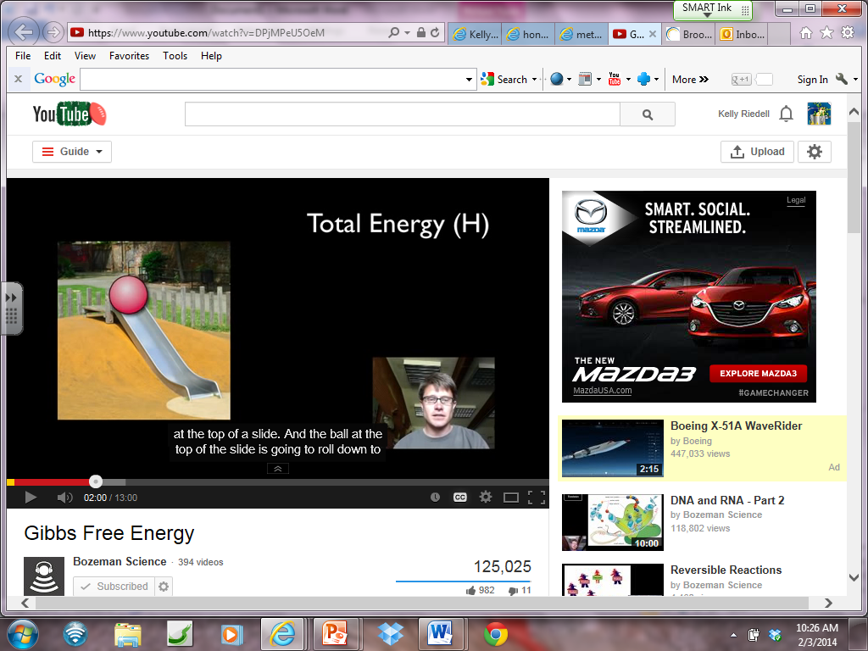GIBBS FREE ENERGY

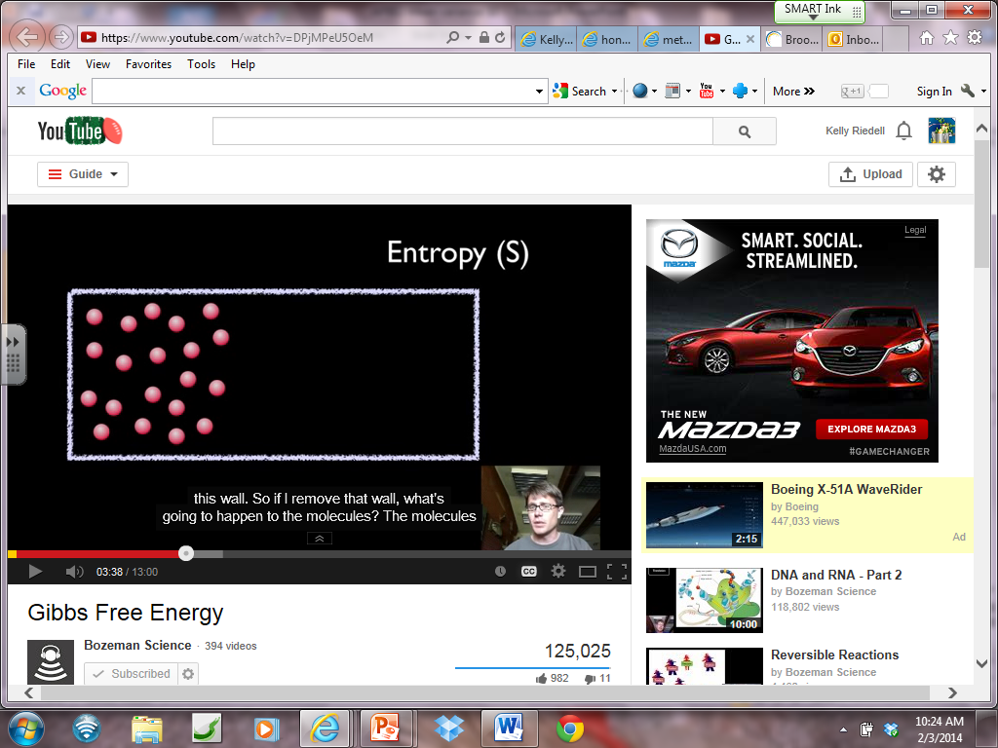

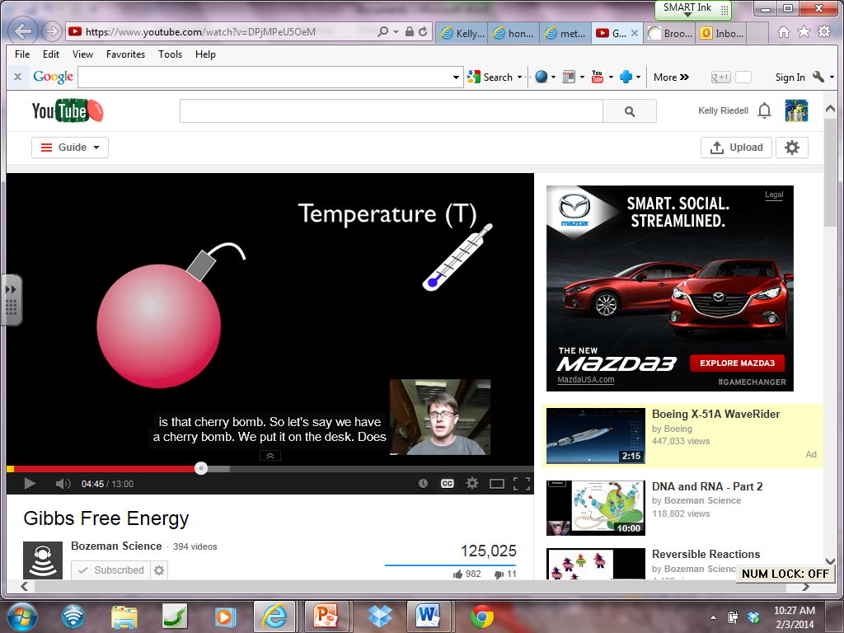

Δ G = ΔH – TΔS

Δ G < 0

Δ G > 0

Δ G = 0

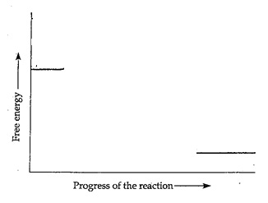CELLULAR RESPIRATION

PHOTOSYNTHESIS

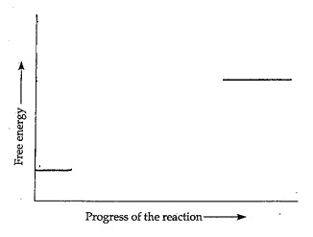

ATP → ADP + Pi + energy ΔG =

ADP + Pi + energy→ ATP ΔG =

