BILL- ENZYME GRAPHS
EXPLAIN why the following graphs have the shape they do.

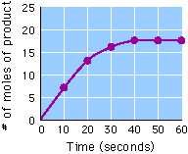
What is the rate, in moles/second, over the
interval from 0 to 10 seconds?

What is the rate, in moles/second, over the
interval from 40 to 50 seconds?

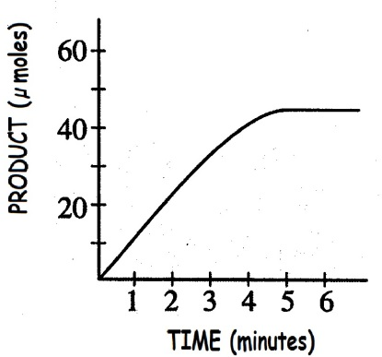
Why does this graph level off after 4 minutes?

PREDICT what the graph would look like if TWICE as
much enzyme was added

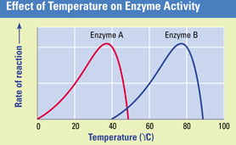
At which temperature does enzyme A perform best?
At which temperature does enzyme B perform best?
One of these enzymes is found in humans and the other in
thermophilic (heat-loving) bacteria,
Hypothesize which enzyme comes from which organism. EXPLAIN YOUR ANSWER
Why does the rate of the reaction catalyzed by enzyme A slow down at
temperatures above 40°C.

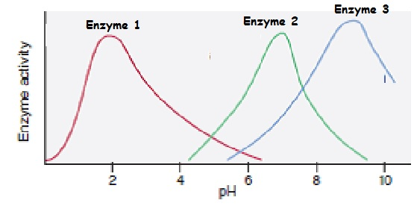
Pepsin is an enzyme that works in the
stomach to break down proteins.
Which graph do you think represents pepsin?
EXPLAIN YOUR ANSWER
E

