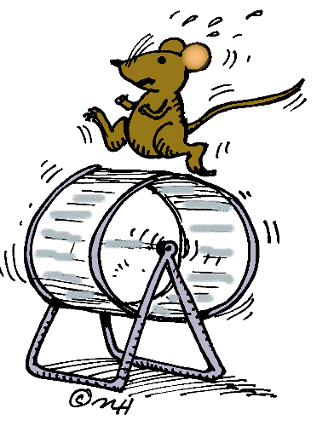
How are TAXIS and KINESIS different?
How are POSITIVE and NEGATIVE TAXIS different?
Find a picture of something that would stimulate positive OR negative chemotaxis
in YOU and paste it below and label which type of taxis it would result in.

How are TAXIS and KINESIS different?
How are POSITIVE and NEGATIVE TAXIS different?
Find a picture of something that would stimulate positive OR negative chemotaxis
in YOU and paste it below and label which type of taxis it would result in.

How are TAXIS and KINESIS different?
How are POSITIVE and NEGATIVE TAXIS different?
Find a picture of something that would stimulate positive OR negative chemotaxis
in YOU and paste it below and label which type of taxis it would result in.

How are TAXIS and KINESIS different?
How are POSITIVE and NEGATIVE TAXIS different?
Find a picture of something that would stimulate positive OR negative chemotaxis
in YOU and paste it below and label which type of taxis it would result in.

How are TAXIS and KINESIS different?
How are POSITIVE and NEGATIVE TAXIS different?
Find a picture of something that would stimulate positive OR negative chemotaxis
in YOU and paste it below and label which type of taxis it would result in.

