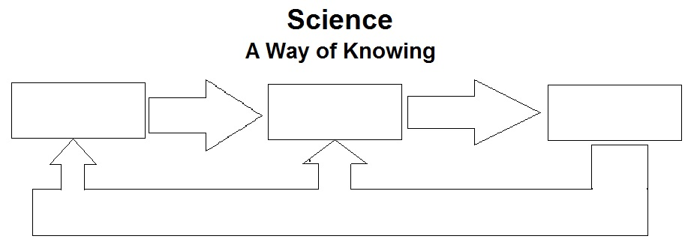WATCH BOZEMAN VIDEO- CER and use diagrams provided to help you  
 take notes in your BILL.

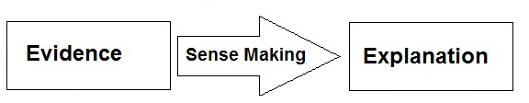

C ________________  
E ______________________________  
R _________________________

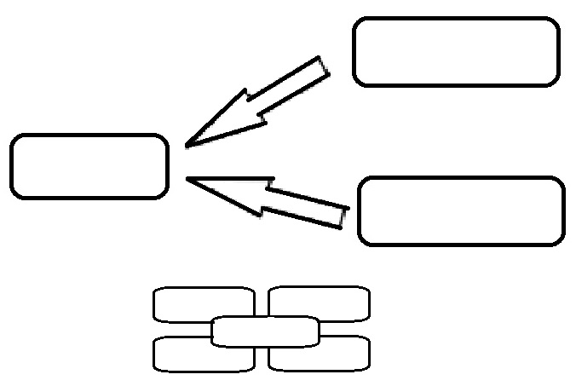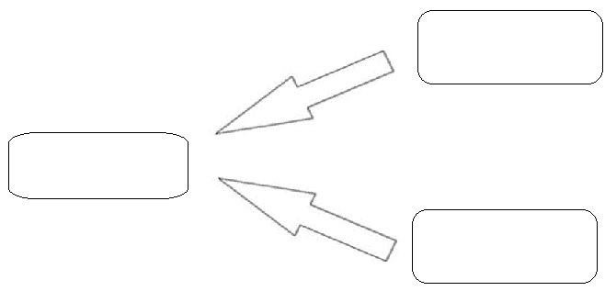

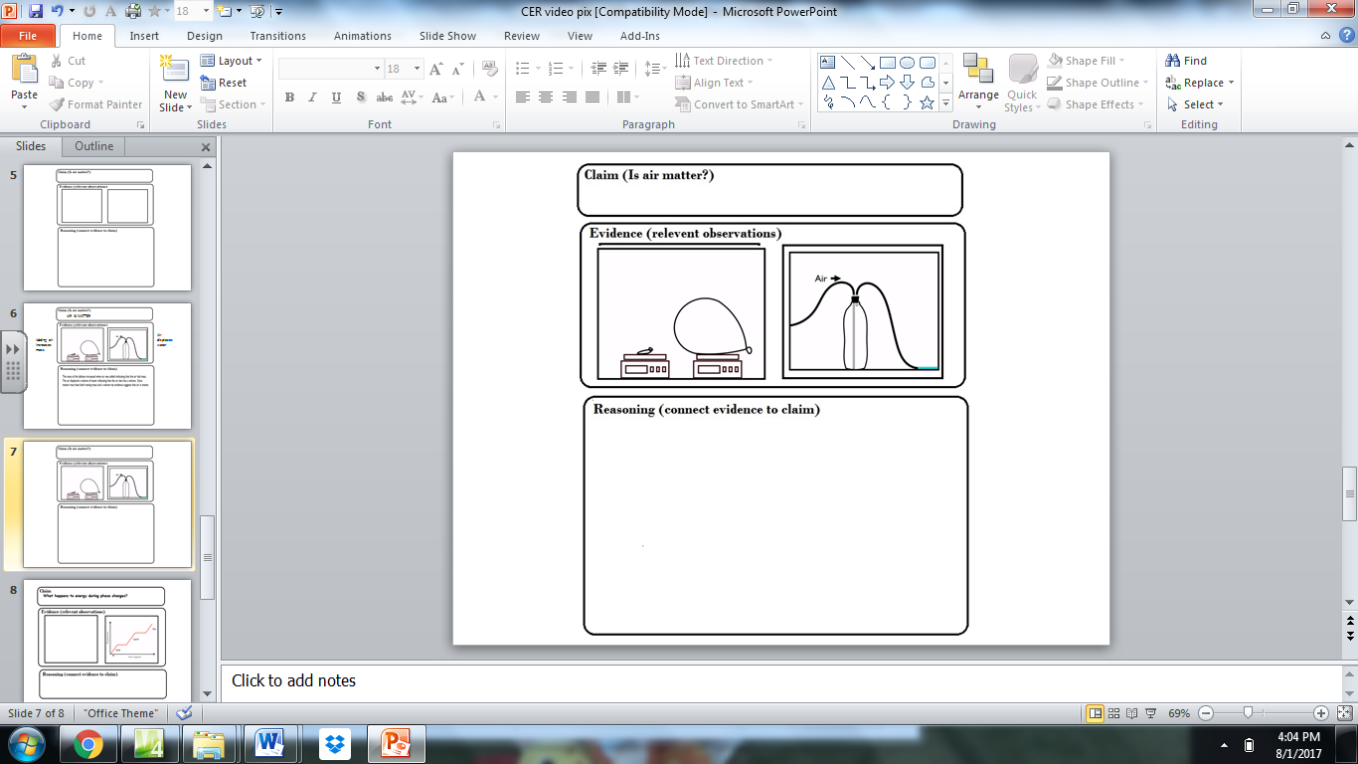

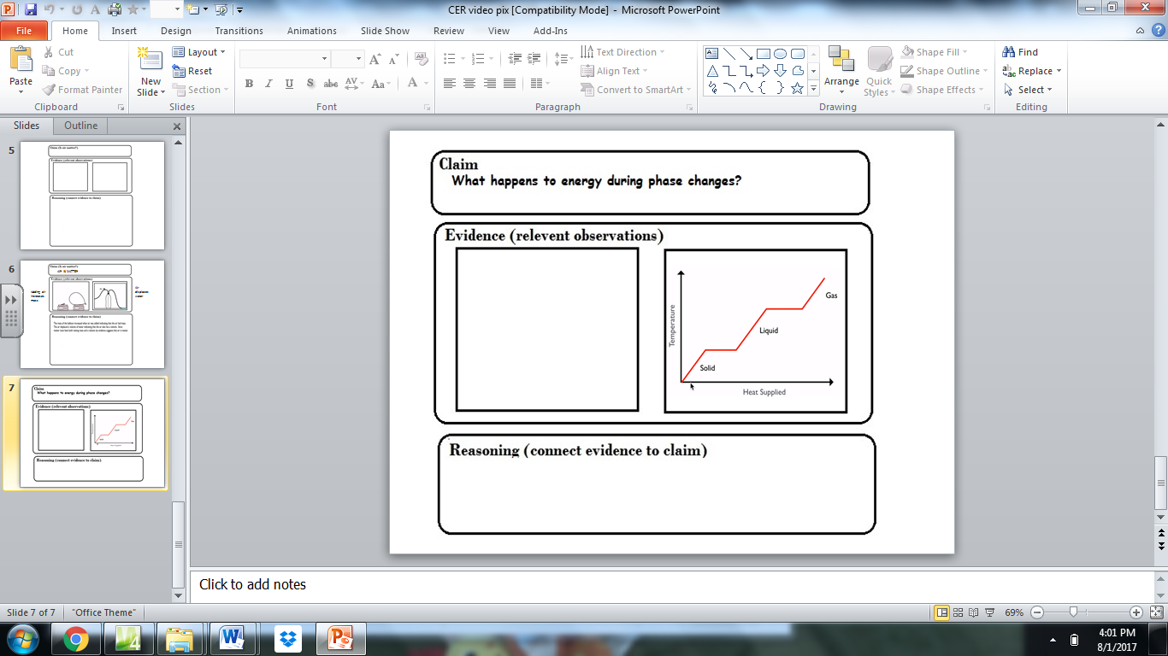

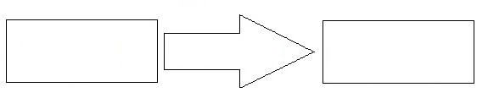

CER