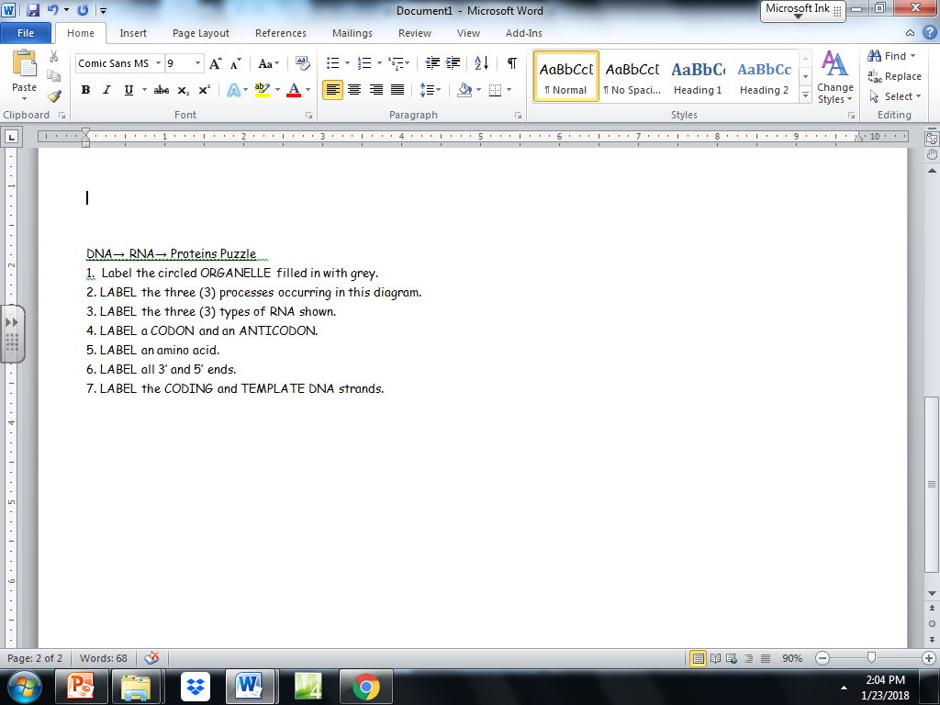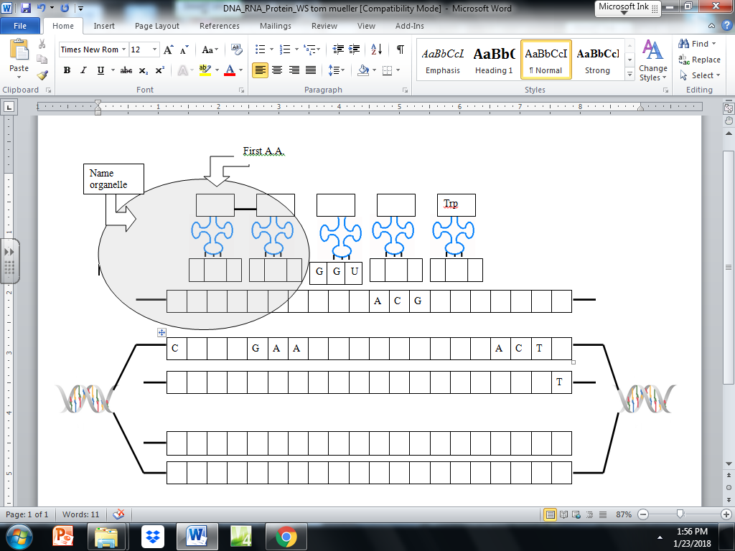NAME _____________________

Modified from a worksheet by: Tom Mueller