DESKTOP RFLP ANALYSIS NAME _________________________
GEL #1
LAY OUT 3 YARN PIECES ON YOUR DESK; DON’T STRETCH !
TRIM ALL YOUR YARN PIECES SO THEY ARE THE SAME LENGTH- 50 cm
Use the SAME EcoRI “restriction enzyme” provided to cut ALL the DNA strands.
- Cut the BLUE yarn ( –Cuts at 8 cm AND 22 cm 8, 14, 28
- Cut the PURPLE yarn– Cuts at cm 10 AND 32 cm 10, 22 18,
- Cut the GREEN yarn –Cuts at 10 cm AND 15 cm AND 40 cm 10, 10 5, 25
Set up the top of your desk as a gel
- Use sticky notes to LABEL the + and – poles
- Use sticky notes to LABEL your lanes

Load each “well” with DNA from one individual.
“Run your gel”. In real life, current would be applied to cause the fragments to move along the gel

BLUE ( ) PURPLE ( ) GREEN ( )

GEL #2:- CUT DNA from the SAME INDIVIDUAL with DIFFERENT RESTRICTION ENZYMES.
LAY OUT 3 YARN PIECES ON YOUR DESK; DON’T STRETCH !
TRIM ALL YOUR YARN PIECES SO THEY ARE THE SAME LENGTH- 50 cm
Use the “restriction enzymes” provided to:
- Cut one piece of yarn with EcoRI –Cuts at 8 cm AND 22 cm
- Cut one piece of yarn with HindIII– Cuts at 18 cm AND 35 cm
- Cut one piece of yarn with BOTH EcoRI AND HindIII (Use BOTH of the above cuts)
Set up the top of your desk as a gel
- Use sticky notes to LABEL the + and – poles
- Use sticky notes to LABEL your lanes
Load your “gel” with your “DNA” that has been cut with “restriction enzymes”.
Complete RFLP analysis and draw a picture of the results below.
EcoR1 HindIII EcoR1 + HindIII

ANALYSIS QUESTIONS:
EXPLAIN WHY DNA moves in an electric field toward the POSITIVE pole.

EXPLAIN the relationship between FRAGMENT SIZE and DISTANCE the fragment moved on a gel.

Linus Pauling used RFLP analysis to show that the sickle cell mutation caused a change in the DNA code. He cut the gene from a person with normal hemoglobin and a person with sickle cell anemia with a restriction enzyme and compared them using RFLP analysis. Use what you know about the sickle cell mutation and restriction recognition sites to EXPLAIN how a mutation could change the NUMBER and LENGTHS OF FRAGMENTS on a gel .

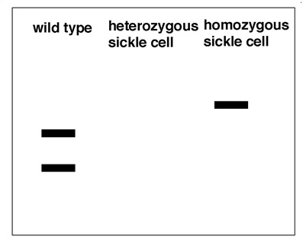
MAKE A PREDICTION about what the gel pattern from a person who is heterozygous for the sickle cell allele might look like. HINT: Think about what the word HETEROZYGOUS means.

Give at least FOUR (4) EXAMPLES of how DNA ANALYSIS can be used to compare DNA.
1.
2.
3.
4.

