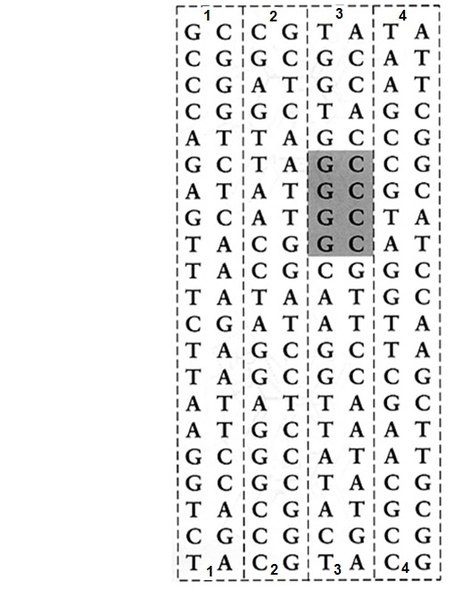
PLASMID DNA

