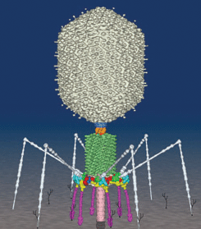
VIRUSES Alive?
Made of NUCLEIC ACID surrounded by PROTEIN COAT
Tiny: smaller than ribosomes
Can be double/single stranded
Can have DNA/RNA
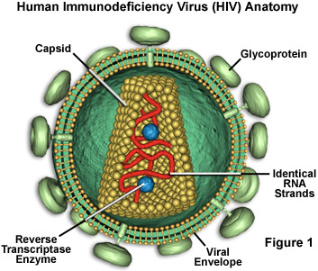
Protein shell = CAPSID
Some have ENVELOPES around capsid that aid in host infection
BACTERIOPHAGES-viruses that infect bacteria
Have no cellular machinery of their own
Can only reproduce in host cells
RETROVIRUSES EX: HIV (AIDS virus)
Have RNA for genetic code
Contain REVERSE TRANSCRIPTASE enzyme
~ uses viral RNA to make a complementary DNA used by host cell
Enzyme used as a genetic tool to turn eukaryotic mRNA into DNA
that can be incorporated and transcribed by bacteria

TWO KINDS OF LIFE CYCLES
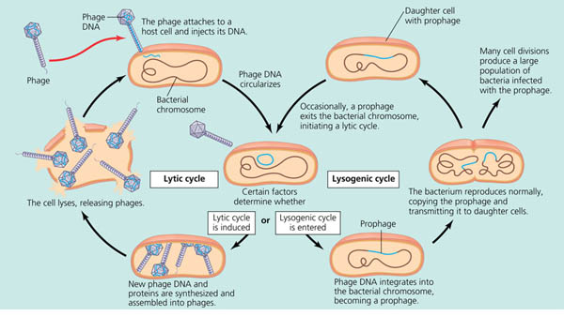



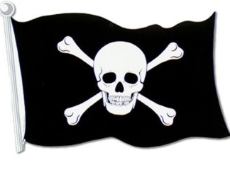

LYTIC – ends in death of host cell
virus injects DNA into host cell
Takes over cell’s machinery to make
copies of viral DNA/proteins
Virus is assembled
Cell is lysed releasing multiple copies of virus

LYSOGENIC- Viral DNA incorporated into host DNA
Replicates along with host DNA
Incorporated viral DNA = PROPHAGE
Can stay in host DNA for years
Certain conditions can cause prophage to
leave host DNA and enter lytic cycle

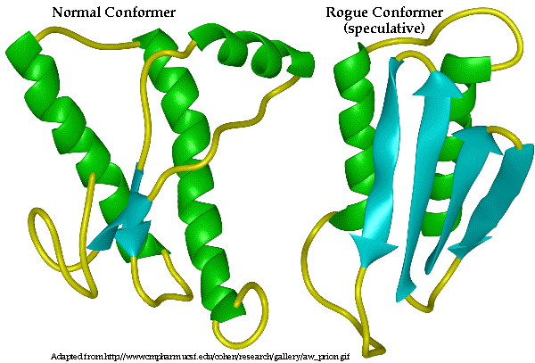
PRIONS = Misshaped infectious proteins
Cause misfolding in proteins they contact
Affect brain; untreatable and fatal
EX: SCRAPIE in sheep;
BOVINE SPONGIFORM ENCEPHALOPATHY (BSE) or “MAD COW DISEASE” in cows;
CREUTZFELD-JAKOB and KURU in humans

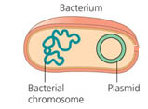
PLASMIDS= Small circular self replicating DNA
•separate from main bacterial chromosome
•Carry 2-30 genes
•Often carry genes for antibiotic resistance (R plasmids)
•Can carry fertility genes (F factor) (See Conjugation below)

•Plasmids used as a genetic tool
•Can be cut with RESTRICTION ENZYMES and used to incorporate foreign DNA into bacteria
•Bacteria then reproduce, copying the inserted gene along with their own plasmid
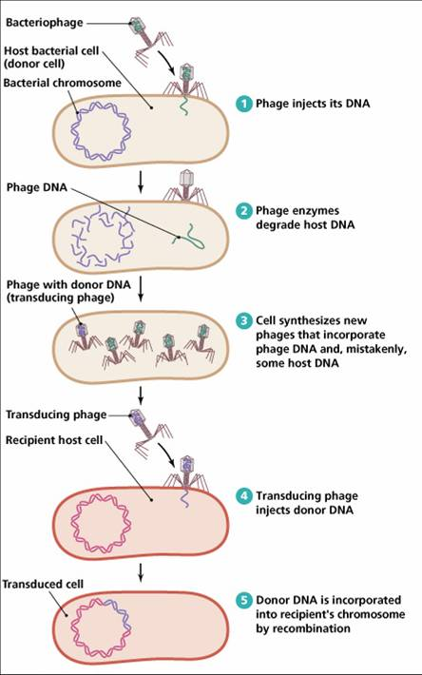
MECHANISMS OF GENE TRANSFER/GENETIC RECOMBINTION IN BACTERIA
TRANSDUCTION
Phage viruses can pick up & transfer DNA
to new host along with viral DNA

TRANSFORMATION
Uptake of naked DNA from another DNA source
Remember . . .Griffith’s pneumonia/mice experiment

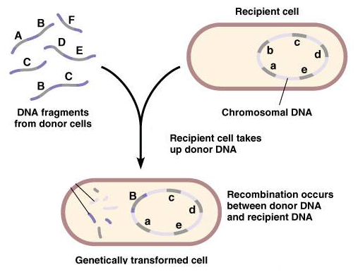

CONJUGATION = bacterial “sex”
Bacteria with F factor plasmids can form sex pili
Structure to directly transfer DNA to another bacteria



