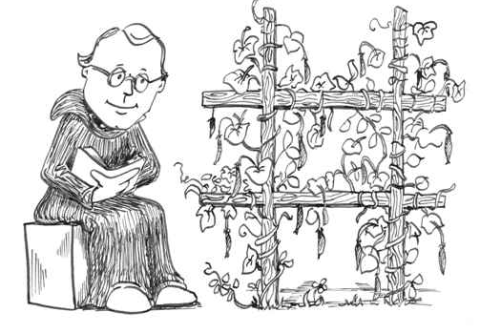
GENETICS-
Observable characteristic = TRAIT
Alternative choices for a gene = ALLELES
DOMINANT allele hides the recessive allele
RECESSIVE allele is hidden by dominant allele if it is present
HOMOZYGOUS organisms have two of the same alleles for a trait (EX: TT or tt)
HETEROZYGOUS organisms have two different alleles for a trait (EX: Tt)
PHENOTYPE= character that is expressed; “way it looks”
GENOTYPE = genetic makeup; “what genes it has”
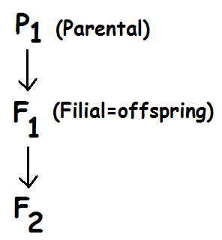

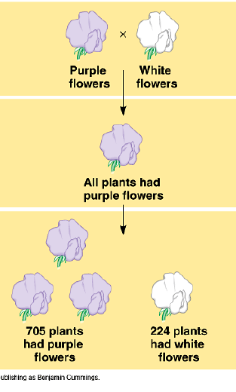
TRUE BREEDING PARENTS in genetic cross = PARENTAL (P₁) generation
Their offspring = first filial generation (F₁)
Off spring of the F₁ generation = SECOND FILIAL generation (F₂)

MENDELIAN INHERITANCE
MONOHYBRID CROSSES – cross to study only ONE character
Aa X Aa = 3:1 ratio
LAW of SEGREGATION = two alleles separate during gamete formation
(separation of homologous partners during ANAPHASE I)
DIHYBRID CROSS- cross to study TWO characters
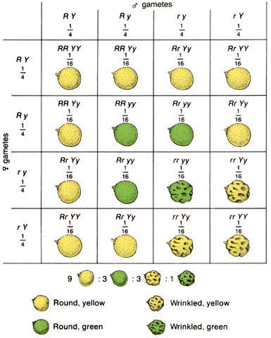
LAW of INDEPENDENT ASSORTMENT= Each pair of alleles segregates (separate) independently in meiosis
Maternal and paternal chromosomes mix up in different combinations during gamete formation (ANAPHASE I)
AaBb X AaBb = 9:3:3:1 ratio
9 = dominant trait 1/dominant trait 2
3 = dominant trait 1/recessive trait 2
3 = recessive trait 1/dominant trait 2
1 = recessive trait 1/recessive trait 2

For TRIHYBRID crosses or if parents NOT HETEROZYGOUS:
Use MULTIPLICATION and ADDITION RULES to determine probability of phenotypes and ratios

Possible different gamete combinations = 2^{n} where n= number of chromosome pairs
3 pairs of chromosomes (AaBbCc ) = 2³ = 8 possible combinations

TESTCROSS-
Used to determine if individual with dominant phenotype is heterozygous or homozygous
Unknown genotype is CROSSED WITH HOMOZYGOUS RECESSIVE (A_ X aa)
NON-MENDELIAN INHERITANCE
1) NATURE vs NURTURE – environment influences phenotypic expression
Siamese cats/Himalayan rabbits- darker fur on areas that are cooler
Hydrangea flower color depends on soil pH
2) SPECTRUM OF DOMINANCE
INCOMPLETE DOMINANCE- heterozygote = blended intermediate phenotype
(EX: red X white four o’clocks; heterozygotes = pink
CO-DOMINANCE- Both alleles are expressed at same time
(EX: Roan horse has BOTH white and red hair; AB blood type)
3) LINKED GENES
X-LINKED- carried on X chromosome EX: Color blindness; hemophilia; Duchenne Muscular Dystrophy
Y-LINKED- carried on Y chromosome EX: Hairy pinnae; SRY=gene for “maleness”
4) MULTIPLE ALLELE TRAIT- More than 2 choices
EX: A, B, O blood alleles produce A, B, O, or AB blood types
5) POLYGENIC TRAIT- trait determined by more than one gene
EX: skin color, intelligence, eye color
“bell curve”
6) EPISTASIS- Gene at one locus alters the phenotypic expression of a gene at another locus
EX: Coat color pigment not deposited in hair without color gene;
7) PLEIOTROPY- one gene has multiple phenotypic effects
EX: dwarfism; cystic fibrosis
8) MULTIFACTORIAL- Genetic component + environmental factors influence disease
(EX: heart disease, diabetes, cancer, manic depression, schizophrenia)
Not well understood; educate people about risk factors/promote healthy lifestyle

CHI-SQUARE (X²) - Used to determine if observed results are significantly different from expected results
KNOW HOW TO USE FORMULA and HOW TO INTERPRET RESULTS
NULL HYPOTHESIS: “There is NO DIFFERENCE between observed and expected”
DEGREES OF FREEDOM = # of classes - 1
If X² < 0.05 p value; then difference can be due to random chance alone: “Accept null hypothesis”
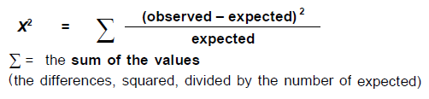

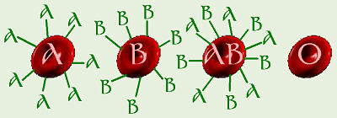
BLOOD TYPES:
GLYCOPROTEINS on surface determine blood type
Important in transfusions/transplants
I^{A} and I^{B} are CODOMINANT; ii (type O) is recessive to A or B
Type O = UNIVERSAL DONOR;Type AB= UNIVERSAL RECIPIENT
Differences in Rh factor (Mom Rh⁻ and baby Rh⁺) can result in
ERYTHROBLASTOSIS FETALIS
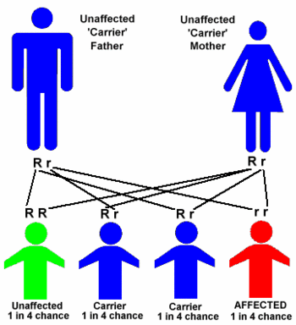
GENETIC SCREENING & COUNSELING
Based on Mendelian genetics and probability rules
Tests for identifying carriers
Fetal testing
Newborn screening
CARRIER = Heterozyous individual that doesn’t show trait, but can pass it on to offspring
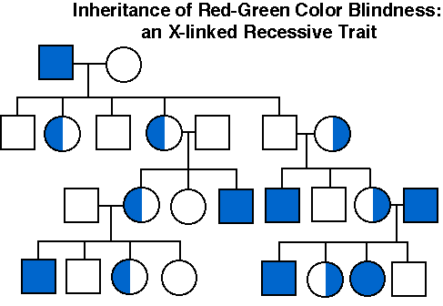

PEDIGREE-
Diagram that shows how traits are passed over generations;
Circles = females;
Squares = males;
Individual with trait= Filled in
CARRIER = half/half filled in
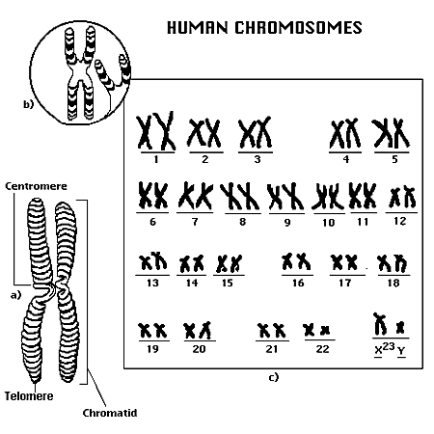
KARYOTYPE-
organizes picture of an individual’s chromosomes
Can show sex: XX = female / XY = male
Can show some genetic disorders:
missing/extra chromosomes (Down, Turner, Klinefelter)
large translocations/deletions (Fragile X)
Can’t show gene mutations (EX: PKU, sickle cell)

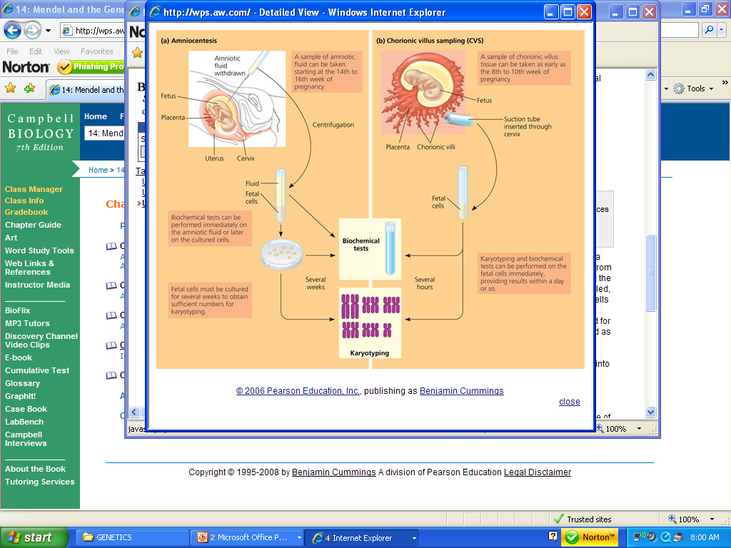
AMNIOCENTESIS
Can’t be done until 14-16 weeks
Needle inserted through abdomen
Sample of amniotic fluid removed
Biochemical tests done immediately on fluid
OR later on cultured cells (EX: karyotype)
Takes weeks
Risk of miscarriage

CHORIONIC VILLUS SAMPLING (CVS)
Can be done sooner (8-10 weeks)
Suction tube inserted through cervix
Biochemical tests/karyotyping can be done on fetal cells immediately
Faster/ results within days
but greater chance of miscarriage than amniocentesis

