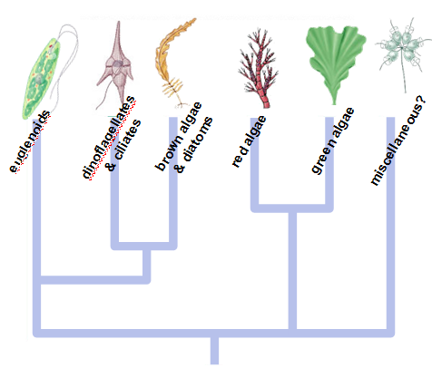
PROTISTS- Chapter 28
“More about what they are not… than what they are”

CHARACTERISTICS
EUKARYOTES that AREN’T animals, plants, or fungi

Primarily unicellular (Paramecium, Euglena);
Some colonial (Volvox); some multicellular (Seaweed)
Cilia or flagella at some time in life cycle
Kingdom is POLYPHYLETIC (from two or more ancestral forms)
Taxonomists are attempting to create monophyletic groups
using nucleic acid sequencing, cell structure
The full spectrum of modes of life
- unicellular to multicellular
- autotrophic to heterotrophic
- asexual to sexual reproduction
- pathogenic to beneficial
- sessile to mobile
THREE CATEGORIES
ANIMAL-LIKE (protozoa): ingestive heterotrophs
EX: amoeba, paramecium, stentor
FUNGUS-LIKE absorptive heterotrophs
PLANT-LIKE (algae): photosynthetic autotrophs
Have chlorophyll a and accessory pigments (carotene, xanthophylls)
EX: Euglena, algae, dinoflagellates, diatoms
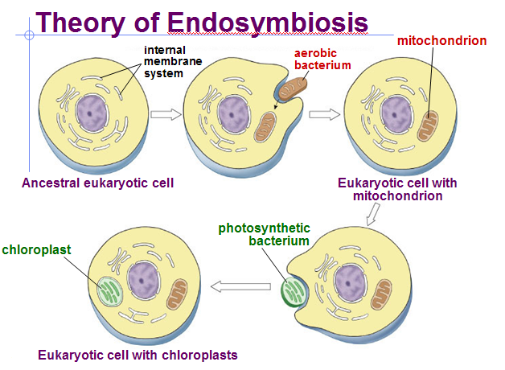
ORIGIN OF EUKARYOTES (ENDOSYMBIOTIC THEORY)
Increasing multicellularity found in prokaryotes
Allows for division of labor, specialization of functions,
and compartmentalization.

Endosymbiotic hypothesis (serial endosymbiosis)
Explains origin of mitochondria and chloroplasts.
Proposed by Lynn Margulis
Heterotrophic and photosynthetic prokaryotes
become endosymbionts.
EVIDENCE:
Bacteria & mitochondria/chloroplasts are similar size
Inner membrane transport proteins, enzymes, lipids similar
Divide by “binary fission”
Circular DNA without histones
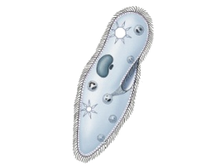
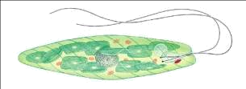
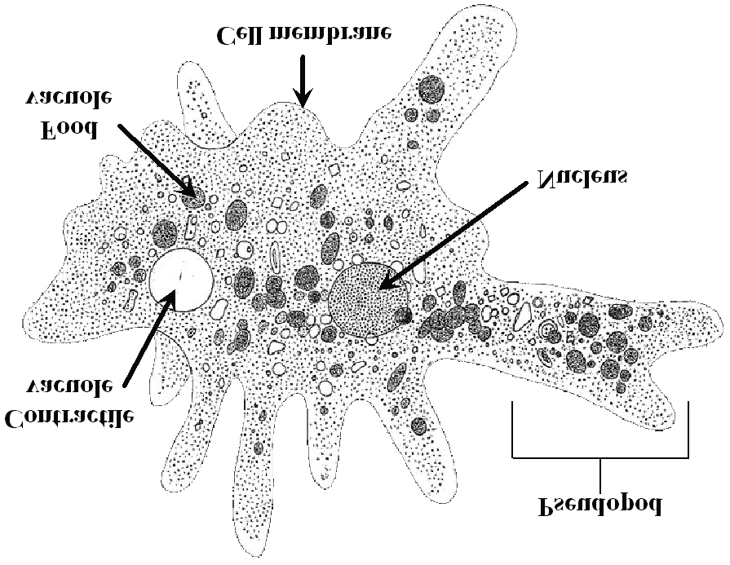
Have own transcription/translation machinery

HOW PROTISTS MOVE
Flagella EX: Euglena Cilia EX: Paramecium Pseudopodia EX: amoeba
BENEFICIAL  Constituents of plankton (passive drifters in water)  phytoplankton – (algae + diatoms)  produce ~ 90% of atmospheric oxygen  zooplankton -key role in aquatic food chains  Symbiosis- LICHENS: (fungi + algae) make soil from rock | HARMFUL- Pathogens  Plasmodium- malaria  Potato blight  Trypanosomes- sleeping sickness  Giardia-diarrhea

