NAME _______________________________

LAB 9- RESTRICTION ENZYME ANALYSIS OF DNA
WHILE YOUR GEL IS RUNNING COMPLETE THE FOLLOWING:
PCR QUESTIONS
1. What components are in the PCR sample?

_______________________________________________________________________________

________________________________________________________________________________

________________________________________________________________________________

2. Why are primers needed to start the replication process during PCR?

_______________________________________________________________________________

________________________________________________________________________________

3. EXPLAIN why Taq polymerase is used for PCR instead of human DNA polymerase.
_______________________________________________________________________________

________________________________________________________________________________

4. All enzymes have a temperature optimum at which they work the best.
If this graph represents human DNA polymerase, ADD a graph that shows the effects of temperature on Taq polymerase

DNA GEL ELECTROPHORESIS QUESTIONS
WHY do DNA fragments migrate through the gel from the negatively charged pole to the positively charged pole?
___________________________________________________________________________________

___________________________________________________________________________________

What is the function of the loading dye when running the DNA in the gel?
_________________________________________________________________________________

_________________________________________________________________________________

DNA is invisible to the naked eye. What did you do to allow the DNA bands in the gel to become visible?
_________________________________________________________________________________

_________________________________________________________________________________

Make a prediction about the RFLP patterns of identical twins cut with the same restriction enzymes?
___________________________________________________________________________________

___________________________________________________________________________________
How would these compare to the RFLP patterns of fraternal (non-identical) twins or triplets?
___________________________________________________________________________________

___________________________________________________________________________________

How is RUNNING TIME related to distance DNA moves in gel?
___________________________________________________________________________________

___________________________________________________________________________________

What do you think would happen if the POLARITY (+ and - ) on the gel was reversed?
___________________________________________________________________________________
___________________________________________________________________________________

Record results of the Niemann-Pick family DNA analysis below.
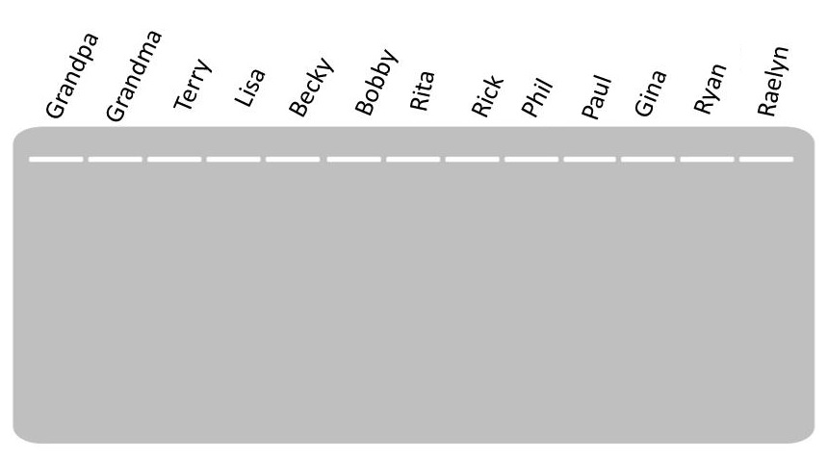

Use the information provided about family relationships and the results from your DNA analysis to create a family PEDIGREE below showing affected individuals /carriers.

JONES FAMILY PEDIGREE

INTERPOLATING DNA SIZES USING A STANDARD CURVE
Running a lane of known sized fragments allows you to predict the sizes of the fragments in other lanes.
Use the BamH1 land in the ideal gel provided to measure the distance (in cm) that each fragment migrated from the origin (starting well). For consistency, measure from the front end of each well to the front edge of each band, i.e., the edge farthest from the well). Enter the measured distances into TABLE 1 below.
See * note below the table for an explanation for why there are only six bands seen but more fragments.

HINDIII |  | EcoR1
Distance  Traveled | BP Length | Distance  Traveled | BP Length
 | *27,491
 | *23,130
 | 9,416
 | 6,557
 | 4,361
 | 2,322
 | 2,027
TABLE !. DNA FRAGMENT MIGRATION DISTANCE

* For this “ideal” gel, assume that these two bands appear as a single
band instead of resolving into separate bands

MAKE A STANDARD CURVE
Using data provided for samples cut with HINDIII from the chart above plot a standard curve on the next page. Connect the data points with a line of best fit. Use the standard curve graph to calculate the approximate sizes of EcoR1 fragments and fill in the data table above.

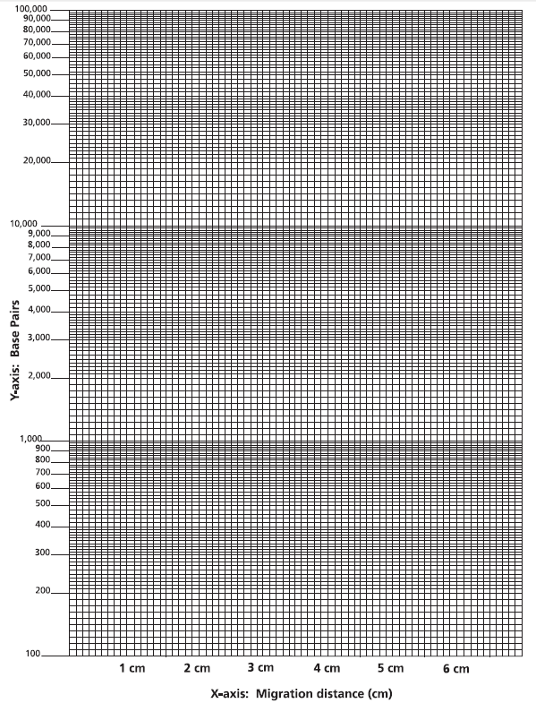
STANDARD CURVE FOR HINDIII digest

Distance fragment moved (cm)
MAKE A PREDICTION
1. Use the standard curve graph on next page to predict how far (in cm) an 8,000 bp fragment would move?

2, A certain restriction enzyme digest results in DNA fragments of the following sizes:
4,000 bp, 2,500 bp, 2,000 bp, 400 bp
Draw a diagram that shows the results of their separation by gel electrophoresis. Show the starting point, positive and negative electrodes, and relative positions of resulting bands.

MAKE A CONNECTION
Electrophoresis can be used to separate any molecules with an electric charge. EXPLAIN how the amino acids that make up proteins might play a role in the movement and separation of a mixture of proteins on an electrophoresis gel.
___________________________________________________________________________________

___________________________________________________________________________________
___________________________________________________________________________________

MODIFIED BY: Kelly Riedell Brookings Biology

