



**Diagnosing Niemann Pick Disease**

**STUDENT HANDOUT – MODIFIED by Kelly Riedell**

**Overview**Niemann-Pick disease is an inherited condition involving lipid metabolism. Mutations in either the NPC1 or NPC2 gene cause Niemann-Pick disease type C. The NPC1 gene provides instructions for producing a protein that is involved in the movement of cholesterol and lipids within cells. A deficiency of this protein leads to the abnormal storage of lipids within cells.  
In people with this condition, abnormal lipid metabolism causes harmful amounts of lipids to accumulate in the spleen, liver, lungs, bone marrow, and brain. ______________________________________________________________________________________________________________________________________________________________________  
  
Niemann-Pick disease type C usually appears in childhood, although infant and adult onsets are possible. Signs of Niemann-Pick disease type C include severe liver disease, breathing difficulties, developmental delay, seizures, poor muscle tone (dystonia), lack of coordination, problems with feeding, and an inability to move the eyes vertically. People with this disorder can survive into adulthood. Niemann-Pick disease type C is further subdivided into types C1 and C2, each caused by a different gene mutation. **What is the genetic cause of Niemann Pick type C.**

Your summer job is as intern in a genetics lab at a Mount Blueberry Children’s hospital. A doctor comes to your team and says that he has a family in which he suspects three cousins of all have Niemann-Pick type C disease. The family would life to confirm that:  
 1) the children indeed have Niemann-Pick type C   
 2) what are the risks of future children in the family developing the disease.

The doctor has collected DNA from the following patients:

Grandpa Jones

Grandma Jones

Terry Jones (son)

Lisa Jones (wife of Terry)

Becky Jones   
 (daughter of Terry and Lisa – has the disease)

Bobby Jones   
 (son of Terry and Lisa -- has the disease)

Rick Robinson (husband of Rita)

Phil Robinson (son of Rita and Rick)

Paul Jones (son)

Gina Jones (ex-wife of Paul)

Ryan Jones (non-identical twin son   
 of Gina and Paul – has the disease)

Raelyn Jones (non-identical twin daughter   
 of Gina and Paul)

Rita Robinson (daughter)

Your job is the following:

1. Set up a PCR screen with each of the patient samples to determine who is a carrier for the disease
2. 2) generate a pedigree map for the family showing affected vs carrier patients

**Polymerase Chain Reaction (PCR)**

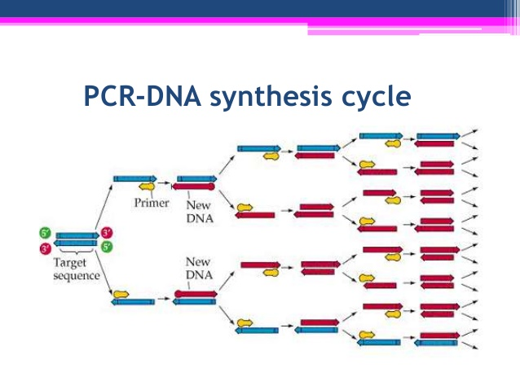

Polymerase chain reaction is a common method used to amplify specific regions of DNA for further analysis.

There is an exponential increase in the number of DNA copies synthesized when performing PCR.

For example, if you start with 1 molecule of DNA, there will be 2 identical copies after one cycle; 4 copies after two cycles; 8 copies after three cycles and so on.

There are several important steps in the PCR process:

Step 1**:   
HEAT TO DENATURE** double-stranded DNA into single strands.

Step 2:   
**COOL to ANNEAL** the primers to a specific region of DNA.  
Primers are used to target specific DNA sequences.

Step 3:   
**EXTEND** using Taq polymerase to add nucleotides to template

**REPEAT CYCLE**

________________________________________________________________________________________

Protocol:

1. Centrifuge DNA sample 1 minute.
2. Transfer 5uL of DNA sample to 0.2mL PCR tube.
3. Add 20uL of PCR reaction mix to DNA sample in 0.2mL PCR tube and pipet up and down to mix.
4. Label tube and place into the thermocycler and run PCR cycle:

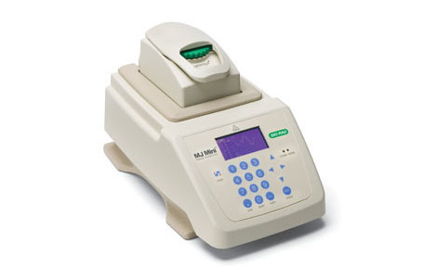95˚C for 2 minutes

95˚C for 30 seconds

60˚C for 30 seconds 20 cycles

72˚C for 1 minute

72˚C for 5 minutes

1. PCR cycle will take just under 1 hour to complete.

**DNA Electrophoresis**

Now that you have performed a PCR reaction to amplify *NPC2*, we need to analyze these samples using DNA electrophoresis to separate DNA based on two physical properties: charge and size.



Protocol:

1. Assemble DNA gel electrophoresis equipment.
2. Pour agarose solution into casting tray and cool at room temperature for 20 minutes.
3. Submerge gel in TAE buffer and remove comb.
4. Practice gel loading by pipetting 10 uL of loading dye. Be sure to hold sample in micropipette directly above well in TAE buffer. Pipet slowly to make sure sample enters well and to avoid any sample loss.



1. Load 10uL of DNA ladder (just need one ladder per gel).
2. Load 10uL of your PCR sample.
3. Attach lid and run gel at 130 volts for approximately 25 minutes.
4. Remove casting try and gel and view on UV box.

____________________________________________________________________________________________  
  
VISUALIZING DNA  
DNA is invisible to the naked eye. Two kinds of dyes will be used to be able to “see” the DNA in the gel.

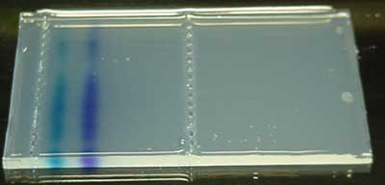

TRACKING DYE- is added to DNA sample.   
  
Labels the front as the DNA moves down the gel.   
  
Signals when to stop running the gel.



Gel-Red DYE- added to agarose gel  
 - will bind to DNA  
 - when excited by UV light it will give off visible light  
 - allows visualization of bands