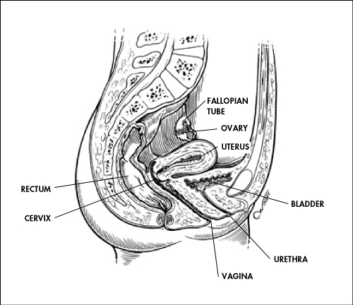
Functions: Produce eggs, Protect and nourish fertilized egg, give birth

Inner Anatomy
Ovaries- Contains follicles (one egg surrounded by follicle cells) that are released during ovulation

Fallopian tubes- Connect ovaries to uterus
Uterus- Thick, muscular organ that expands during pregnancy

Endometrium- Inner lining of uterus that is supplied with blood vessels
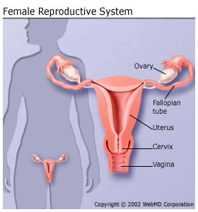
Cervix- Neck of the uterus which opens into the vagina

Vagina- Thin-walled chamber that serves as the birth canal
Hymen- Thin piece of tissue that covers the vaginal opening

Outer Anatomy (Vulva)

Labia Minora- Slender skin folds next to vestibule
Labia Majora- Encloses and protects the labia minora and vestibule
Clitoris- A Short shaft supporting a rounded glans, or head.
Bartholin’s glands- Located near the vaginal opening, secretes mucus into the vestibule

Pregnancy
Human Chorionic Gonadotropin (HCG)-embryonic hormone that maintains secretion of progesterone and estrogen

Human pregnancy is divided into three trimesters
  - First Trimester-almost all organs form (organogenesis)
  - Second Trimester-fetus grows about 30cm and begins to be active
  - Third Trimester-fetus grows to 3-4 kg and 50 cm in length, birth of the baby happens
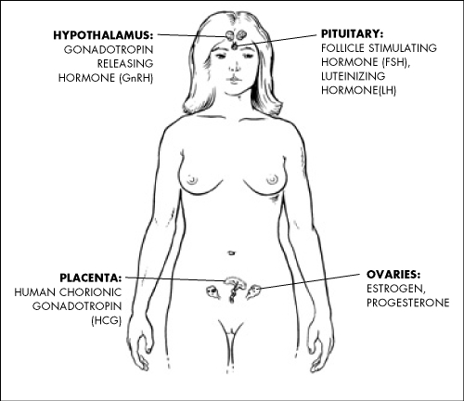

Major Hormones
Follicle-stimulating hormone (FSH)
Luteinizing hormone (LH)
Estrogen
Progesterone
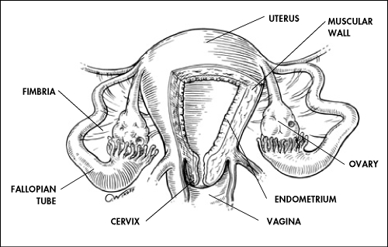
Gonadotropin Releasing hormone (GnRH)

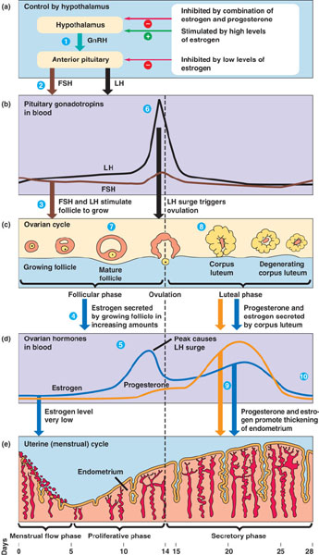
Female Reproductive Cycles

Menstrual Cycle

Humans and primates have menstrual cycles
In menstrual cycles the endometrium is shed by menstruation

Estrous Cycle

Other mammals have estrous cycles
In estrous cycles the endometrium is reabsorbed by the uterus
Vagina only permits a certain time for mating
Often called “being in heat”

Ovarian Cycle

Follicular Phase
1. GnRH is released and stimulates the pituitary gland to secrete small amounts of FSH and LH
2. FSH stimulates follicle growth, helped by LH
3. Growing follicles make estrogen

Ovulatory Phase
1. Rise in estrogen from the dominant follicle stimulates a surge of LH
2. Dominant follicle releases its egg from its ovary (ovulation)
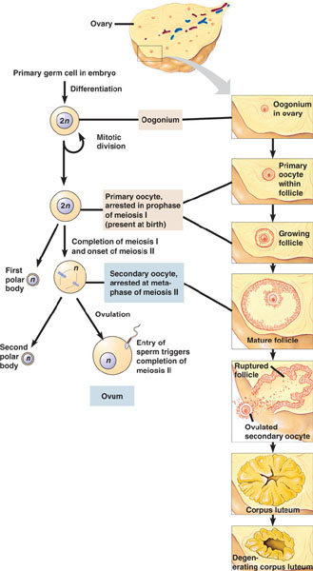
3. Egg travels down fallopian tubes

Luteal Phase
1. Empty follicle develops into corpus luteum
2. Corpus luteum secretes progesterone
3. Progesterone prepares uterus for a fertilized egg to implant

Menstrual Cycle
1. Estrogen signals endometrium to thicken
2. After ovulation, estrogen and progesterone continue to stimulate care of endometrium
3. The rapid drop of hormones when corpus luteum disintegrates causes the menstrual flow phase
4. The upper two-thirds of the endometrium disintegrates and is shed from the body by menstruation

Oogenesis
Forms 3 polar bodies and 1 ovum (egg cell)

