Male Reproductive Anatomy
Testes – the male gonads, consisting of many highly coiled tubes surrounded by several layers of connective tissue
Seminiferous Tubules – the tubes that make up the testes, it’s where sperm is formed
Leydig Cells – cells that are scattered between the seminiferous tubules that produce testosterone and other androgens
Spermatogenesis – the continuous and prolific production of mature sperm cells in the testis.
Scrotum – a fold outside of the body wall where production of the sperm occurs. This is because production of sperm cannot occur at the body temperatures of most mammals. The temperature of a scrotum is 2 Celsius degrees colder than the rest of the body!
Epididymis – a coiled tubule located adjacent to the testes where sperm are stored. It takes about 20 days for the sperm to travel through the 6 METERS of tubules!
Ducts
Vas Deferens – the tube in the male reproductive system in which sperm travel from the epididymis to the urethra
Ejaculation – when the sperm are propelled (at speeds of up to 18 miles an hour!!!) from the epididymis through the muscular vas deferens, ejaculatory duct, and urethra
Ejaculatory Duct – the short section of the ejaculatory route in mammals formed by the convergence of the vas deferens and a duct from the seminal vesicle. The ejaculatory duct transports sperm from the vas deferens to the urethra.
Urethra – a tube that releases urine and semen from the body through the penis in males
Glands – three sets of accessory gland – the seminal vesicles, prostate gland, bulbourethral glands – add secretions to the semen, the fluid that is ejaculated.
Seminal Vesicles – a gland in males that secretes a fluid component of semen that lubricates and nourishes sperm. Seminal vesicles contribute about 60% of the total volume of semen! The fluid from seminal vesicles is thick, yellowish, and alkaline. It contains mucus, the sugar fructose (which provides most of the energy used by the sperm), a coagulating enzyme, ascorbic acid, and prostaglandins, a local regulator.
Prostate Gland – a gland in human males that secretes an acid-neutralizing component of semen. It’s the largest of the secretory glands! Prostatic fluid is thin and milky. It contains anticoagulant enzymes and citrate (a sperm nutrient).
Bulbourethral Glands – one of a pair of glands near the base of the penis in the human male that secretes fluid that lubricates and neutralizes acids in the urethra during sexual arousal. Bulbourethral fluid also carries sperm released before ejaculation, which is one reason for the high failure rate of the “pull out” method of birth control.
Penis – the copulatory structure of male mammals composed of three cylinders of spongy erectile tissue derived from modified veins and capillaries. During sexual arousal, the erectile tissue fills with blood from the arteries. As this tissue fills, the increasing pressure seals off the veins that drains the penis, causing it to engorge with blood. The resulting erection is essential to insertion of the penis in the vagina.
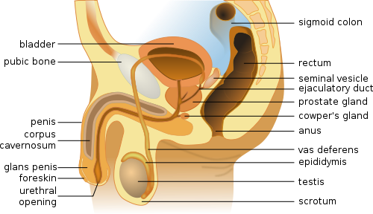
Baculum – a bone that is contained in, and helps stiffen, the penis of rodents, raccoons, walruses, whales, and several other mammals.
Glans Penis – the head end of the penis.
Prepuce – a fold of skin covering the head of the penis.

Sexual Responses – there are two types physiological reactions predominate in both sexes: vasocongestion and myotonia.
Vasocongestion – the filling of a tissue with blood, caused by increased blood flow through the arteries of that tissue.
Myotonia – increased muscle tension.
Coitus – the insertion of a penis into a vagina, also called sexual intercourse.
Orgasm – rhythmic, involuntary contractions of certain reproductive structures in both sexes during the human sexual response cycle.

Hormonal Control of the Male Reproductive System
The principle sex hormones are the androgens, of which testosterone is the most important. Androgens are steroid hormones produced mainly by the Leydig cells of the testes, interstitial cells located near the seminiferous tubules.
Testosterone and other androgens are responsible for primary and secondary sex characteristics of the male.
Primary sex characteristics are associated with the reproductive system: development of the vasa deferentia and other ducts, development of external reproductive structures, and sperm production.
Secondary sex characteristics are features not directly related to the reproductive system, including deepening of the voice, distribution of facial and pubic hair and muscle growth (androgens stimulate protein synthesis).

