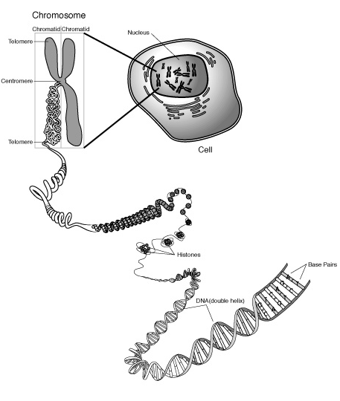
THE CELL CYCLE-Chapter 9
• Ability to reproduce = one characteristic of living things
• Continuity of life based on the reproduction of cells
• Cell division functions in reproduction, growth, and repair
UNICELLULAR ORGANISMS use cell division for reproduction
MULTICELLULAR ORGANISMS use cell division to:
-repair/renew cells that die from normal wear and tear
-grow and develop from a single fertilized egg (zygote)
-reproduce asexually (EX: plants grow by cuttings)
• Results in genetically identical daughter cells

• DNA molecules packaged into chromosomes
• GENOME= cell’s genetic information
Prokaryotes genome - single circular loop of DNA
Eukaryotes - several DNA molecules in multiple chromosome bundles
• Every eukaryotic species has characteristic number of chromosomes in each cell nucleus
~Human SOMATIC cells (body cells) have 46 chromosomes (two sets of 23; one from each parent).
~Human GAMETES (sperm or eggs) have one set (23 chromosomes); ½ number in somatic cells
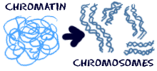
• Eukaryotic chromosome
- made of CHROMATIN (DNA + associated proteins)
PROTEINS maintain shape and control gene activity
- one long, linear DNA made up of 100’s-1000’s of genes
- spread out as CHROMATIN in NONDIVIDING cells;
allows access to info
- condensed as CHROMOSOMES in DIVIDING cells;
allows easier transport
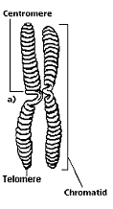
Duplicated chromosomes made up of:
-TWO IDENTICAL SISTER CHROMATID ARMS
- TELOMERES-region at ends of arms; prevent degradation
- Region where chromatids are most closely attached = CENTROMERE
- KINETOCHORES-proteins in centromere region where microtubules attach
- Once chromatids separate in anaphase ~ considered individual chromosomes

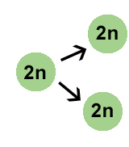MITOSIS (in all body cells)
produces
TWO IDENTICAL
daughter nuclei (clones)
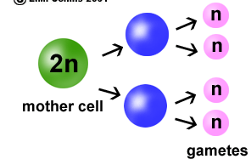MEIOSIS in gonads (ovaries or testes) produces
FOUR NONIDENTICAL
daughter cells with
½ the number of chromosomes
as parent cell

CELL CYCLE:
INTERPHASE = 90% of cell cycle
NON dividing phase
nuclear envelope/nucleoli are visible;
DNA spread out as CHROMATIN
Cell is “doing its job”
G₁ phase (“first gap”)
grow by producing proteins and organelles;
S phase (“synthesis”) – grow; copy DNA
G₂ phase (“second gap”) grow;
make molecules/organelles needed for cell division
EX: CENTROSOMES copied
(Contains CENTRIOLES in ANIMAL cells)
G G₀ phase-cell leaves cycle; stops dividing
Some cells can rejoin cycle with external cues
(Liver divides when injured)
Some cells never divide once mature (nerve,muscle)

TYPICAL HUMAN CELL might divide once every 24 hours
M phase < 1 hour S = 10-12 hours G₁ and G₂= rest of time G₁ most variable G₀- cell stops dividing
MITOTIC PHASE (M)- dividing phase includes
• MITOSIS-division of nucleus & CYTOKINESIS-division of cytoplasm

MITOSIS = continuum broken into 5 subphases;
PROPHASE
-chromatin becomes tightly coiled into chromosomes
-nucleoli disappear
- mitotic spindle begins to form
microtubules that extend from the centrosomes = ASTERS
-centrosomes move toward poles
PROMETAPHASE
- nuclear envelope fragments
- microtubules attach to centrosome at kinetochore proteins
- nonkinetochore fibers don’t attach to chromosomes
METAPHASE
-longest dividing phase
-spindle fibers push chromosomes to line up along imaginary plane at equator =METAPHASE PLATE
ANAPHASE
- shortest dividing phase
-sister chromatids separate and move to opposite poles
TELOPHASE
- also called “reverse prophase”
- two daughter nuclei begin to reform
- nuclear envelope reforms
- chromosomes spread out as chromatin
- spindle/centrosomes disappear
CYTOKINESIS = cytoplasm splits
-usually underway in late telophase
- CLEAVAGE FURROW splits animal cells
• ACTIN and MYOSIN proteins interact to contract ring
- CELL PLATE deposited by vesicles from Golgi divides plant cells; cell wall prevents “pinching”

HOW SPINDLE WORKS:
Assembled from elements of cytoskeleton
Fibers elongate by adding TUBULIN subunits
Assembly starts in CENTROSOME= “microtubule organizing center”
Possible mechanisms:
-chromosomes are “reeled in” by the shortening of microtubules at the poles
-evidence suggests microtubules shorten at chromosome end as MOTOR PROTEINS on kinetochore
“walk” chromosomes along microtubules toward poles
-MOTOR PROTEINS walk along nonkinetochore microtubules to lengthen/move them apart and elongate cell

BINARY FISSION- used by BACTERIA reproduce
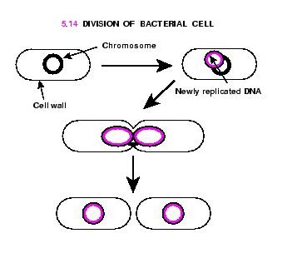
• Chromosome = single, circular coiled loop
• Replication begins at one point = ORIGIN OF REPLICATION
moves in both directions
• Cell elongates
• Plasma membrane grows inward
• Divides cell into 2 daughter cells with a complete genome
• No spindle or microtubules; several proteins play role

MITOSIS HAD ORIGINS IN BINARY FISSION:
• some proteins similar to eukaryotic proteins
• two of these related to tubulin and actin
Possible intermediate evolutionary steps:
• Dinoflagellates-replicated chromosomes are attached to the nuclear envelope
• Diatoms- the spindle develops within the nucleus

REGULATION OF CELL CYCLE
Timing crucial for normal growth, development, maintenance
Frequency varies with cell type
- some divide frequently (skin cells, blood cells)
- some can be induced to divide (liver cells)
- some don’t divide after maturity (nerve, muscle cells)
Understanding mechanisms of regulation may explain cancer
Chemical signals in cytoplasm drive cycle
Cyclical molecules trigger and coordinate key events in the cell cycle
Cycle has a built-in clock, but also regulated by external/internal controls
Critical control point where stop and go signals regulate cycle = CHECKPOINT
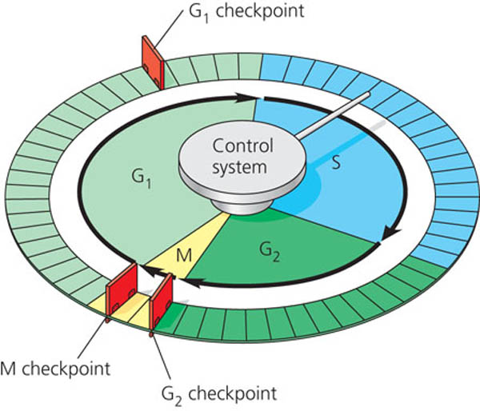
Cell stops at checkpoint until surveillance mechanisms indicate key processes have been completed
then stop signal is overridden

THREE MAJOR CHECK POINTS in the G₁, G₂, and M phases
G₁ = “restriction point” is most important in mammalian cells
If gets go-ahead signal cell → cell copies its DNA & divides
If no signal-cell exits cycle → nondividing state = G₀ phase
- Most human body cells in G₀
-Some can return to cycle with external cues
EX: growth factors released by injury stimulate liver cells to divide again
-Some never divide once mature EX: nerve and muscle cells

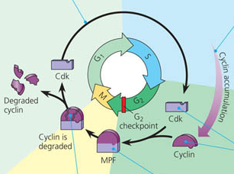
CYCLIN-DEPENDENT KINASES (Cdk’s)
• Inactive form of Cdk present all the time
• Activated by attachment of CYCLIN proteins
• Levels of cyclin rise throughout interphase;
fall abruptly during mitosis
• MPF = Cyclin-Cdk complex
“maturation-promoting factor”/“M-phase-promoting-factor”
-triggers passage past G₂ checkpoint into M phase
-At least 3 Cdk proteins/several cyclins regulate G₁ checkpoint
-Most mechanisms unknown;
but KINASES (Cdk’s) work by phosphorylating other proteins

INTERNAL SIGNALS
M phase checkpoint makes sure all chromosomes are attached to spindle at metaphase before anaphase

EXTERNAL SIGNALS
Particularly important for mammalian cells
1) GROWTH FACTOR = protein released by one group of cells that stimulate other cells to divide
EX: PDGF (platelet-derived growth factors) produced by platelet blood cells
Needed by fibroblasts in culture to divide
Released in body in vicinity of injury; proliferation of fibroblasts heals wound
2) DENSITY DEPENDENT INHIBITION of cell division
Crowded cells stop dividing
Cultured cells divide until form a single layer on surface of container
If a gap is created, the cells will grow to fill the gap; then stop dividing
At high densities, insufficient growth factors/nutrients stop growth

3) ANCHORAGE DEPENDENCE
Cells must be anchored to substrate/extracellular matrix to divide
CANCER CELLS
• Causes are diverse but always involve the alteration of genes that control cell cycle
• may have unusual numbers of chromosomes
• may secrete signal molecules that cause blood vessels to grow toward tumor
• have lost both: density-dependent inhibition /anchorage dependence
• Continue to divide excessively and invade other tissues
• Don’t stop when growth factors are depleted
• Don’t stop at normal cell cycle checkpoints
• Most cells divide 20-50 times in culture conditions; then stop, age, die; cancer cells are “immortal”
-HeLa cells from a tumor removed from a woman (Henrietta Lacks) in 1951 are still reproducing in culture

SO: making its own growth factors? Abnormality in cell cycle control system? Signaling abnormality?
Change from normal cell→ cancer cell = TRANSFORMATION
Normally immune system recognizes & destroys transformed cells;
if not found can proliferate → TUMOR =mass of abnormal cells
MALIGNANT tumors invade and impair functions of other organs
METASTASIS-cancer cells are carried in blood & lymph system to start tumors in new places

TREATMENT: (target actively dividing cells)
High energy radiation
Many chemotherapeutic drugs interfere with specific steps in the cell cycle
EX: Taxol interferes with breakdown of microtubules; cells get stuck in metaphase
Side effects of treatment due to effects on normal cells

