WATER POTENTIAL PROBLEMS #2 Name ______________________________ f16
Solution A has an osmotic potential of -5 bar,
Solution B has an osmotic potential of -8 bars
Flask B
Flask A
1 a.Which solution has the greater molarity? EXPLAIN YOUR ANSWER
b. Which one is hypertonic to the other? EXPLAIN YOUR ANSWER

c. Which one has greater water potential? EXPLAIN YOUR ANSWER

2. What is the SOLUTE potential (Ψs) for a 0.5M solution of SODIUM CHLORIDE that is in an open beaker? (assume i = 2 and a temperature of 10°C) SHOW YOUR WORK!

3. What is the WATER potential (Ψ) for a GLUCOSE solution that is 0.1M in an open beaker at 22°C?
SHOW YOUR WORK!

4. The value for Ψ in root tissue was found to be -3.3 bars. If you place the root tissue in a 0.1 M solution of sucrose at 20°C in an open beaker, what is the Ψ of the solution, and in which direction would the net flow of water be? Show your work.

_________________________________________________________________________________
Three funnels containing three different starch solutions were placed for 24 hours into a beaker that contained a starch solution of UNKNOWN concentration. The end of each funnel was covered by a selectively permeable membrane.
5. What is the concentration of the unknown solution in the beaker?
EXPLAIN the results shown in the diagram above.

6. A red blood cell has a Ψ_{S} of -4.4 bars. It is place in a solution of .3M glucose. DRAW A PICTURE!
What will happen to the cell?
7. The dialysis bags pictured below are impermeable to solutes, but permeable to water. Which dialysis bag in the beakers below will lose the most water? Which will gain the most water? Which will not change in mass? Explain what will happen to EACH bag in beakers A through E. Explain your answers.

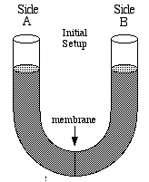
8. In the curved tube, the membrane is permeable to glucose but not to sucrose. If side A has a glucose concentration of 0.5M and a sucrose concentration of 0.8M, while side B has a glucose concentration of 0.6M and a sucrose concentration of 0.2M, which side will rise or fall? Explain.

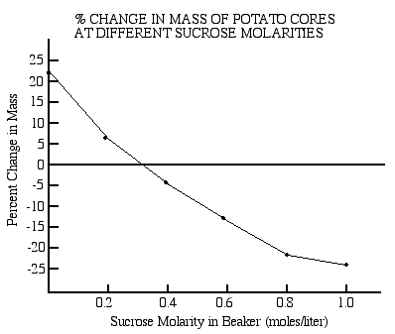
9. This graph summarizes potato core mass percent changes in a sucrose solution at 25°C.
Calculate the solute potential (ψ_{s}) of the potato cores.

10.

a. Which beaker with potato cores is at equilibrium?
b. What is the water potential (Ψ) of the potato core in beaker #1?
c. What will happen to the potato core in beaker 1? EXPLAIN
d. What is the water potential (Ψ) of the potato core in beaker #2?
e. What will happen to the potato core in beaker #2? EXPLAIN

11. You are on a ship at sea that sinks and a few survivors (including you) escape by climbing into a life raft. You begin to get thirsty while waiting for rescue and someone suggests drinking sea water. Use what you learned in AP Bio class to determine if this is a good idea.
a. NaCl is the main dissolved ions in seawater at roughly a 0.5 M concentration.
Calculate the SOLUTE potential for seawater if you know the water temperature is -5° C.
SHOW YOUR WORK

b. Human body cells have a 0.15M NaCl concentration. Calculate the SOLUTE potential for body cells knowing body temperature is 37° C. SHOW YOUR WORK

c. Is drinking seawater a good idea? Why or why not? Include a discussion of WATER POTENTIAL in your answer.

12. Given the following data and blank graph, be able to graph the data and calculate the water potential of carrots.

