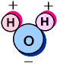**NAME __________________________ PARTNER _______________________  
  
 PROPERTIES OF WATER LAB  
  
Introduction:**Water's chemical formula is H2O. As the diagram to the left shows, that is one atom of oxygen bound to two atoms of hydrogen. There are more electrons orbiting the oxygen atom compared to the hydrogen atoms, resulting in a water molecule having a positive charge on the side where the hydrogen atoms are and a negative charge on the other side, where the oxygen atom is. This uneven distribution of charge is called **polarity**. Since opposite electrical charges attract, water molecules tend to attract each other, making water kind of "sticky."

The **INTRA**-molecular bonds that hold the hydrogen and oxygen atoms together to make a water molecule are covalent bonds..

1) Explain what a covalent bond is.

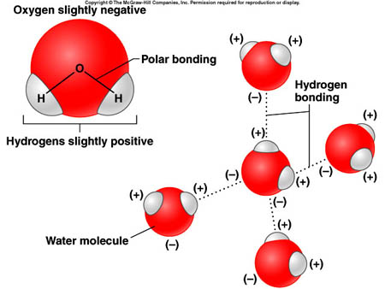The **INTER**-molecular bonds that hold water molecules to each other are the result of the unequal sharing of electrons within a water molecule. Water is considered a **POLAR** molecule because of this unequal sharing; part of water is negatively charged and part of water is positively charged.   
  
 Look at the picture to the right.   
 2) What atoms in water have a more negative charge?

3) What atoms in water have a more positive charge?

4) What kind of bond holds water molecules to each other?

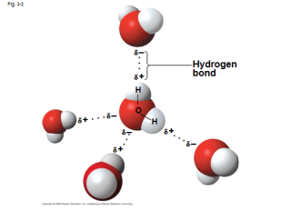

This property of water is known as **COHESION.** The attraction between all these water molecules causes them to clump together. This is why water drops are, in fact, drops! If it wasn't for some of Earth's forces, such as gravity, a drop of water would be ball shaped -- a perfect sphere. Even if it doesn't form a perfect sphere on Earth, we should be happy water is sticky.

* * * * * * * * * * * * * *

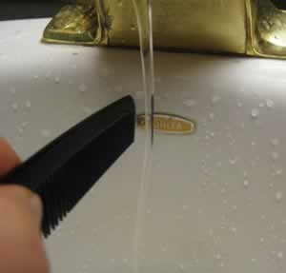**STATION #1  
IF** water molecules are polar and have a slight electric charge , , ,  
 **THEN** they should be attracted to another object with a charge.   
Use the rod and fur provided to **TEST THIS HYPOTHESIS**  
 5) Rub the bar on the fur to build up an electric charge and hold the bar   
 near a stream of running water. What happens?

**STATION #2**The POLAR nature of this molecule allows water to be a “dissolver” of other polar substances. Water is called the "universal solvent" because it dissolves more substances than any other liquid. This means that wherever water goes, either through the ground or through our bodies, it takes along valuable chemicals, minerals, and substances that do not break apart, or dissolve, in water are called **NONPOLAR.**

Take a spoonful of sugar and put it into a beaker. Now fill the beaker halfway with warm water. Gently swirl the mixture for 15-30 seconds.

6) After observing the result do you think sugar is polar or nonpolar? Explain why.

7) Sometimes nonpolar substances are called hydrophobic. Breaking the word down into its root   
 words, what do you think hydrophobic means?

8) The opposite of hydrophobic is hydrophilic. What do you think this term means?

Look at the salad dressing container filled with oil and vinegar. Gently swirl the mixture and allow it to sit for 2 minutes.  
 9) Does the oil dissolve? Does that mean that it is hydrophilic or hydrophobic? Why?

Oil is a type of lipid and all lipids will have the same reaction with water as oil. THINK ABOUT IT:  
 10) Why does it make sense that our cell membranes are made of lipids?

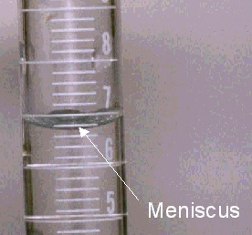* * * * * * * * * * * * *  
**STATION #3**Water molecules are not only attracted to each other, but can also be attracted to substances and surfaces around them. This attraction to other surfaces is called **ADHESION.**

Fill BOTH the graduated cylinders (GLASS & PLASTIC) with water.   
Notice the level of the water at the top of the cylinder.  
11) How is the level of water at the top of each cylinder different?  
  
  
When the water molecules are attracted to the surface and stick to the sides of the cylinder causing it to dip down in the center, this is called a **MENISCUS.** When reading a graduated cylinder, always read the number at the **BOTTOM** of the meniscus.

12) The forces of ADHESION are greatest between water and which surface? PLASTIC GLASS   
 EXPLAIN YOUR ANSWER   
  
 ___________________________________________________________________________

**STATION #4.**

Place the construction paper strip vertically into a beaker filled with 25mL of water. Tape the top of the paper to the top of the beaker. Be sure the end of the construction paper is submerged into the water. Wait 5 minutes.

13) What happens to the water and the paper?

14) The ability of water to **MOVE ALONG THE PAPER** is called **CAPILLARY ACTION**. Tape is   
 sometimes called an adhesive. What does do you think adhesive means?

15. One of water’s properties is adhesion. Thinking about how water moved up the paper. what do you think adhesion means?

16) How is this different than cohesion?

17) If water enters a plant through the roots, how do you think the property **AD**hesion helps the water get to the leaves?

**\* * * * * * * * * * * * \***  **STATION #5**

Fill a beaker with water and try to balance a paperclip on the surface of the water.

18) Why is this paperclip able to sit on the top of the water (Think about the properties of the water we’ve discovered in this inquiry so far)?

19) When the paperclip is floating push on the top of the paperclip. What happens? Why?

20) The floating paperclip is very similar to how animals like the “water strider” can walk on the water. Describe what is happening when insects like this can walk on the water, and explain why humans cannot walk on the water.

**STATION #6**Explore surface tension further. Add enough water to cover the bottom of the glass bowl. Sprinkle enough pepper to cover the surface of the water. Insert a **PLAIN** toothpick into the pepper.   
 21) Describe what happens.

_______________________________________________________________________

Repeat the procedure using **ONE** of the **SPECIAL** toothpicks from the labeled cup.   
 22) Describe what happens.

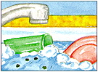 ______________________________________________________________________

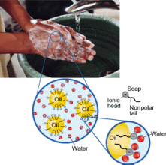In order to clean clothes or wash dirty dishes/hands, surface tension must be reduced so water can spread and wet surfaces. Chemicals that are able to do this effectively are called surface active agents, or surfactants. They are said to make water "wetter." Surfactants perform other important functions in cleaning, such as loosening, emulsifying (dispersing in water) and holding soil in suspension until it can be rinsed away. Surfactants can also provide alkalinity, which is useful in removing acidic soils.

The SPECIAL toothpick has been soaked in dish DETERGENT. Soap works because it has a POLAR end that has an affinity for water and a NON-POLAR end that has an affinity for “greasy dirt”. By attaching to both water and dirt at the same time, the soap can wash away the dirt from your hands and clothes.

23) In order to clean a surface, surface tension must be INCREASED REDUCED? (Circle one)

24) What do you think the surfactant was on the special toothpicks used at STATION #6.   
  
  
  
**\* * * * * * * * * * * * * \***

**STATION #7**

Observe the ice in the water.

25) The hydrogen bonds between water molecules in ice are farther apart than when water is a liquid. How do you think this affects the amount of space water takes up when frozen as opposed to as a liquid?

26) How would life in a lake be affected if ice sank and lakes froze from the bottom up?

27) How do you think this property of water is responsible for all the potholed roads in South Dakota?

**STATION #8**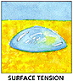 The **POLARITY** of water molecules and the ability to form **HYDROGEN BONDS** results in property called **surface tension**. In the center of a drop of water, each molecule is   
 surrounded and attracted by other water molecules. However, at the surface, those   
 molecules are surrounded by other water molecules only on the water side. A tension is   
 created as the water molecules at the surface are pulled into the body of the water.   
  
Surface tension causes water to bead up on surfaces, which slows wetting of the surface. You can see surface tension at work by placing a drop of water onto a penny. The drop will hold its shape and round up into a dome.

Add one of drop water at a time to the penny until the water falls over the edge. Be sure mark down how many drops took before the water fell. Dry off the penny, and then try again. You should test this 3 times.

Repeat the procedure using **RUBBING ALCOHOL** instead of PLAIN water. Complete the data table.

|  |  |  |
| --- | --- | --- |
| Trials | Water Drops | Alcohol Drops |
| 1 |  |  |
| 2 |  |  |
| 3 |  |  |
| Average |  |  |

28. Draw a picture of what the water looks like on the penny just before it falls over the edge.

29. EXPLAIN the relationship between cohesion and surface tension.

30) Which liquid (alcohol or water) do you think has the highest surface tension?   
 Provide evidence to support your conclusion.

31) The property of water demonstrated in the penny activities is called cohesion. We know that

adhesion means that water molecule stick to other things. What do you cohesion could mean?

32) How are hydrogen bonds and cohesion related?

**STATION #9**

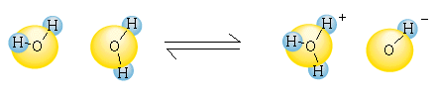Most chemical reactions in organisms involved solutes dissolved in water. To understand chemical reactions, we need to know how many atoms and molecules are involved. Measuring small numbers of molecules is not practical. We usually measure molecules in units called moles. 1 MOLE (mol) represents an exact number of molecules

(AVAGADRO’s NUMBER = 6.02 X1023).

Occasionally a hydrogen atom participating in a HYDROGEN BOND between two water molecules shifts from one molecule to another forming an H3O+ ion called a HYDRONIUM ION and an OH- ion (HYDROXIDE ION).

In PURE water the concentration of each is 1 X 10-7 M. That means there is 1/10,000,000th of a mole of hydronium ions per liter of pure water and an equal number of hydroxide ions. In any aqueous solution at 25° C, the PRODUCT of the H+ and OH- concentrations is constant at 10 -14 . So the exponents for the hydrogen concentration [H+] and the hydroxide concentration [OH-] always add up to 14. [H+] [OH-] = 10 -14

Example: If a solution has a H+ concentration of 1 X 10 -2 the OH- concentration would equal 10 -12.

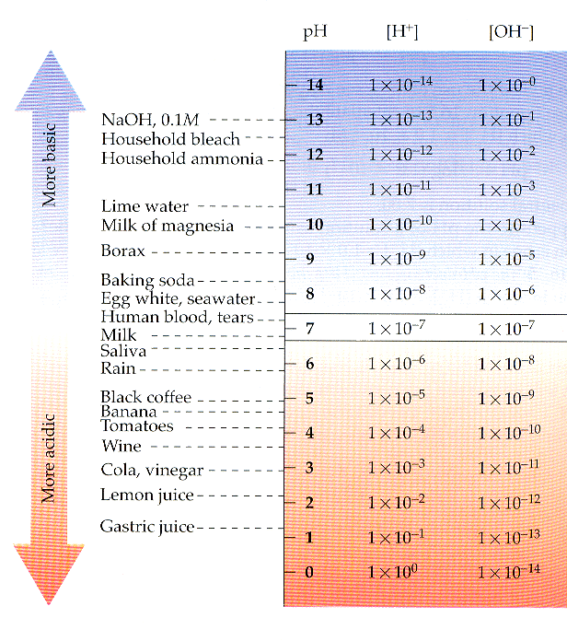

Concentrations of hydronium and hydroxide ions are EQUAL in PURE WATER, but adding certain kinds of solutes called acids and bases, disrupts this balance. Biologists use something called a pH scale to describe how acidic or basic a solution is. AN ACID is a substance with a pH LESS THAN 7 that increases the H+ concentration of a solution. A substance with a pH GREATER THAN 7 reduces the H+ ion concentration and is called a BASE. NEUTRAL solutions have a pH = 7.

Each pH unit represents a 10 fold difference in H+ and OH- concentrations. A solution with a pH of 3 is NOT THREE TIMES as acidic as a solution with a pH of 6, but a 1000 TIMES more acidic.

Use the pH paper provided to test the pH of the liquids listed below:

|  |  |  |
| --- | --- | --- |
| SUBSTANCE | pH | Is it an acid, base, or neutral? |
| Apple juice |  |  |
| Water |  |  |
| Pop |  |  |
| Vinegar |  |  |
| Maalox |  |  |
| Baking soda |  |  |
| Glass cleaner (Windex) |  |  |
| Rubbing alcohol |  |  |

33) Which is more acidic, pop or rubbing alcohol? ____________________

34) Which is more basic, Ammonia cleaner or apple juice? ________________________

35) Which contains more hydrogen ions, Windex or Maalox? __________________

36) Pop is _______ times ___________ acidic than Vinegar.

? more less

37) Baking soda is _________ times ___________ basic than bottled water.  
 ? more less

38) The pH for Pop = ______   
  
39) What is the concentration of H+ ions in pop? _________________

40) What is the concentration of OH- ions in pop? ________

41) Our stomachs produce hydrochloric acid to kill germs and help break down nutrients in the food we eat. Too much stomach acid can cause an upset stomach. Use what you learned about acids and bases at this station to explain why people take antacids (like Maalox, Tums, or Rolaids) when they get heartburn.   
(Hint: The chemical in Maalox is magnesium HYDROXIDE)

______________________________________________________________________________

STATION 10:   
  
SCIENCE PRACTICE 1:  
Students can use representations and models to communicate scientific phenomena and solve scientific problems.

Use the “cups of water” to MODEL some of the properties of water you have learned about.  
Add pictures to your BILL.

Lab by Kelly Riedell <http://kr021.k12.sd.us> Modified from:   
http://sps.k12.ar.us/massengale/properties_of_water.htm AND D2L Learning Power AP BIOLOGY