 |  | POLAR  ACIDIC, HYDROPHILIC  IMPORTANT IN ENERGY TRANSFER  Found in:  NUCLEOTIDES, ATP, PHOSPHOLIPIDS, | 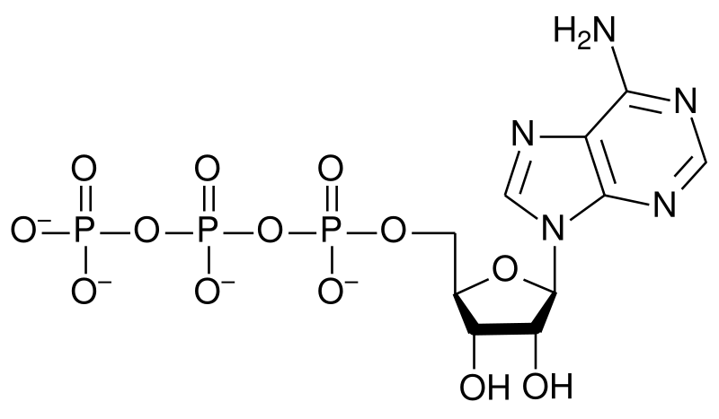  ATP
 |  | POLAR HYDROPHILIC  WEAK ACID  Found in:  CARBOXYLIC ACIDS  FATTY ACIDS,  AMINO ACIDS | 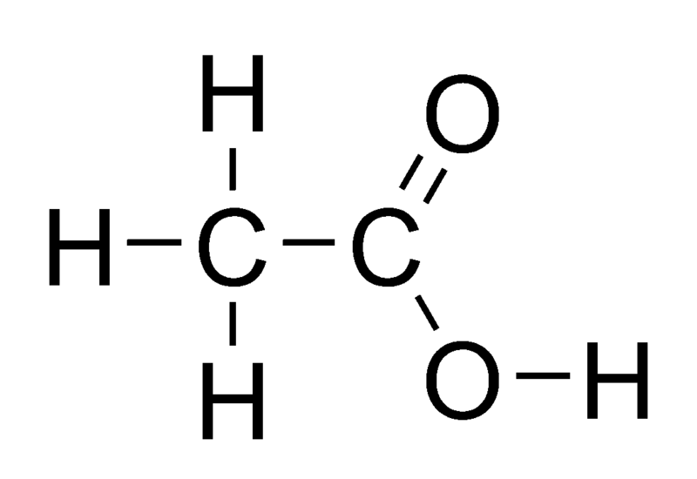  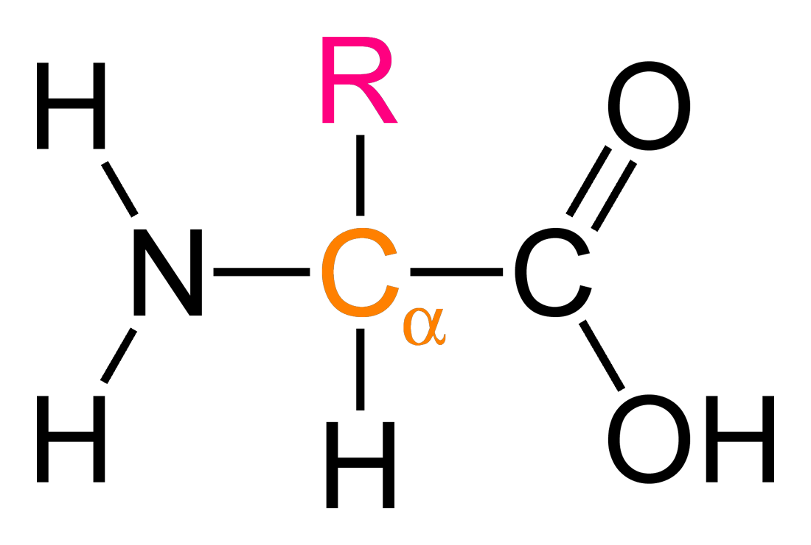 Acetic acid Amino acids
 |  | FORM DISULFIDE BRIDGES  HELP STABILIZE TERTIARY  STRUCTURE OF PROTEINS | 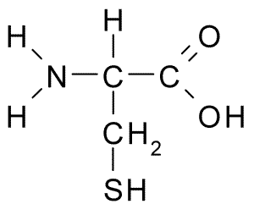 Cysteine
 |  | POLAR  HYDROPHILIC  Found in :  SUGARS/ ALCOHOLS,  FEW AMINO ACIDS | 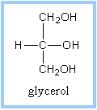  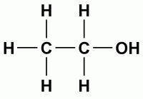 Ethanol Glycerol
C=O IN MIDDLE OF
CARBON CHAIN
POLAR
HYDROPHILIC
C = O AT END OF
CARBON CHAIN
POLAR
HYDROPHILIC
 |  | NON-POLAR  HYDROPHOBIC  METHYLATION OF DNA  TURNS “TURNS GENES OFF” | 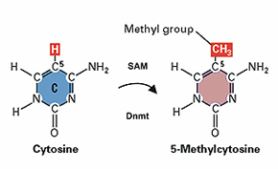
 |  | POLAR  WEAK BASE  HYDROPHILIC  Found in:  AMINO ACIDS | 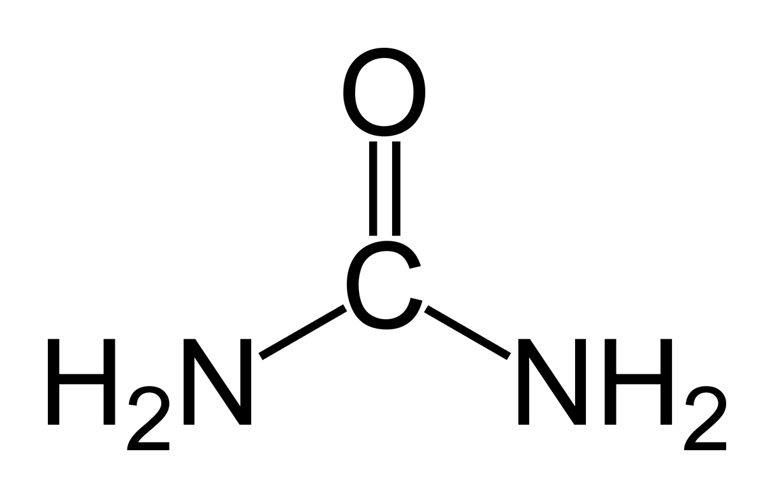  Amino acid Urea
· Each functional group behaves consistently from one organic molecule to another.
· Number and arrangement of functional groups help give molecules their unique properties

