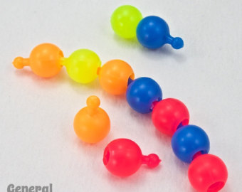
MONOMERS/POLYMERS GAME
From: Mary Garrison Neimeyer
Use pop beads. Run the cards below on different colored cardstock.
The objective is to be the first to build a chain of five "amino acids".
Each student starts with one bead and one water.
WHEN IT IS YOUR TURN:
You can make as many plays as you can with cards you have.
EX: Use a hydrolysis card and water card to break another player’s polymer and take the removed monomer. Then build your polymer by using a dehydration card to connect two monomers and you get a water card. When you are done making plays, roll the die. Once you roll the die and take a card or bead, your turn is over (you can't play the ones you just got, you'd need to wait until your next turn).
ROLL THE DIE:
If you roll an odd number, you get another monomer (But can't connect them until your next turn.)
If you roll an even number, choose a dehydration synthesis card, a hydrolysis card, OR a water card.

H₂O

H₂O

H₂O

H₂O

H₂O

H₂O
H₂O
H₂O

H₂O

H₂O

H₂O

H₂O

H₂O
H₂O
H₂O

H₂O

H₂O

H₂O

H₂O

H₂O
H₂O

HYDROLYSIS

HYDROLYSIS

HYDROLYSIS

HYDROLYSIS

HYDROLYSIS

HYDROLYSIS

HYDROLYSIS

HYDROLYSIS

HYDROLYSIS

HYDROLYSIS

HYDROLYSIS

HYDROLYSIS

DEHYDRATION
SYNTHESIS

DEHYDRATION
SYNTHESIS

DEHYDRATION
SYNTHESIS

DEHYDRATION
SYNTHESIS

DEHYDRATION
SYNTHESIS

DEHYDRATION
SYNTHESIS

DEHYDRATION
SYNTHESIS

DEHYDRATION
SYNTHESIS

DEHYDRATION
SYNTHESIS

DEHYDRATION
SYNTHESIS

DEHYDRATION
SYNTHESIS

DEHYDRATION
SYNTHESIS

