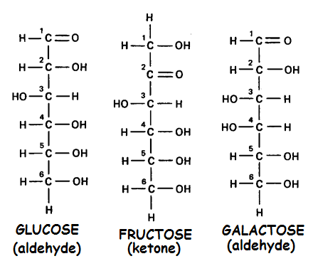
WHAT SHOULD I KNOW - CARBOHYDRATES
= sugars and their polymers
FUNCTIONS:
Energetic fuel source/storage
Structural building blocks
MONOSACCHARIDES:
• C, H, O in 1:2:1 ratio (CH₂O )_{n}
• 3-7 carbons
• Pentoses (5C) & hexoses (6C) most common;
but glycerol (3C) also important
• OH attached to each carbon except one
• Major nutrient for cells
• names often end with -ose.
• ALDEHYDES (=O at end) OR KETONES (=O in middle)
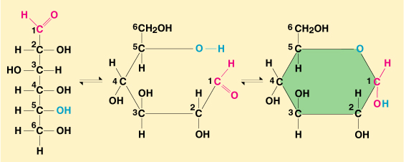
Glucose & fructose = structural isomers
Glucose & galactose = stereoisomers
All = (C₆H₁₂O₆)
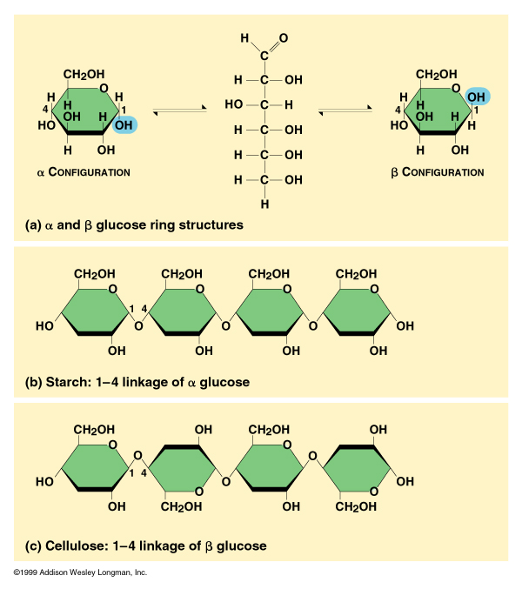
Straight chains form rings in water (Cyclization)
C₁ attaches to oxygen on C₅
Ketose form makes a 5-membered ring
Aldose form makes a 6-membered ring
Sugar rings = planar (-H and –OH groups below and above the plane of the ring)
2 isomers of glucose ring differ in OH group on C₁
OH below ring= α glucose
OH above ring= β glucose
In solution, glucose changes
back and forth between forms

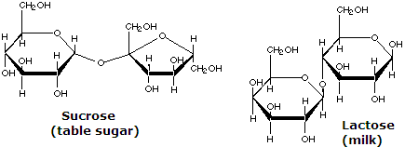
DISACCHARIDES:
2 monosaccharides joined together by a condensation (dehydration synthesis) reaction
= GLYCOSIDIC linkage (covalent)
• Sucrose = glucose + fructose
• Maltose = glucose + glucose
• Lactose = glucose + galactose
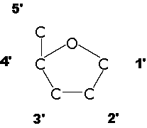
OLIGOSACCHARIDES -“FEW” 2-10 sugars EX: glycoproteins
POLYSACCHARIDES
• long polymers of monosaccharides (100’s-1000’s)
• formed by condensation dehydration synthesis) reactions
• Numbers identify the linked carbons and form of glucose
* Bonding between carbohydrate subunits determines their relative orientation in the
carbohydrate, which determines the secondary structure of the carbohydrate.

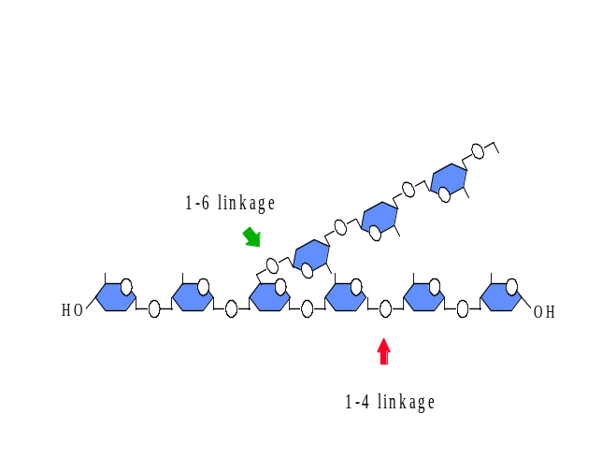
STARCH - energy storage in plants (EX: potatoes)
• α-glucose; 1-4 linkage
• forms spirals (α−helix) stabilized by hydrogen bonds
TWO FORMS OF STARCH
  1) AMYLOSE
• straight unbranched glucose chain
• MW= thousands to hundred thousands
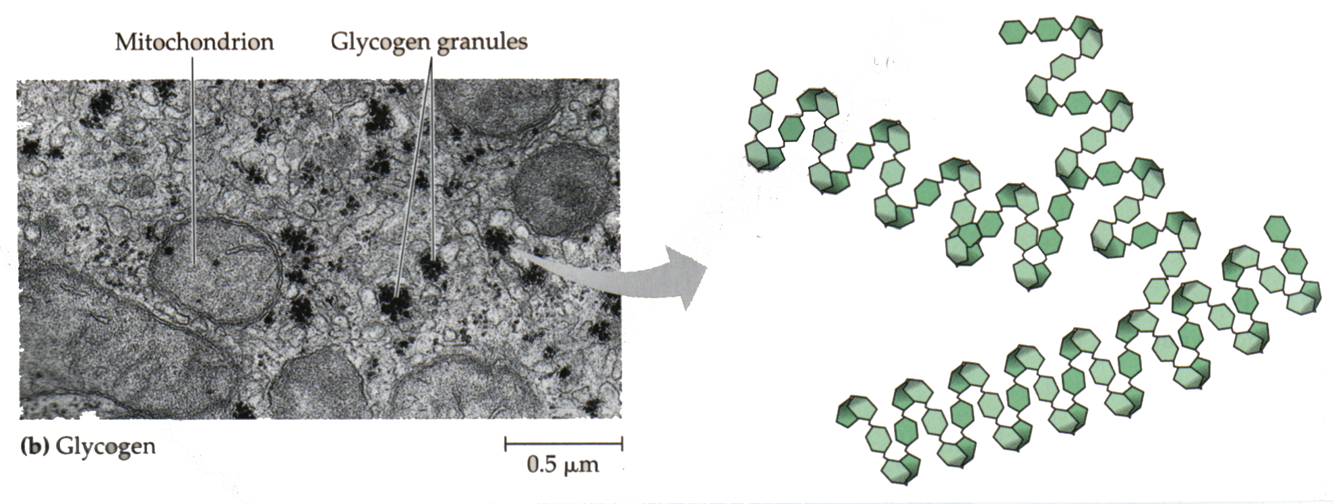
2) AMYLOPECTIN
• many linked short amylose chains
• α 1-4 links with α 1-6 linked branch points
• similar to glycogen but less branched
• MOST STARCH = 10-30% amylose/70-90% amylopectin
• stored as granules in plastids (chloroplasts and amyloplasts)
GLYCOGEN – Energy storage in ANIMALS
• α-glucose; 1-4 linkage
• α−helix stabilized by hydrogen bonds
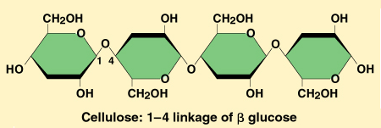
• structure similar to amylopectin
but more branched
• MW = hundreds of thousands
• Stored as cytoplasmic granules in liver and muscle
Liver controls blood sugar level
low blood sugar between meals (glycogen→ glucose) (GLUCAGON)
high blood sugar after eating (glucose →glycogen) (INSULIN)
Muscle tissue- source of ATP for muscle contraction
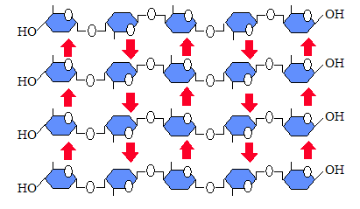
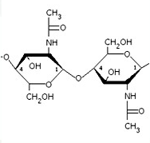
CELLULOSE
• major component in plant cell walls (EX: wood, cotton)
• β-glucose; 1-4 linkages
• straight unbranched chains
• every other glucose upside down
• arrangement allows HYDROGEN BONDING between chains
• Form MICROFIBRILS that give cellulose its structural rigidity
• Dietary fiber in human diet
• Can’t be digested by animals without the help of symbiotic microorganisms
• Don’t have enzymes to break β linkages
CHITIN:
• β 1,4 linkages
• N-acetyl glucosamine (NAG) subunits (sugar + nitrogen group)
• straight unbranched chains
• every other glucose upside down
• Support and protection EX: Cell walls in fungi; exoskeletons in arthropods

