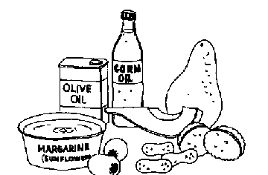
WHAT SHOULD I KNOW - LIPIDS – Kelly Riedell
Many NONPOLAR C—H bonds/long hydrocarbon skeleton
HYDROPHOBIC - insoluble in water (dissolve in nonpolar solvents)
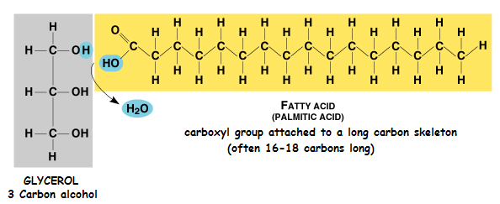
FATS = TRIACYLGLYCEROL = TRIGLYCERIDE
• store large amounts of energy
• NOT polymers but assembled from smaller molecules
by dehydration synthesis reactions
• Adipose tissue is made primarily of tri-acylglycerols (fat)
• FAT = 1 glycerol + 3 fatty acids
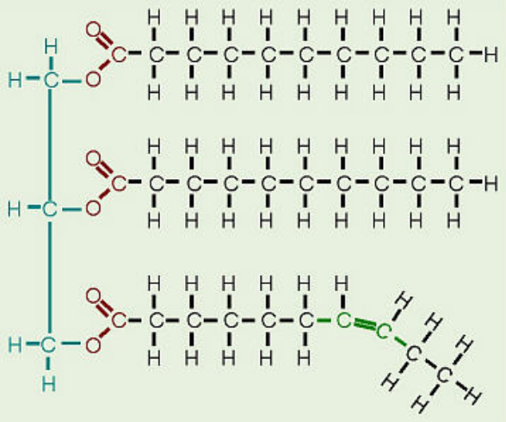
FATTY ACID:
Hydrocarbon chain of 10-50 carbons in length
Fatty acids vary in length (number of carbons)
and in the number and locations of double bonds
Three fatty acids can be the same or different
SATURATED - no double bonds in carbon chains
Form straight chains
Most animal fats are saturated (butter, lard)
Solid at room temperature
UNSATURATED –one/more double bonds in tails
have kinks wherever there is a double bond
prevents tight packing of molecules so not solid
Plant and fish fats = liquid at room temperature
= oils (olive oil, cod liver oil)
POLYUNSATURATED = many double bonds
“HYDROGENATED VEGETABLE OILS” on food labels
means unsaturated fats have been synthetically converted to saturated fats by adding hydrogen
also makes unsaturated fats with trans double bonds (trans fats)
• Peanut butter and margarine are hydrogenated to prevent lipids from separating out as oil
• Both saturated fats & trans-fats in diet contribute to cardiovascular disease (atherosclerosis) through plaque deposits
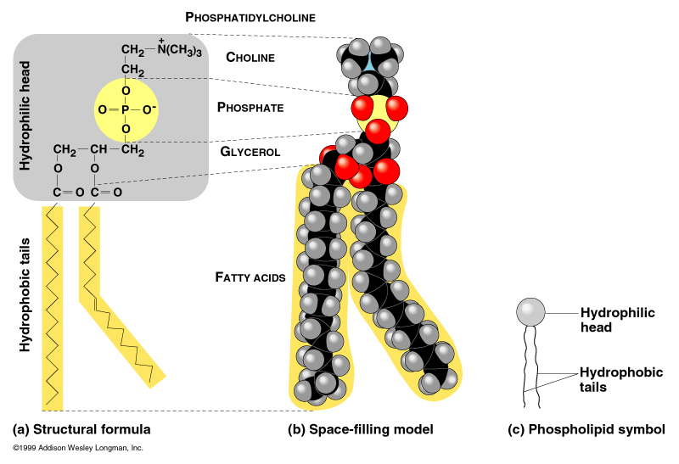
FUNCTION (fats, oils)
ENERGY STORAGE
• Compact energy storage; energy stored in C-H bonds; about 3X the energy of carbohydrates
• Humans and other mammals store fats as long-term energy reserves in adipose cells
• Adipose tissue also functions to cushion vital organs, such as the kidneys
• A layer of fat can also function as insulation
(especially in whales, seals, and most other marine mammals)
PHOSPHOLIPIDS
FAT with one fatty acid replaced by a phosphate group
• The phosphate group carries a negative charge
• Additional sugars, amines, or other groups may be attached to
the phosphate group to form a variety of phospholipids
• Heads are often zwitterions: they have both + and -charge.
AMPHIPATHIC –
• Both phobic AND philic parts
• polar head
• non-polar tails

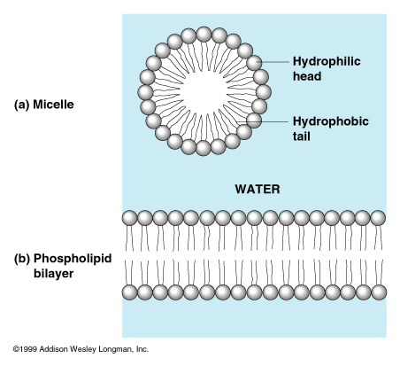
ADDING PHOSPHOLIPIDS TO WATER
• self-assemble into MICELLES
• sphere with hydrophobic tails toward interior
• polar/philic heads toward outside

FUNCTION OF PHOSPHOLIPIDS
• Major component in cell membranes
• Arranged as a bilayer
• Hydrophilic heads toward the outside of the bilayer
in contact with the aqueous solution
• Hydrophobic tails point toward the interior of the bilayer away
from aqueous solution
• Forms a barrier between the cell and the external environment.
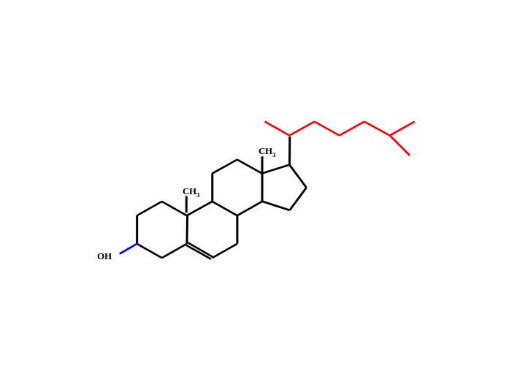
STEROIDS
• Lipids with a carbon skeleton with four fused rings
and a small ACYL (carbon chain) tail
• Insoluble in water (nonpolar)
• Different steroids vary in the functional groups attached to the rings
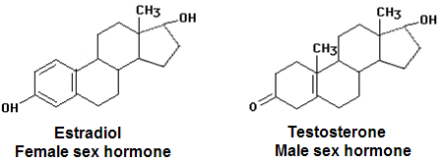

CHOLESTEROL
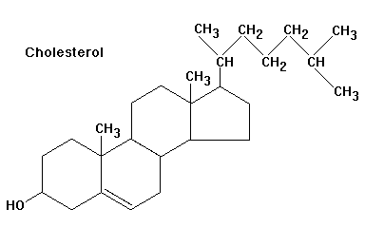
• Important precursor for all other steroids
Hormones: cortisone, cortisol, testosterone, estradiol, estrogen
• Cholesterol also found in animal cell membranes
• Synthesized in the liver
• Obtained in the diet (meat, cheese,eggs)
• Essential in animals, but high levels of cholesterol in the blood
may contribute to cardiovascular disease (atherosclerosis)
• Negative effect of saturated fats and trans-fats due to their
impact on cholesterol levels
- LDL's (low density lipoproteins)
'bad' cholesterol (deposits in coronary blood vessels)

- HDL's (high density lipoproteins)
'good' cholesterol

WAXES-protective, waterproof coatings:
• fur, feathers, and skin
• leaves/fruits of plants
• insect exoskeletons

