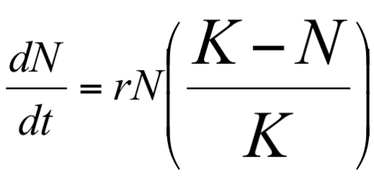
1. What do r, N, and K stand for in this equation?

2. This equation is used for problems involving populations showing _____________ growth.
exponential logistic

3. Kentwood, Michigan had a population of 49,000 in the year 2013. The infrastructure of the city allows for a carrying capacity of 60,000 people. r_{max} = 0.9 for Kentwood
a. Is the current population above or below the carrying
capacity?
b. Will the population increase or decrease next year?

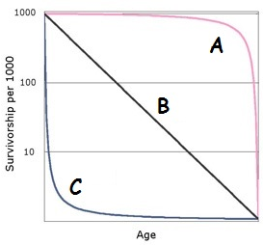
4. a. Which of the graphs shown here represents
a Type III survivor curve?

b. Give 3 characteristics of this kind of population.
c. ___ selected organisms show this kind of curve.
d. Give an example of an organism like this.

5. In the early 1960's people living near Minimata Bay, Japan became ill with a crippling neurological disease, which was later discovered to be caused by mercury being dumped in the ecosystem there. The toxin passed along the food chain and people became ill from eating fish caught in the bay. This is an example of __________________

6. Which of the following interspecific interaction is
NOT an example of a +/- interaction?
A. pathogen and host
B. carnivore and prey
C . ectoparasite and host
D. herbivore and plant
E. honeybee and flower

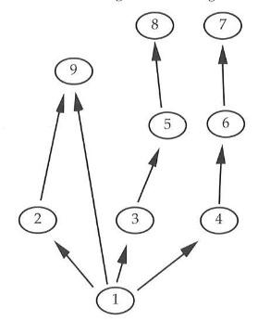
7. #7 in this food web is a
________________.
A. primary producer
B. quaternary consumer
C. tertiary consumer
D. primary consumer

8.
a. #2, #3, and #4 in this food web are ____ consumers.
1° 2° 3° 4°
b. What is another name for organisms like these that
feed at this trophic level?
9. Many species have bright and conspicuous colors which indicate these individuals are dangerous or distasteful. Predators learn to avoid these organisms after an initial experience with them; for example: Black and white skunk stripes, yellow and black stripes on stinging wasps, and red/black polka dots on foul tasting ladybeetles. This is an example of
A. Mϋllerian mimicry
B. Batesian mimicry
C. cryptic coloration
D. aposematic coloration

10. Which of the following is the direct effect of the thinning of the ozone layer?
A. increase in cataracts and skin cancer
B. acid precipitation
C. global warming
D. greenhouse effect
E. increase in species diversity

11. Tell how primary and secondary succession are different.

12. Explain the symbiotic relationship that is found between legumes and nitrogen fixing bacteria.

13.
a. Explain the relationship between predator and prey populations as shown in this graph.
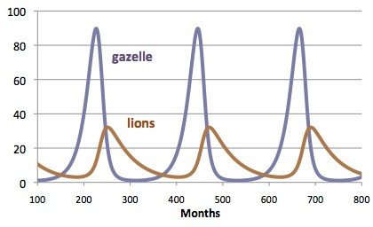

b. Why are lion numbers always lower than gazelle numbers?
14. Give THREE (3) examples of INTRASPECIES information communication in an ecosystem.

15. The dominant species in a community is one that
A. has the largest biomass
B . has the greatest number of genes per individual
C. is at the top of the food chain
D. eats all other members in the community
E. produces the most offspring in each mating

16.
a. 78% of our atmosphere is nitrogen gas (N₂), however most organisms, including humans, lack the enzymes to break down nitrogen gas and use it. How do humans get the nitrogen they need to build biomolecules?
b. Give 2 examples of molecules that contain nitrogen in your body.

c. Give one example of a biomolecule that doesn’t contain
nitrogen.

17.
a. If 2000 kcal of energy is available in grass, approximately how much energy from the grass would be available to the cow that eats the grass?
b. To the human that eats the cow?
c. What percent of the energy originally produced by the grass is consumed by humans?

18.
a. Explain why lakes in South Dakota turn green during the summers.
b. This process is called _________________.
c. What happens to organisms at the bottom of the lake below the green layer?

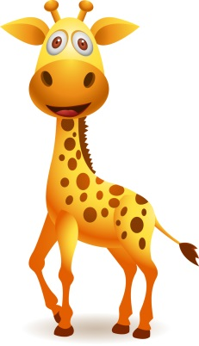
19. Suppose a giraffe must eat 10 kg of leaves each day to survive. The trees in an area can provide 100 kg of leaves a day and still remain healthy .
a. The maximum population size that the environment can sustain indefinitely, given the food, habitat, water, and other necessities available is called the ___________________.
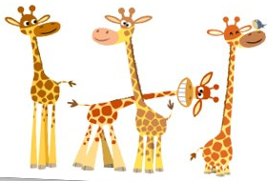
b. Show what would happen to this graph if the number of trees growing in the area was increased by an environmental group trying to improve giraffe habitat.

20. Put the following in order from least to most INCLUSIVE.
organism biosphere biome community
population ecosystem

21. Name the biogeochemical cycle in which photosynthesis and cellular respiration are a part.

22. On the African savannah, large herbivores such as elephant and giraffe would be found in which trophic level?

23. Which of the following is NOT a greenhouse gas?
CO₂ O₂ methane water vapor

24. Which of the following is an example of a community?
A. all the geese in the world
B. All the animals in North America
C. All the organisms living within a lake
D. All the grass in a meadow
25. An organism that feeds only on heterotrophs is a(n) ________________
A. primary consumer
B. autotroph
C. herbivore
D. carnivore
E. omnivore

26. After a forest fire, the first signs of ecological recovery occur with the appearance of
A. trees
B. lichens
C. large herbivores
D. grasses and small shrubs
E. predators

27. The evaporation of water off the surface of plant leaves is called ________________.

28. When a lima bean plant is attacked by caterpillars it releases a fragrance which warns its nearby bean neighbors of the impending danger. Together all the lima bean plants start producing a sweet nectar which attracts wasps. The wasps lay their eggs inside the caterpillars. The wasp larvae feast on the caterpillars from the inside out. Identify TWO types of symbiosis in this story.

29. Explain how the movement of matter and energy in ecosystems is different.

30. Give THREE examples of ABIOTIC factors in an ecosystem.

Remember when we went to the lake on our field trip. For the lab you collected water samples and placed screens on the bottles and placed them under light.
PRIMARY PRODUCTIVITY =
the rate at which plants and other photosynthetic organisms produce organic compounds in an ecosystem.
31. There are two aspects of primary productivity:
GROSS PRODUCTIVITY and NET PRODUCTIVITY
HOW ARE THESE DIFFERENT?

Imagine a biology class used two aquatic cultures as described below for the experiment with screens that reduce light. They measured dissolved oxygen initially, and then after 24 hours. The contents of the bottles are shown below.
Culture A | Culture B
Little phytoplankton | Rich in phytoplankton
Rich in zooplankton | Rich in zooplankton
Low initial dissolved oxygen | High initial dissolved oxygen

32. What results would you predict for this experiment? EXPLAIN WHY.
A. The net productivity in culture A will be much higher than in that in culture B.
B. Culture B will have both higher gross productivity and higher net productivity
than culture A.
C. The net productivity for culture A will be negative at greater light intensity than
that for culture B.
D. Cultures A and B will show similar results because of the comparable quantities
of zooplankton
E. Net productivity in culture B will exceed gross productivity in high light
intensity.

33. In the whole plant transpiration experiment you did in class, which condition would result in the greatest % mass change: light or dark? EXPLAIN WHY

34. How are niche and habitat different?

35. A _______ species (such as a sea otter, a wolf, or a seastar) plays a critical role in maintaining the structure of an ecological community, and helps to determine the types and numbers of various other species in the community.
36. A lake that has been depleted of walleye is stocked with a population of 1000 walleye fish in 2013. The birth rate= 0.73 walleye/year. The death rate = 0.32
dN = (b-d) N
dt

a. What is r ?
b. Predict the population in 2014, if the growth rate stays the same?

