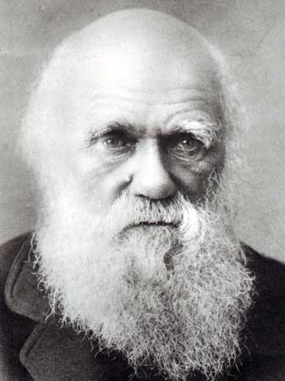
Darwin’s Theory
Theodosius Dobzhansky~ "Nothing in Biology Makes Sense Except in the Light of Evolution"
EVOLUTION = a change over time in the genetic composition of a population
= change in allele frequency
•also refers to the gradual appearance of all biological diversity

IDEAS THAT INFLUENCED DARWIN:
ARISTOTLE- Anti-evolutionist- saw species as fixed (unchanging)
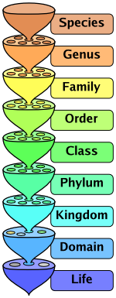
• all living forms could be arranged on a ladder of increasing complexity (scala naturae)
CAROLUS LINNAEUS
• Taxonomy =science of grouping and naming organisms
• Nested hierarchy classified organisms using similarities/differences in characteristics
• Binomial nomenclature (Genus species naming ) D,K, P, C, O, F, G, S
• Anti-evolutionist – saw species as fixed

GEORGE CUVIER- Father of Paleontology - Anti-evolutionist
•CATASTROPHISM-mass extinctions/repopulations explain changes in fossil record
•Extinction possible
JAMES HUTTON-
• Earth is MILLIONS NOT THOUSANDS of years old
• GRADUALISM = profound change is cumulative result of slow but continuous processes

CHARLES LYELL- Geologist
• UNIFORMITARIANISM (incorporated Hutton’s gradualism)-
• Geological processes that have shaped Earth over millions of years are still happening
• Darwin read Lyell’s book Principles of Geology on the Beagle

If earth can change, why can’t slow processes over long periods of time also produce changes in living organisms?
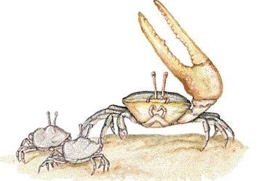
JEAN BAPTISTE LAMARCK - One of first to suggest “life has changed over time”
• published a theory of evolution before Darwin (1809) to explain fossil record
“Use and disuse”
• body parts that get used become larger and stronger; Unused parts become smaller
“Inheritance of acquired characteristics”
• modifications acquired during the life of an organism could be passed to offspring
Giraffes stretch for food → Their necks elongate → Longer necks are passed to offspring
NO EVIDENCE that acquired traits are inherited without changing DNA, but. . . what about epigenetics ?
• Appears some “acquired traits” may cause changes in genes
EX: Remember video: grandparents diet impacting grandchildren’s health
THOMAS MALTHUS
• Human suffering (disease, famine, homelessness, war) = consequence of overpopulation
If resources are scarce, some organisms will not survive

WHAT DARWIN DIDN’T KNOW
• MENDEL’s genetic experiments were published AFTER Origin of Species was published
• VARIATION in population due to MUTATIONS in GENES and GENETIC RECOMBINATION
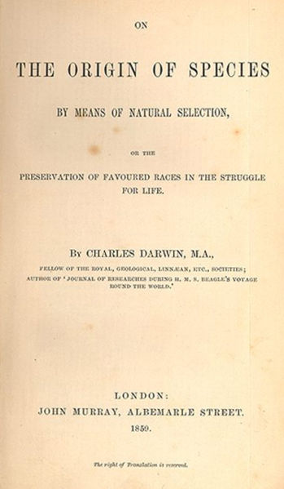
DARWIN’S THEORY = Revolutionary;
• accepted view at time = living things were created once and were unchanging
• Returned from voyage on Beagle (1831-1836) and spent 20+ years studying/writing;
• Didn’t publish his ideas because he knew they were radical
• Reluctantly published when Alfred Russel Wallace wrote essay with same ideas
• On the Origin of Species by Means of Natural Selection- published 1859
• At first rejected/ridiculed;
• Evidence for evolution has been/continues to be overwhelming
• Evolution is “universal theory linking all biological concepts”
DARWIN’S THEORY:
NATURAL VARIATION- “Each individual is unique”
ADAPTATION-characteristic that helps an organism be more suited to its environment/survive and reproduce OVERPRODUCTION of offspring results in more offspring than can survive
STRUGGLE FOR EXISTANCE-Organisms must compete for food, space, mates
NATURAL SELECTION also called “SURVIVAL OF FITTEST”
- Individuals that are best adapted to their environment will survive and reproduce
- Inherited favorable characteristics become more common from one generation to the next
FITNESS = measure of organism's reproductive success (greater number of offspring that carry your genes)
DESCENT WITH MODIFICATION-organisms have descended from a common ancestor;
EXTINCTION occurs when previous adaptations are no longer suitable to a changed environment

* * * * IMPORTANT TO REMEMBER>>> POPULATIONS evolve NOT INDIVIDUALS * * * *

MYTHS:
Evolution is like a climb up a ladder of progress; organisms are always “getting better”
“Best” depends on environment; A trait that is beneficial in one environment may be detrimental in another
Evolution is a “theory” so it’s a “hunch” or “opinion”
THEORY = broad explanation that can be used to make predictions and generate new hypotheses
and is supported by large body of evidence
Evolution gives organisms the traits they “need“
Organisms don’t “get what they need” from natural selection
Traits some individual organisms already have are selected for
EVIDENCE FOR DARWIN’S THEORY
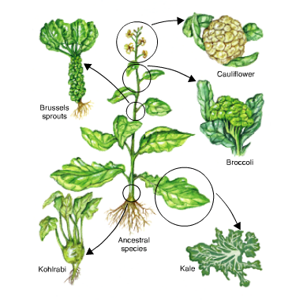
ARTIFICIAL SELECTION- “If we can pick & change organisms’ traits, why can’t nature?”
Nature provides differences; humans choose useful traits
Ex: broccoli/ cauliflower share same ancestors;
dogs; increased milk production in modern cows; Butterball turkeys

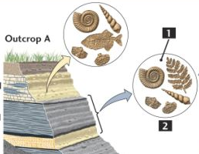
FOSSILS-
Fossils at the lowest level = oldest; younger layers as you move upward
FOSSIL RECORD SHOWS SEQUENTIAL CHANGES
~ a succession of organisms have populated Earth throughout time.
More than 98% of organisms that once lived are now extinct
prokaryotes appear before eukaryotes;
single celled appear before multicellular;
invertebrates appear before vertebrates;
fish < amphibians < reptiles < birds < mammals
Cambrian Explosion- around 530 million years ago
rapid appearance of most major groups of complex animals
Similar rapid increase in species of land plants 400 million years ago

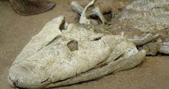
TRANSITIONAL FOSSILS = “in betweens”
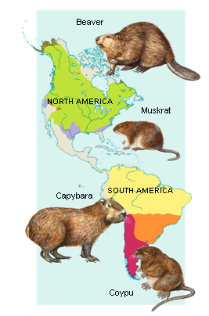
–organisms with intermediate characteristics
- show relatedness of species
Ex: Tik taalik = has both fish/amphibian characteristics
Archeopteryx = shares bird/reptile characteristics

BIOGEOGRAPHY-study of the distribution of organisms
• Related organisms are found living close to one another
DIVERGENT evolution (=ADAPTIVE RADIATION)
- closely related species become different as move into new environments
EX: Galapagos finches/tortoises

CONVERGENT evolution- different organisms that share similar habitats become more alike
Ex: whale and sharks have similar body shape
COMPARATIVE ANATOMY-
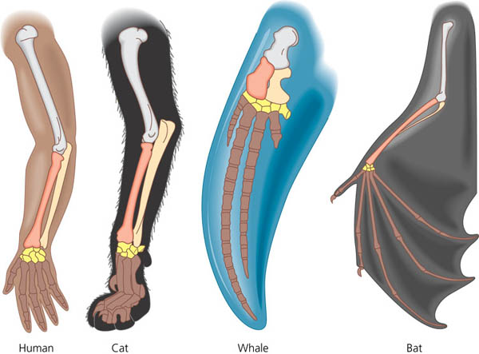
HOMOLOGOUS STRUCTURES- evidence of divergent evolution (shared common ancestor)
• body parts with similar structure but not necessarily same function
• share same embryonic origin
Ex: bird wind, human arm, whale flipper

ANALOGOUS STRUCTURES- Evidence of convergent evolution
• Different structures with similar function in different species
EX bird wing and butterfly wing
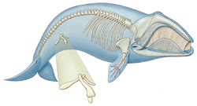
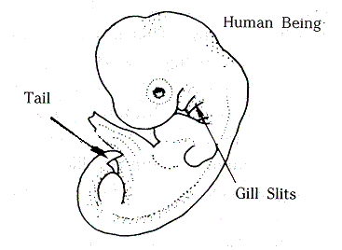
VESTIGIAL ORGANS- evidence of divergent evolution
• remnants of structures that had functions in ancestors
but are no longer essential/function changed
Ex: whale hipbones, human tail/cecum; skink legs

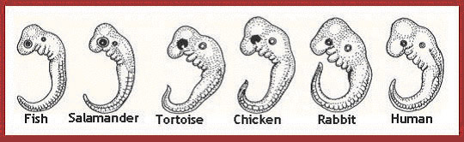
EMBRYOLOGY- similar developmental patterns seen in all vertebrates
Ex: zygote→ blastula → gastrula;
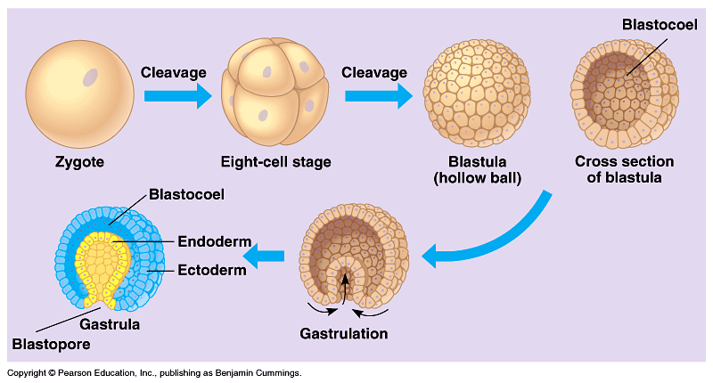
tail/pharyngeal pouches in humans

MOLECULAR BIOLOGY-
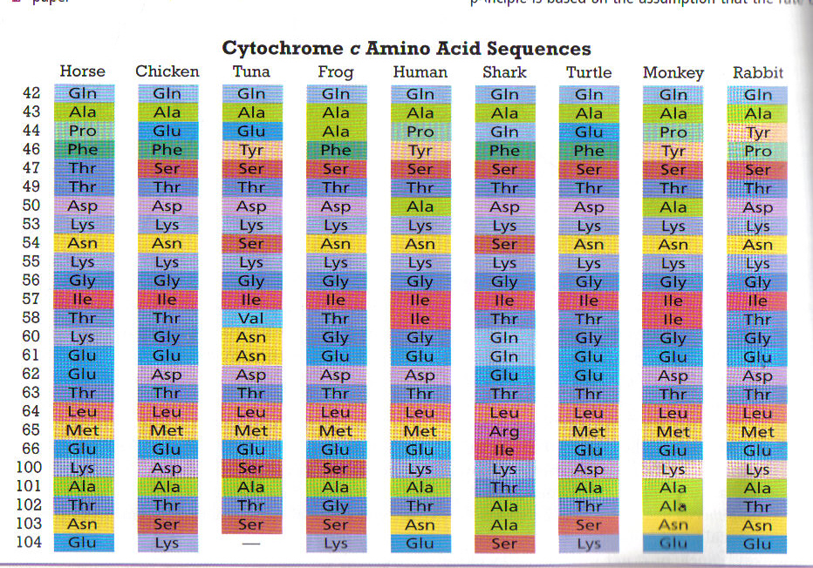
UNIVERSAL genetic code/cell machinery in all living things
AMINO ACID/DNA COMPARISON
• Closely related species have more similarities
EX: human/chimp cytochrome C = identical
• More differences in more distantly related species
• Can track shared mutations over time
Ex: hemoglobin; cytochrome C, pseudogenes)
• Essential genes are conserved (little variation) between different organisms
EX: HOX GENES- control embryonic development
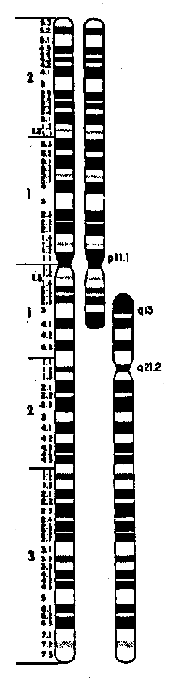
HUMAN CHROMOSOME #2 -Humans have one large chromosome (#2) chimps don’t have
• Chimps have two smaller chromosomes humans don’t have
• Banding pattern matches;
• Human chromosome #2 has telomeres in middle; and extra inactive centromere
• Suggests it formed by fusion of two smaller chimp chromosomes

VESTIGIAL GENES (PSEUDOGENES & ENDOGENOUS RETROVIRUSES)
• Remnants of shared mutations found in related organisms
• Genetic code similar to functional genes but have lost function due to mutations
• Many intron sequences = nonfunctional pseudogenes
Ex: gene mutations for vitamin C production in primates; smell receptors in humans
• Remnants of retrovirus infections
SEE IT HAPPEN
• Emergence of new viruses diseases (HIV; Ebola; Bird flu, H1N1);
• Drug resistant HIV virus; Antibiotic resistant bacteria (MERSA); Pesticide resistant insects

• Peppered Moth data-
• population became darker as industrial pollution increased in England;
• lighter when anti-pollution laws went into effect

• Endler and Reznick Guppy experiments (1980’s) - changes in populations happened within 11 years
-Age and size at sexual maturity change depending on predators
Small killifish eat juvenile guppies; Large pike-cichlids eat adult guppies
Guppies in populations with pike-cichlids begin reproducing at a younger age and are smaller at maturity
than guppies in populations preyed on by killifish
Moving guppies to pools with different predators changes size and age of maturity in population
Changes are heritable

