1. During the light dependent reactions where do H⁺ ions accumulate?

2. What are the TWO sources of these H⁺ ions?

3. During photosynthesis, which molecule
acts as the final electron acceptor at the end of the electron transport chain?

4. Write the overall equation for cellular respiration.
5. How does this compare to the equation for photosynthesis?

6. Which color wavelength(s) of light do/does chlorophyll absorb best?

7. The effect of which kind of enzyme inhibititor could be altered by the addition of more substrate?
Competitive Non-competitive Both of these

8. The process in photosynthesis that most closely resembles chemiosmosis and oxidative phosphorylation in cellular respiration is
A) cyclic phosphorylation
B) non-cyclic phosphorylation
C) ATP synthase coupling
D) Calvin cycle
E) acetyl CoA formation
9. Dinitrophenol (DNP) is an uncoupler. It separates the flow of electrons and the creation of a H⁺ gradient for ATP synthesis. DNP causes mitochondrial membranes to become “leaky” , letting H+ ions escape without passing through ATP synthase. This means that the energy from electron transfer in ETC cannot be used for ATP synthesis. Fifty years ago DNP was given as a drug to help patients lose weight. How could this help someone to lose weight? Why would this be dangerous?

10. Why do plants switch to cyclic rather than noncyclic photophosphorylation?

11. Where does the oxygen that ends up in glucose during the Calvin cycle originally come from?

12. What are the products of the light dependent reactions?

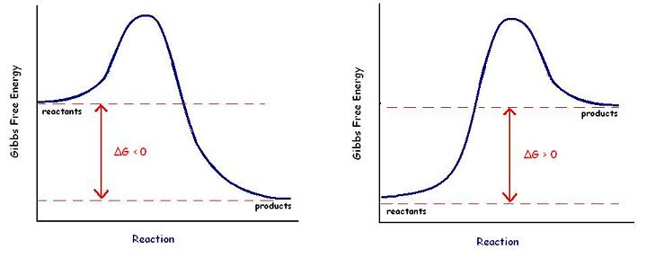
A B
13. Which of these diagrams represents a chemical reaction with a +∆G ?

14. TRUE OR FALSE The ∆G of this reaction would decease if an enzyme was added.

15. NONCOMPETITIVE enzyme inhibitors bind to the __________ site on an enzyme.
active allosteric

16. If oxygen is low or unavailable what pathway do cells use to obtain energy?

17. Explain why NADH produces more ATP than FADH₂ when it passes its electrons through electron transport in the mitochondria?
18. Compare the amount of ATP produced during the 3 stages of cellular respiration.

19. What determines whether a cell does fermentation or switches into Krebs cycle?

20. Name the two types of fermentation and give example of an organism that uses each kind.

21. Cells can get ATP from doing glycolysis. Continuing on into fermentation produces no additional energy. For what reason do cells do fermentation?

22. What is the electron acceptor at the end of the electron transport chain in mitochondria?

23. Where do the carbons from glucose end up following the Krebs cycle?

24. Another name for the Krebs cycle is
_________________.

25. Explain the effect of temperature on an enzyme catalyzed reaction.
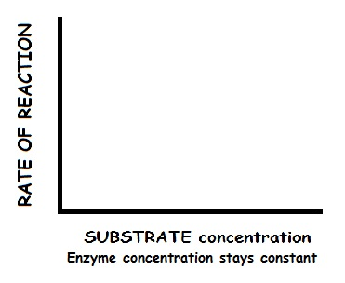
26. What would this graph look like?

27. Which bonds are disrupted in an enzyme when it denatures?

28. What is the cofactor found in chlorophyll?

29. The hydrolysis of ATP is a – Δ G reaction. Explain how cells use energy coupling to provide power for cell activities that are endergonic?

30. This equation describes the free energy of a system
∆G=∆H - T ∆S
What does S represent?

31. Name a cell part where you would find chemiosmosis happening.

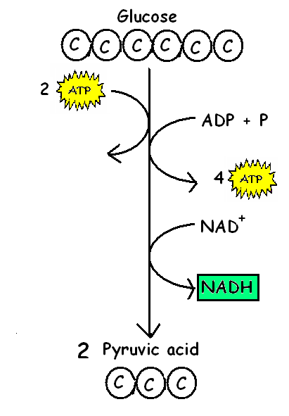
32. Using energy from breaking a chemical bond to add a phosphate directly from a phosphorylated molecule to ADP without
a proton gradient as shown at the right is called _________________

33. How many “turns” of the Calvin cycle are required to make ONE MOLECULE of glucose?

34. MATCH THE FOLLOWING WITH THEIR LOCATION DURING PHOTOSYNTHESIS (You can use them once, more than once, or not at all)
______ Splitting of water A. STROMA
B. THYLAKOID SPACE
______ Calvin cycle C. THYLAKOID MEMBRANE
D. CYTOPLASM
______ Electron Transport Chain
______ Phosphorylation of ADP →ATP
______ Reduction of NADP⁺ → NADPH
______ Build up of H⁺ ions

ANSWERS
1. In the thylakoid space
2. From water splitting; Proton pumps in ETC move H⁺ from stroma to thylakoid space
3. NADP⁺
4. C₆H₁₂O₆ + 6 O₂ → 6 CO₂ + 6 H₂O + energy
5. Exact opposite
6. Red and blue-violet
7. competitive
8. B-non-cyclic
9. If ETC gradient doesn’t make ATP, more sugar must be metabolized for energy needs.
Blocking production of ATP can KILL you. Massive burning of sugar can cause patient to overheat leading to seizures/death.
10. Need more ATP than NADPH to do Calvin cycle
11. CO₂
12. O₂, ATP, NADPH
13. B; products have more energy than reactants
14. FALSE; enzymes change activation energy but NOT overall ∆G
15. allosteric
16. Fermentation
17. NADH drops off its electrons higher up in the ETC; FADH₂ skips the first proton pump
18. Glycolysis- net 2 ATP; Krebs cycle- 2 ATP; ETC- (10 NADH X3 + 2 FADH₂ X 2) =34 ATP
(Plus net 2 from glycolysis + 2 from Krebs minus 2 ATP for transport = 36 total ATP/1 glucose)
19. Availability of oxygen
20. Alcoholic- bacteria make beer, wine; yeast makes bread
Lactic acid-human muscle cells during exercise;
bacteria –yogurt, sauerkraut, pickles
21. Needs to get rid of built up pyruvic acid AND regenerate NAD⁺
22. oxygen
23. As CO₂ in atmosphere
24. Citric acid cycle/tricarboxylic acid (TCA) cycle
25. Increasing temp speeds up reaction up to a point. Too hot-denatures enzymes
26. 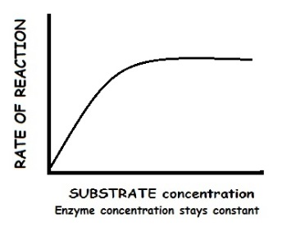
27. Disrupts hydrogen/ionic bonds/phobic/philic interactions in 2°, 3°, 4° structure (NOT primanry)
28. Magnesium (Mg)
29. Cells couple the – Δ G reaction of hydrolysis of ATP to provide power for + Δ G reactions.
30. Entropy (disorder)
31. Mitochondria or chloroplasts
32. Substrate level phosphorylation
33. Two turns. Each makes a 3-carbon molecule (G3P)
34. Splitting of water- B (thylakoid space);
Calvin cycle-A (stroma);
Electron transport chain –C (thylakoid membrane);
Phosphorylation of ADP →ATP – A (stroma);
Reduction of NAPD⁺ → NADPH- A (stroma);
build up of H+ ions – B (thylakoid space)

