1. During the light dependent reactions where do H⁺ ions accumulate?

2. What are the TWO sources of these H⁺ ions?

3. During photosynthesis, which molecule
acts as the final electron acceptor at the end of the electron transport chain?

4. Write the overall equation for cellular respiration.
5. How does this compare to the equation for photosynthesis?

6. Which color wavelength(s) of light do/does chlorophyll absorb best?

7. The effect of which kind of enzyme inhibitor could be altered by the addition of more substrate?
Competitive Non-competitive Both of these

8. The process in photosynthesis that most closely resembles chemiosmosis and oxidative phosphorylation in cellular respiration is
A) cyclic phosphorylation
B) non-cyclic phosphorylation
C) ATP synthase coupling
D) Calvin cycle
E) acetyl CoA formation
9. Dinitrophenol (DNP) is an uncoupler. It separates the flow of electrons and the creation of a H⁺ gradient from ATP synthesis. DNP causes mitochondrial membranes to become “leaky”, letting H⁺ ions escape without passing through ATP synthase. This means that the energy from electron transfer in ETC cannot be used for ATP synthesis. Fifty years ago DNP was given as a drug to help patients lose weight. How could this help someone to lose weight? Why would this be dangerous?

10. Why do plants switch to cyclic rather than noncyclic photophosphorylation?

11. Where does the oxygen that ends up in glucose during the Calvin cycle originally come from?

12. What are the products of the light dependent reactions?

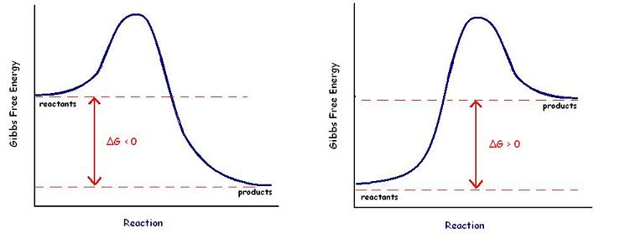
A B
13. Which of these diagrams represents a chemical reaction with a +∆G ?

14. TRUE OR FALSE: The ∆G of this reaction would decease if an enzyme was added.

15. NONCOMPETITIVE enzyme inhibitors bind to the __________ site on an enzyme.
active allosteric

16. If oxygen is low or unavailable what pathway do cells use to obtain energy?

17. Explain why NADH produces more ATP than FADH₂ when it passes its electrons through electron transport in the mitochondria?
18. Compare the amount of ATP produced during the 3 stages of cellular respiration.

19. What determines whether a cell does fermentation or switches into Krebs cycle?

20. Name the two types of fermentation and give example of an organism that uses each kind.

21. Cells can get ATP from doing glycolysis. Continuing on into fermentation produces no additional energy. For what reason do cells do fermentation?

22. What is the electron acceptor at the end of the electron transport chain in mitochondria?

23. Where do the carbons from glucose end up following the Krebs cycle?

24. Another name for the Krebs cycle is
_________________.

25. Explain the effect of temperature on an enzyme catalyzed reaction.
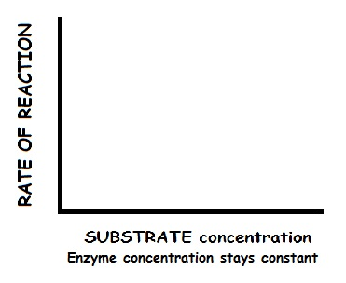
26. What would this graph look like?

27. Which bonds are disrupted in an enzyme when it denatures?

28. What is the cofactor found in chlorophyll?

29. The hydrolysis of ATP is a – Δ G reaction. Explain how cells use energy coupling to provide power for cell activities that are endergonic?

30. This equation describes the free energy of a system
∆G=∆H - T ∆S
What does S represent?

31. Name a cell part where you would find chemiosmosis happening.

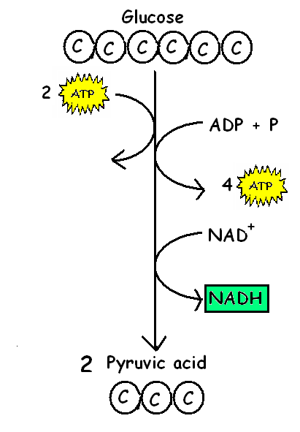
32. Using energy from breaking a chemical bond to add a phosphate directly from a phosphorylated molecule to ADP without
a proton gradient as shown at the right is called _________________

33. How many “turns” of the Calvin cycle are required to make ONE MOLECULE of glucose?

34. MATCH THE FOLLOWING WITH THEIR LOCATION DURING PHOTOSYNTHESIS (You can use them once, more than once, or not at all)
______ Splitting of water A. STROMA
B. THYLAKOID SPACE
______ Calvin cycle C. THYLAKOID MEMBRANE
D. CYTOPLASM
______ Electron Transport Chain
______ Phosphorylation of ADP →ATP
______ Reduction of NADP⁺ → NADPH
______ Build up of H⁺ ions

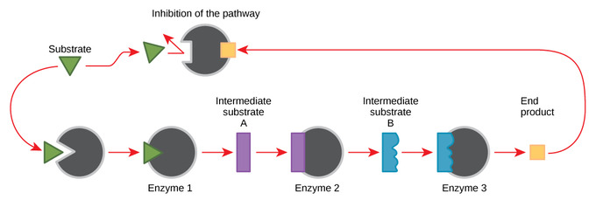
35.

This diagram is showing ___________________________.
The end product of this pathway is acting as a(n)
__________________ inhibitor for Enzyme 1.
competitive non-competitive

Explain why it is beneficial to the cell that the end product inhibits Enzyme 1 and NOT Enzyme 2 or Enzyme 3.

36. How do plants and animals differ in the way they store
excess glucose for later?

When glucose stores are low in humans, what other
molecules are burned for energy?
Explain how fats can be used as fuel when sugar is low.

37. “Dust off your Biology Brain”.
Photosynthesis and Cellular Respiration are parts of the
carbon cycle. How do these 2 pathways interact to keep
nutrients cycling in ecosystems?

38. Green plants “look green” because they _________ green wavelengths of light. absorb reflect
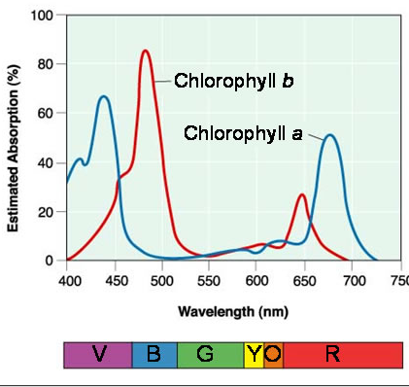
39. This diagram shows the absorbance of different wavelengths of light by chlorophyll.

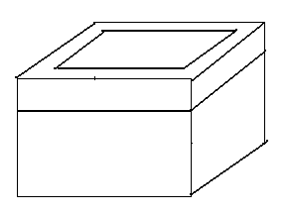
Make a prediction about plant growth and ability
to photosynthesize if plants were grown under conditions where they only received green light.

AP BIO METABOLISM Card Review by Kelly Riedell

