GIBBS FREE ENERGY

Δ G = ΔH – TΔS

Δ G < 0
Δ G > 0
Δ G = 0
CELLULAR RESPIRATION
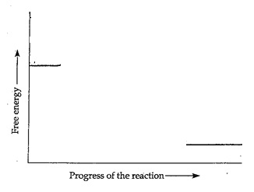

PHOTOSYNTHESIS
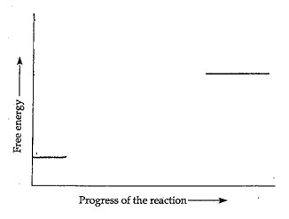

ATP → ADP + P_{i} + energy ΔG =
ADP + P_{i} + energy→ ATP ΔG =

