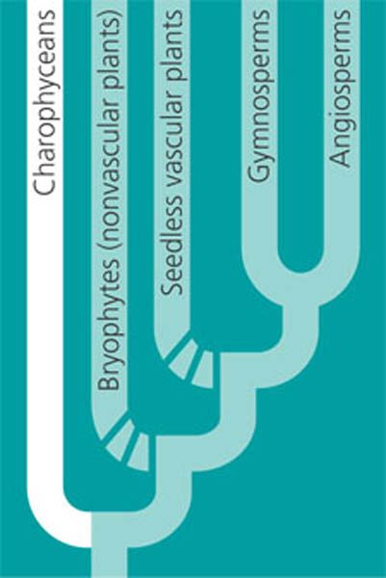
PLANT DIVERSITY –Chapters 29 & 30
Evidence plants descended from green algae (CHAROPHYCEAN) ancestors
Both have rose-shaped complexes for cellulose synthesis
Both have peroxisome enzymes to reduce effects of photorespiration
Both have similar flagellated sperm
Both form cell walls in same way during cell division
Cellular/chloroplast DNA similarities
ADVANTAGES OF LIVING ON LAND  -increased sunlight unfiltered by water  -more CO₂ available from atmosphere  -soil rich in nutrients  -fewer predators | PROBLEMS TO OVERCOME  -lack of water  -dessication  - SPOROPOLLENIN polymer prevents  spores from drying out  - CUTICLE-waxy layer on epidermis  -lack of structural support against gravity

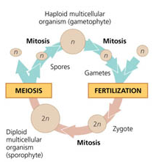
ALL PLANTS HAVE A LIFE CYCLE with TWO MULTICELLULAR STAGES
= ALTERNATION OF GENERATIONS
HAPLOID GAMETOPHYTE undergoes MITOSIS to produce 1n GAMETES
(sperm or egg)
FERTILIZATION (egg + sperm) produces DIPLOID ZYGOTE
ZYGOTE develops into DIPLOID SPOROPHYTE
SPOROPHYTE (2n) undergoes MEIOSIS to produce HAPLOID SPORES
SPORES (1n) develop into HAPLOID GAMETOPHYTE
SPORES are produced in SPORANGIA

Gametes produced in multicellular organs = GAMETANGIA
MALE gametangia = ANTHERIDIA- make sperm
FEMALE gametangia = ARCHEGONIA –make single egg

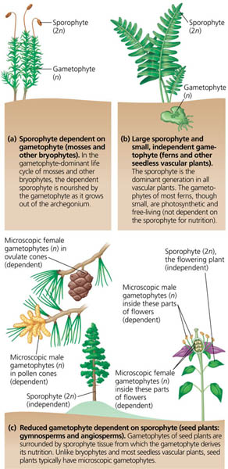
4 MAIN GROUPS OF PLANTS
SEEDLESS VASCULAR
Ferns, club mosses, horsetails
= PTERIDOPHYTES
DOMINANT SPOROPHYTE
grows from GAMETOPHYTE
Mature sporophyte independent
NEED WATER for sperm to swim
SEEDLESS NONVASCULAR
(no xylem and phloem)
Mosses, liverworts, hornworts
= BRYOPHYTES
GAMETOPHYTE DOMINANT
SPOROPHYTES DEPENDENT
grow from gametophyte
NEED WATER for sperm to swim

VASCULAR WITH SEEDS
Flowering plants =ANGIOSPERMS
DOMINANT SPOROPHYTE
GAMETOPHYTE microscopic
dependent on sporophyte
Sperm carried by wind/animals

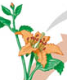
NAKED SEED VASCULAR
Conifers, Cycads, Ginkos
= GYMNOSPERMS
SPOROPHYTE DOMINANT
GAMETOPHYTE REDUCED in size
Sperm carried by wind/insects

VASCULAR PLANTS = TRACHEOPHYTES

KEY ADAPTATIONS TO LIFE ON LAND UNIQUE TO SEED PLANTS
REDUCED GAMETOPHYTES-microscopic
protects antheridia/archegonia
HETEROSPORY-two kinds of spores
MEGASPORES produce female gametophytes which make eggs
MICROSPORES produce male gametophytes which contain sperm nuclei
OVULES-made of megasporagium, megaspore, and protective tissue
increased protection for egg and developing zygote
POLLEN- eliminates need for water for transfer sperm
Has protective coating
can be carried by wind/animals
Pollen grain = male gametophyte containing TWO sperm nuclei
SEEDS-multicellular with protective layers
contain stored food (ENDOSPERM) so seed can wait for good conditions to germinate
embryo can use stored energy for early growth

90% of all plant species = ANGIOSPERMS
MAJOR REPRODUCTIVE ADAPTATION OF ANGIOSPERMS = FLOWER
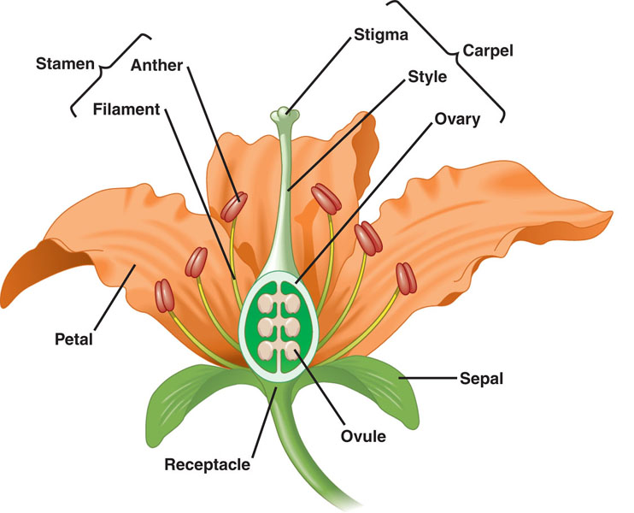

SEPALS- enclose and protect floral bud

PETALS- color/UV light attract insect pollinators

STAMEN-
FILAMENT = stalk
ANTHER- produce pollen

CARPEL-
STIGMA = sticky top receives pollen
STYLE- slender neck
OVARY- contains multiple OVULES

FRUIT = mature ovary
EUDICOTS (DICOTS)
Includes most Angiosperms
Examples: peas, beans, roses, oaks
TWO cotyledons in seed
Net veination
vascular tissue in ring
Taproot
Pollen grain has 3 openings
Flower parts in multiples of 4’s & 5’s
Fertilized ovules develop into SEEDS
Seeds develop from ovules
Walls thicken to become fruit
Animals help disperse seeds
MONOCOTS
Examples: corn, orchids, lilies, grasses
ONE cotyledon in seed
parallel leaf veination
Vascular tissue scattered
Fibrous roots
Pollen grain has 1 opening
Flower parts in multiples of 3’s

