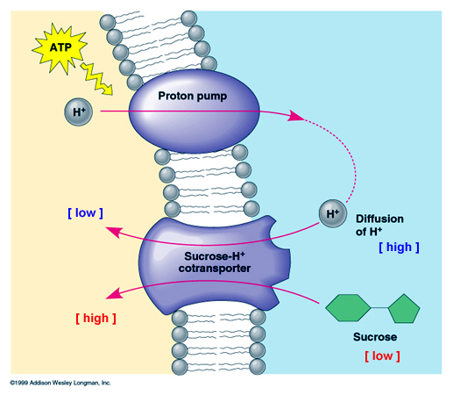
TRANSPORT IN VASCULAR PLANTS - CHAPTER 36
PROTON PUMP-uses energy from ATP to pump H⁺ ions out of cell CHEMIOSMOSIS – Produces H⁺ gradient; membrane potential
Energy from gradient can be harnessed for active transport
~ drives CATIONS INTO CELL; Ex: K⁺
~ COTRANSPORT
moves ANIONS (NO₃⁻) & SUGARS INTO cell when H⁺ returns
OSMOSIS = PASSIVE transport of WATER across cell membrane
WATER POTENTIAL determines direction of movement
water moves from HIGH → LOW water potential
AQUAPORIN transport proteins CHANGE RATE NOT DIRECTION of water movement
Plants in HYPOTONIC environment → water enters; cells become TURGID
Plants in HYPERTONIC environment → water leaves; cells become FLACCID; plant wilts
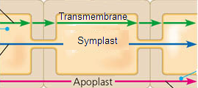
HOW WATER & SOLUTES MOVE IN PLANTS
APOPLAST- continuum of CELL WALLS + extracellular spaces
SYMPLAST- continuum of CYTOSOL
neighboring cells connected by PLASMODESMATA
TRANSMEMBRANE – cell walls + cytosol pathway

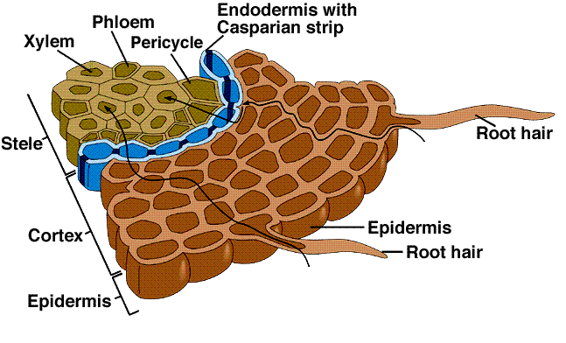
BULK FLOW= movement of water from HIGH pressure to LOW pressure regions
= Movement of water/solutes through xylem/phloem
Water taken up by EPIDERMIS
ROOT HAIRS/MYCORRHIZAE increase surface area
CASPARIAN STRIP- belt of waxy SUBARIN
Blocks APOPLAST path
Forces water INTO XYLEM via SYMPLAST path

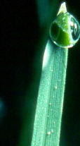
TRANSPIRATION-COHESION-TENSION METHOD
XYLEM MOVES WATER/MINERALS ONE WAY
Evaporation of water from leaves = TRANSPIRATION due to lower water potential of air
Creates NEGATIVE pressure to pull water up from roots to shoots
Water forms column and moves by CAPILLARY ACTION (water moving in tube)
COHESION (water molecules stick to each other due to HYDROGEN BONDING)
ADHESION (water molecules stick to surface of xylem cells)

GUTTATION- At night transpiration is low; roots still pump ions into xylem
Movement of water creates root pressure = upward push of xylem sap
Excess water drops are exuded from tips of plant; (NOT SAME AS DEW)

TURGOR PRESSURE in GUARD CELLS controls water loss through STOMATA
K⁺ transported into guard cells; water follows; TURGID cell = stomata OPEN
Loss of K⁺ and water makes guard cells FLACCID = stomata CLOSE
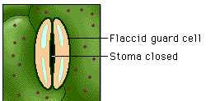
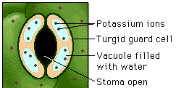

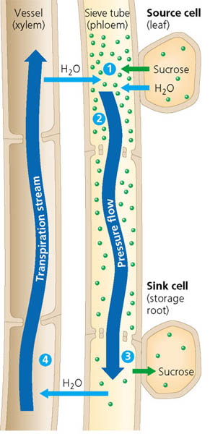
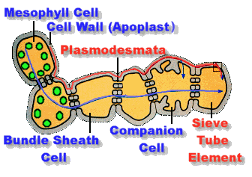
PRESSURE FLOW MECHANISM
PHLOEM SAP moves from SOURCE (where it’s made) to SINK (where it’s stored/used)
Driven by POSITIVE PRESSURE
COMPANION CELLS help load sugars into SIEVE TUBE ELEMENTS
HIGH sugar concentration REDUCES WATER POTENTIAL in sieve tubes;
water moves into tubes; pressure moves sap downward
Removal of sugar at sink INCREASES WATER POTENTIAL in sieve tubes
water moves out of tubes into xylem

