AP Bio Station Review

STATION 1: OPERONS  
**Use the pool noodles to review *trp* and *lac* operons.**1. What do the terms repressible and inducible mean?

|  |  |
| --- | --- |
| OPERON | INDUCIBLE/REPRESSIBLE |
| *lac* operon |  |
| *trp* operon |  |

2. What environmental conditions make the repressor in each of these “active”?

3. DRAW A PICTURE OF the *trp* operon when tryptophan is available to cell.  
Be sure to include RNA POLYMERASE, REPRESSOR protein, tryptophan,

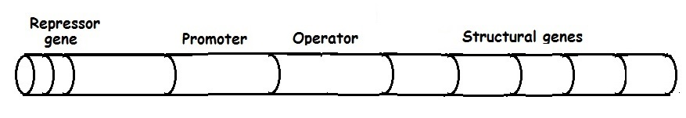

4. DRAW A PICTURE of the *lac* operon when GLUCOSE is LOW and LACTOSE is PRESENT.  
Be sure to include cAMP, CAP, LACTOSE, RNA POLYMERASE, REPRESSOR protein, etc



STATION 2: ACTIVE/PASSIVE TRANSPORT  
Use the cards provided to build a concept map on the desktop.  
Use the chart in your BILL to check your map.

5. EXPLAIN how ACTIVE TRANSPORT and PASSIVE TRANSPORT work together to do the following: BE SURE TO IDENTIFY the type of transporter used (ion channel, proton pump, endocytosis, etc.) and whether each is ACTIVE or PASSVIVE.

a. Set potential on a nerve cell and depolarize cell when a signal is received

b. Photophosphorylation in thylakoids during the light dependent reactions

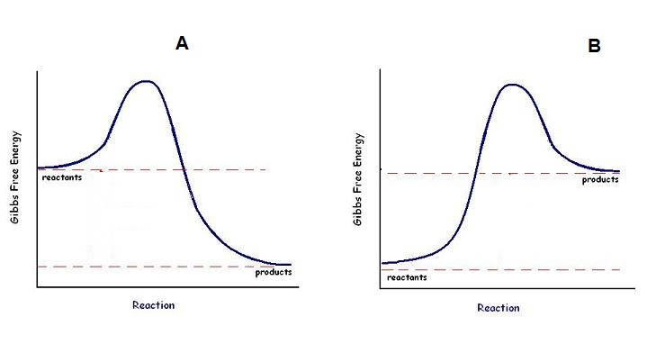STATION 3:  
Identify the graphs as NEGATIVE DELTA G or POSITIVE DELTA G reactions.  
LABEL the graphs as EXERGONIC or ENDERGONIC

___________________________ ________________________

___________________________ ________________________

6. EXPLAIN how you can tell which is which?

7. Which of these requires energy to get started?

8. How does adding an enzyme affect the DELTA G of these reactions?

9. Which of these diagrams would represent the HYDROLYSIS OF ATP?

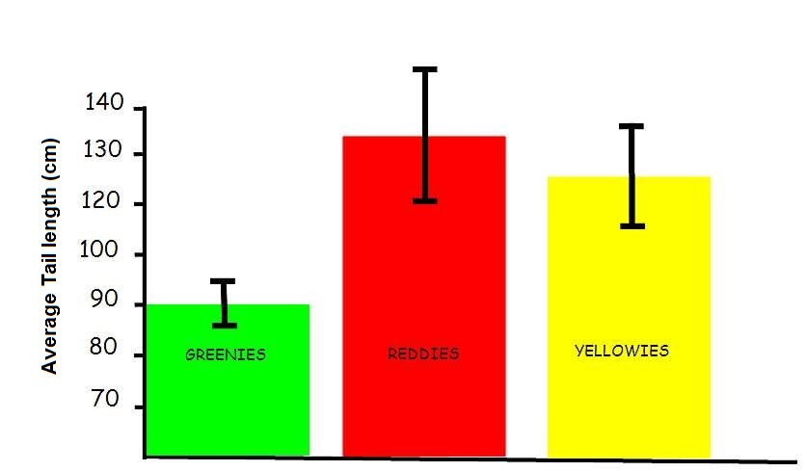STATION 4:  
The following graph shows data collected on the average tail length of 3 different types of  
aliens. Error bars show 95% confidence levels (2 SEM).

10. What conclusion(s) can be drawn from this about the differences in tail lengths between  
the 3 types of aliens? EXPLAIN YOUR ANSWER

STATION 5:  
 Water potential in potato cells was determined in the following manner. The initial masses of six groups of potato cores were measured. The potato cores were placed in sucrose solutions of various molarities. The masses of the cores were measured again after 24 hours. Percent changes in mass were calculated. The results are shown below. Graph these data shown.

11. From your graph, label where the cells were   
HYPOTONIC and the solution was HYPERTONIC, and VICE VERSA.   
  
12. Determine the apparent molar concentration (osmolarity) of the potato core cells.

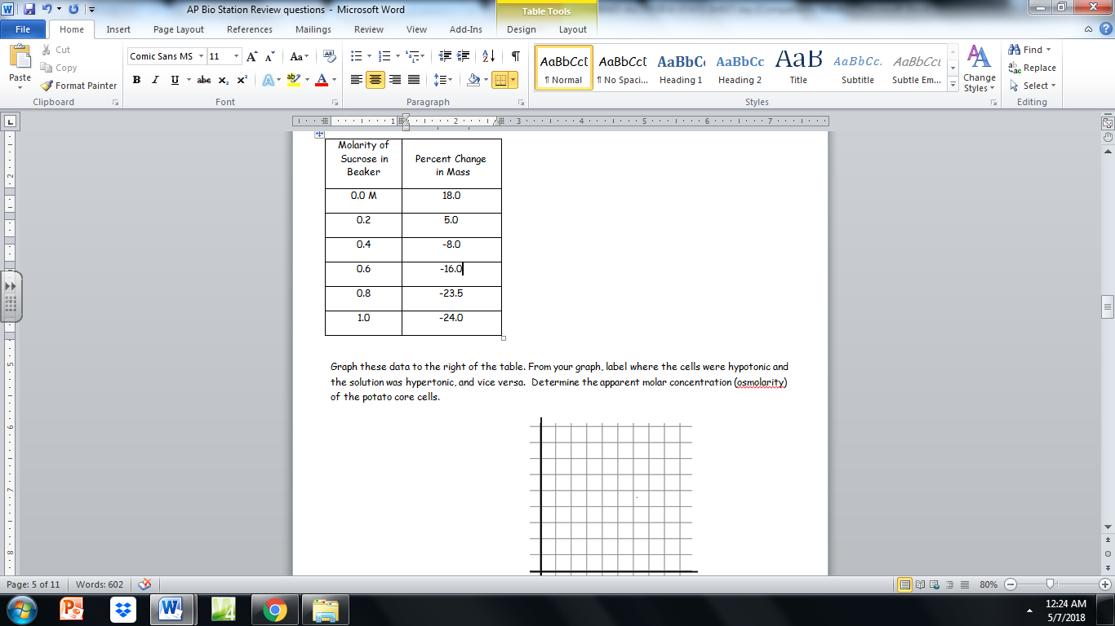



STATION 6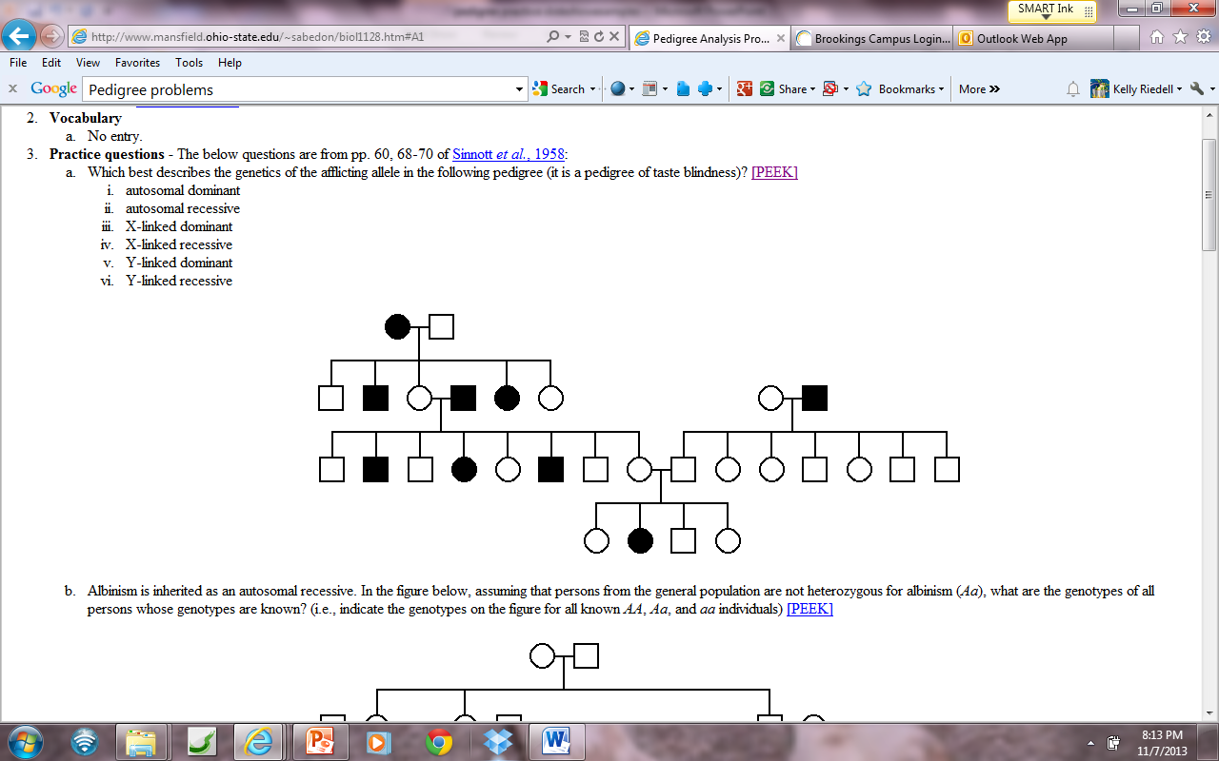- PEDIGREES

13. Is it possible that this trait inherited as AUTOSOMAL DOMINANT? YES NO  
EXPLAIN YOUR ANSWER

***********************************************************************************

14. The inheritance of the disorder in II-3 from his father rules out what form of inheritance?  
EXPLAIN YOUR ANSWER.

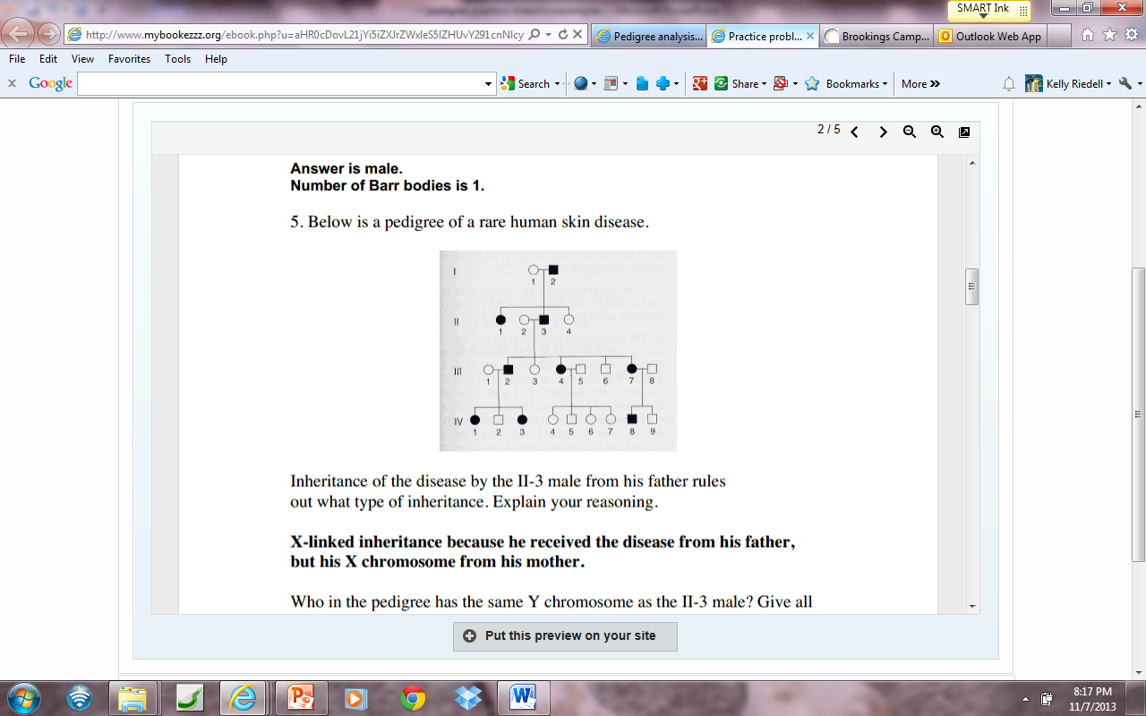

STATION 7: CHI SQUARE ANALYSIS   
15. WHAT IS ALWAYS THE **NULL HYPOTHESIS** FOR A CHI SQUARE ANALYSIS?

In corn, purple kernels (P) are dominant over yellow (p) and smooth kernels (S) are dominant over shrunken (s). AN ear of corn has 381 kernels,  
purple, smooth = 216  
purple, shrunken = 79  
yellow, smooth = 65  
yellow, shrunken = 21

16. Use Chi square analysis to determine if the data fits the predicted phenotypic ratio if this is a double heterozygous dihybrid cross?

|  |  |  |  |  |
| --- | --- | --- | --- | --- |
| Observed Phenotypes (o) | Expected (e) | (o-e) | (o-e)2 | (o-e)2  e |
|  |  |  |  |  |
|  |  |  |  |  |
|  |  |  |  |  |
|  |  |  |  |  |
|  |  |  | X2 = |  |

How many degrees of freedom? ___________

CONCLUSION

STATION 8: GENETICS- FRUIT FLY DATA  
Results of a cross between homozygous WT (red eyed) male flies and homozygous sepia eyed females   
are shown below.

|  |  |  |  |  |
| --- | --- | --- | --- | --- |
|  | WT eyed male | WT eyed female | Sepia eyed male | Sepia eyed female |
| F1 | 4916 | 5010 | 0 | 0 |

|  |  |  |  |  |
| --- | --- | --- | --- | --- |
|  | WT eyed male | WT eyed female | Sepia eyed male | Sepia eyed female |
| F2 | 3764 | 3717 | 1195 | 1251 |

17. How is this trait inherited?  
   
 dominant recessive autosomal X-linked

18. EXPLAIN HOW YOU KNOW

19. Draw a Punnett showing the parents & offspring in the F2 cross.

STATION 9:  
A new species of fly was discovered on an island in the South Pacific. Several different crosses were performed, each using 100 females and 100 males. The phenotypes of the parents and the resulting offspring were recorded.

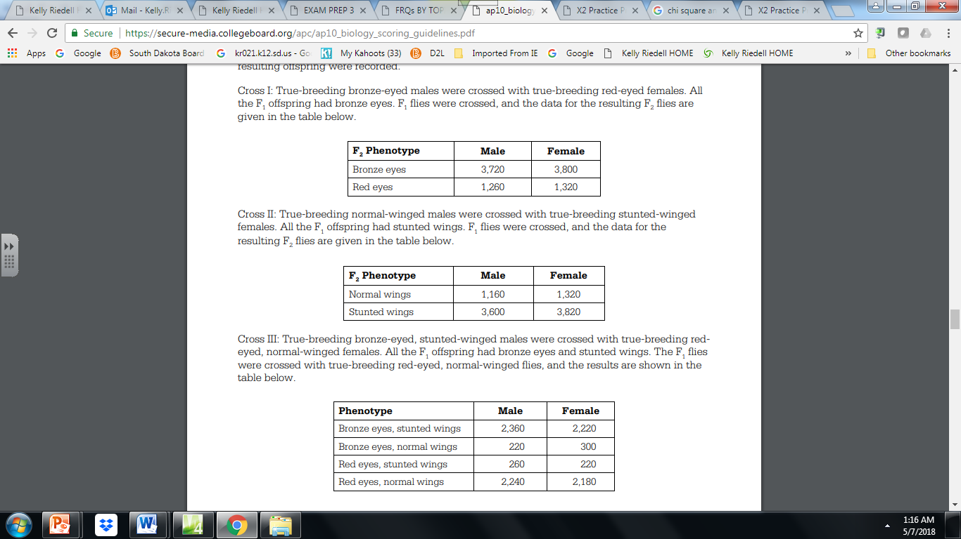Cross I: True-breeding bronze-eyed males were crossed with true-breeding red-eyed females. All the F1 offspring had bronze eyes. F1 flies were crossed, and the data for the resulting F2 flies are given in the table below.

Cross II: True-breeding normal-winged males were crossed with true-breeding stunted-winged females. All the F1 offspring had stunted wings. F1 flies were crossed, and the data for the resulting F2 flies are given in the table below.

Cross III: True-breeding bronze-eyed, stunted-winged males were crossed with true-breeding red eyed, normal winged females. All the F1 offspring had bronze eyes and stunted wings. The F1 flies were crossed with true breeding red-eyed, normal-winged flies, and the results are shown in the table below.

20 a) What conclusions can be drawn from cross I and cross II?   
       **Explain**how the data support your conclusions for each cross.

(b) What conclusions can be drawn from the data from cross III?  
      **Explain**how the data support your conclusions.

STATION 10.  
In fruit flies, the phenotype for eye color is determined by a certain locus. E indicates the dominant allele and e indicates the recessive allele. The cross between a male wild-type fruit fly and a female white-eyed fruit fly produced the following offspring.

|  |  |  |  |  |
| --- | --- | --- | --- | --- |
|  | **Wild-type males** | **Wild-type females** | **White-eyed males** | **White-eyed females** |
| F1 | **0** | **45** | **55** | **0** |

 The wild type and white-eyed individuals from the F1 generation were crossed to produce the following;

|  |  |  |  |  |  |
| --- | --- | --- | --- | --- | --- |
|  | **Wild-type males** | **Wild-type females** | **White-eyed males** | **White-eyed females** |  |
| F2 | **25** | **31** | **22** | **24** |  |

a) DETERMINE the genotypes of the original parents (P1 generation) and EXPLAIN your reasoning. You may use Punnett squares to enhance your description, but the results from the Punnett squares must be discussed in your answer.

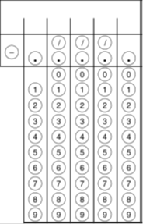STATION 11 : MATH PRACTICE

There are 252 deer in a population. There is no net immigration or   
  
emigration. If 47 deer die and 32 deer are born in one month, what is   
  
the population size at the end of the month? Round to the nearest  
whole number.



If 250 people out of a population of 1,000 are born with sickle-cell anemia, what is the frequency of the population that will be more resistant to malaria because they are heterozygous for the  
 sickle-cell gene? Give your answer as a decimal to 2 places.



If parents have the following genotypes:   
 AaBbCcDd X AaBbCcDd

What is the probability of producing a offspring with this gene combination AaBBccDD ? Give your answer as a fraction.

STATION 12:

