Cell Signaling and Homeostasis Modeling

Reception:
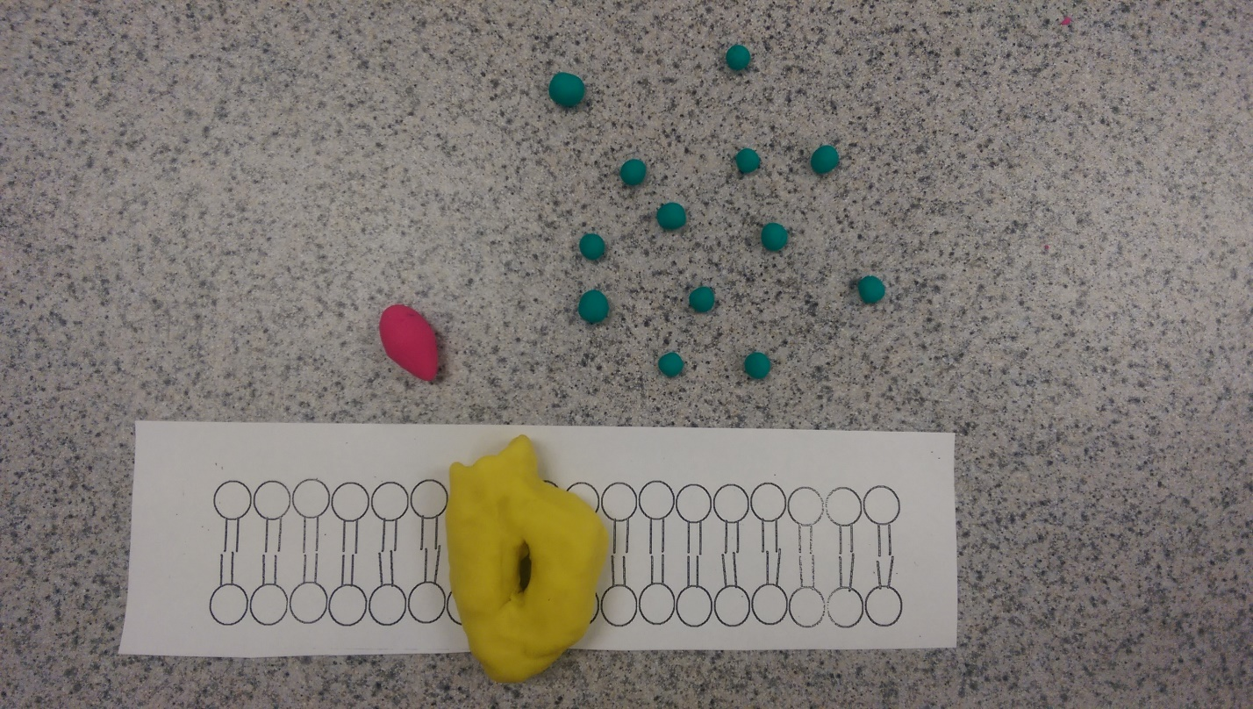
Figure 1 – This is a picture of a ligand-gated ion channel receptor where the gate is closed until a ligand binds to it.

Transduction:
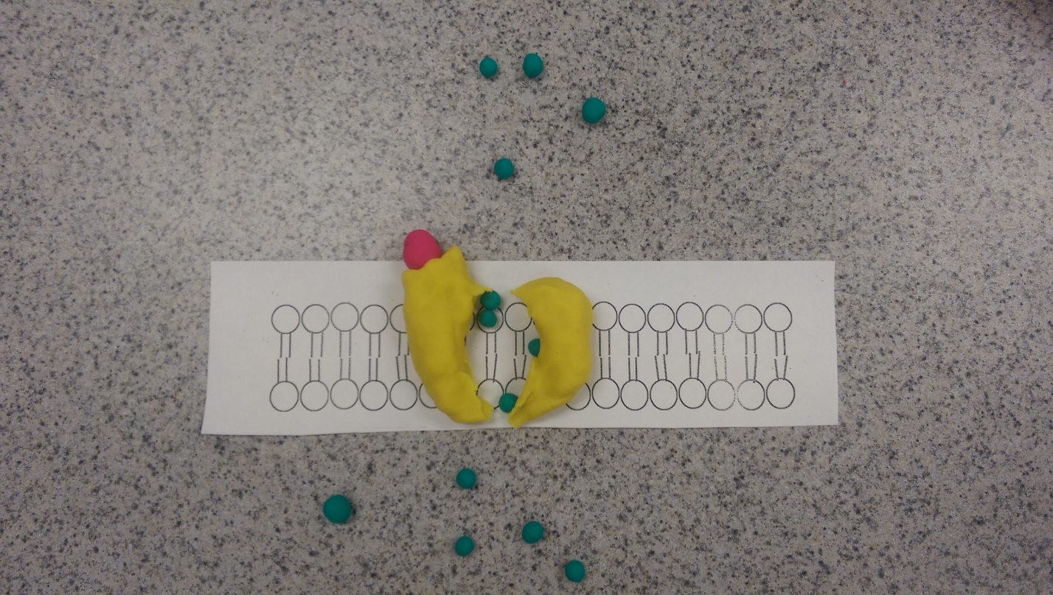
Figure 2 - The gate opens when the ligand binds to the receptor and specific ions can flow through the channel which rapidly changes the concentration of that ion in the cell. This change may affect the behavior of the cell.

Cell Response:
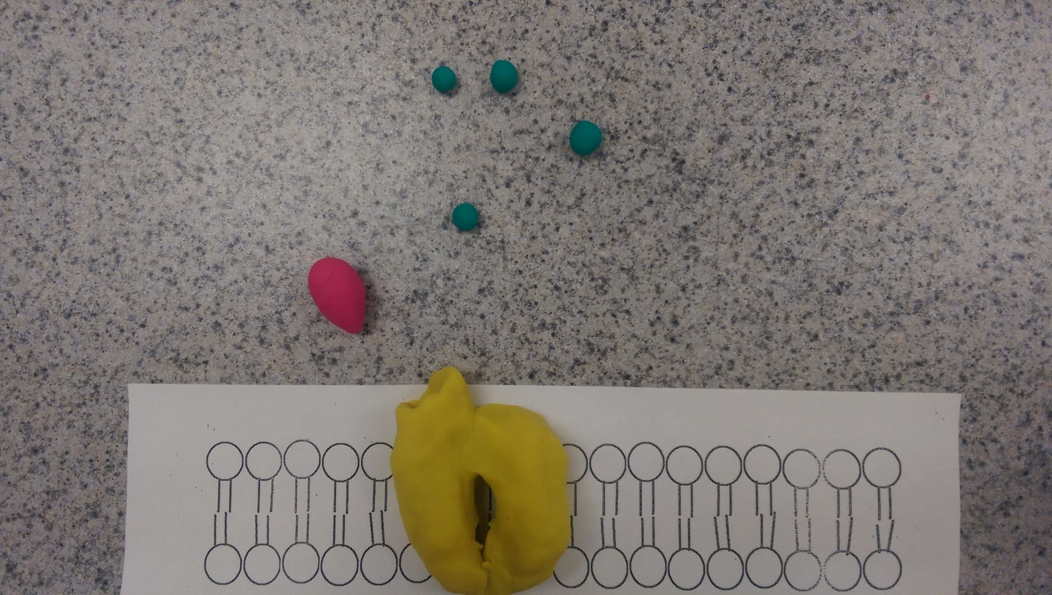
Figure 3- The ion transmits a signal to the cell due to the change in ion concentration. The ligand detaches from the receptor and the gate closes. Specifically, electric signals are transmitted through nerve cells.
Questions:
a) They regulate protein activity
b) They carry signals from the plasma membrane into the cell’s interior.
c) Because they are small, nonprotein, water-soluble molecules that don’t need something to bind to a membrane receptor.
d) Cell signaling maintains the proper mixture of ions and un-ionized molecules.
e) Hormones are small hydrophobic signaling molecules that diffuse across a plasma membrane.
f) Cells maintain homeostasis by passive forms of transport such as: osmosis, diffusion, and filtration.
g) An example of a behavior mechanism is hunting in packs, like wolves. An example of a physiological mechanism in a change in environment is the hibernation of bears.

