1. Loosely, attached to the cytoplasmic side of the membrane, the G protein functions as a molecular switch that is either on or off, depending on which of two guanine is attached, GDP or GTP- hence the term G protein. When GTP is bound to the G protein, as shown above, the G protein is inactive. The receptor and G Protein work together with another protein, usually an enzyme.

2. When the appropriate signal molecule binds to the extracellular side of the receptor, the receptor is activated and changes shape. Its cytoplasmic side then binds an inactive G protein, causing a GTP to displace the GDP. This activates the G protein.

3. The activated g protein dissociate from the receptor and diffuses along the membrane, then binds to an enzyme and alters it activity. when the enzyme is activated, it can trigger the next step in a pathway leading to cellular response

4. The changes in the enzyme ang G protein are only temporary, because the G protein also functions as a GTPase enzyme and soon hydrolyzes its bound to GTP and GDP. Now inactive again, the G protein leaves the enzyme, which returns to its original state. The G protein is now available to reuse. The GTPase function of the G protein allows the pathway to shut down rapidly when the signal molecule is no longer present

QUESTIONS:
7a. Phosphorylation is the addition of a phosphate group to a protein or other organic molecule. Phosphorylation turns many protein enzymes on and off, thereby altering their function and activity. Dephosphorylation is the removal of a phosphate group. Dephosphorylation happens when the GTP binds to an enzyme and changes into GDP, also removing a phosphate group along with the GDP from the enzyme.
7b. Secondary messengers are activated by an external signal or first signal and then relay the message to internal parts through the second signal.
7c.Secondary messengers get their name from the job as of releasing the second signal inside the cell during cell signaling.
7d.Homeostatisis is the maintained regulation of the body. Cell signaling helps to maintain homeostasis through self regulation of the cell if anything is out of balance.
7e.In long-distance cell signaling hormones are used to send the first signal to a cell to begin a cellular response. Hormones from the endocrine system and the nervous system work together sending signals to cells.
7f. Cell membranes maintain homeostasis through controlling what substances can enter and leave the cell, the cell maintains an isotonic solution, the transportation out of unnecessary parts, regulation of temperature and ph.
7g. In a desert environment many organisms develop the physiological mechanism of retaining water in order to prevent dehydration when in a habitat that lacks water resources. They also can develop a behavior mechanism such as being nocturnal avoiding the hot sun during the day and scavenging for food at night.

GDP
G-protein receptor
GTP
G-protein

Arrow
Hydrophilic Ligand
Phosphate
Inactive Enzyme
Active Enzyme

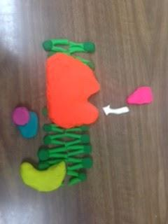
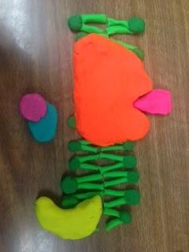
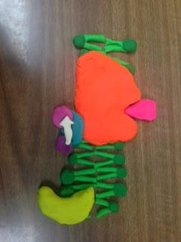
1. G Protein Receptor waits for an external signal.
2. A hydrophilic ligand approaches the G-protein receptor.
3. A hydrophilic ligand binds to the G-protein-coupled receptor in the plasma membrane.
RECEPTION
4. The conformation change causes inactive G-protein to attach. GTP then displaces GDP and activates G-Protein.
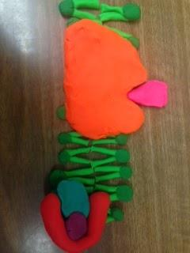
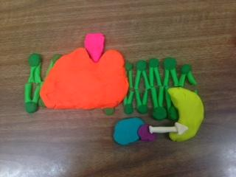
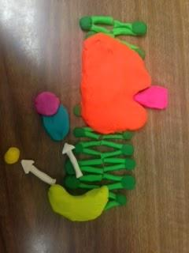
5. The activated G-protein then approaches the inactive enzyme.
TRANSDUCTION
6. The active G-protein then activates the enzyme, which then activates a cellular response.
7. Once enzyme is activated, the G-protein leaves the enzyme as GDP displaces GDP in the G-protein. A phosphate is given off.
CELL RESPONSE

